Universal Charging Friend
U.C.F.

Fall 2010
Group A

Alfred Berrios
Tristan Byers
Melanie Cromer
Michael Matthews

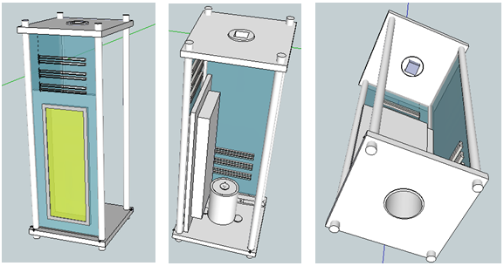
Table of Contents
Executive Summary 7
Motivation and Rationale 7
Goals and Objectives 8
Solar Input 8
Kinetic Input 9
Storing Power 9
Monitoring System 9
Physical Design 10
Final Design Overview 10
Specifications 11
Solar 11
Kinetic 11
Battery 12
Microcontroller 12
Full Design Specification 12
Research 13
Resources 13
Solar Power Research 14
Solar Power Availability 15
Angle of Incidence 17
Maximum Power Tracker 17
Concentrated Sunlight 18
Photovoltaic Solar Cells 19
Temperature Considerations 20
Heat Transfer Equations 20
Forced and Natural Convection 22
Silicon Thermal Characteristics 25
Properties of Steel 26
Properties of Aluminum 27
Thermal Adhesive 28
Kinetic Research 28
Potential Energy from People 30
Power from Breathing 30
Power from Arm Motion 31
Power from Walking 31
Power from Pedaling/Hand Crank 33
Alternative to Bike Pedaling 33
Transduction Mechanisms 33
Piezoelectric Transduction 36
Electromagnetic Transduction 38
Electrostatic Transduction 41
Switched Mode (Type 1 Electrostatic Transducer) 42
Fixed Charge (Type 2 Electrostatic Transducer) 42
Thermoelectric Generators 43
Bike Pedaling Generator 44
A completed 12 Volt Pedal Powered Generator 45
Hand Crank Generator 47
Completed Electromagnetic Research Project 48
Limitations 53
Ways to store the harvested energy 53
Additional Issues to be Considered 55
Microcontroller 55
Microchip’s PIC16 Series Microcontroller 56
Microchip’s PIC18 Series Microcontroller 57
Atmel ATmega88PA 60
Texas Instrument’s MSP430 62
Microcontroller Decision 64
ADC Requirements 64
Interrupts 64
LCD Display 65
Touchscreen vs. Segment 65
Color vs. Monochrome 65
Alphanumeric vs. Graphical Display 65
Passive-matrix vs. Active-matrix 66
Comparing LCD Displays 66
Final Considerations 69
Best Battery for the Device 70
Multiple Outputs 74
Voltage Conversions 75
Monitoring the Battery 76
Charging the Battery 79
Efficiency of Unit 83
Other Battery Options 87
Design 88
Batteries 89
Optimizing Performance 90
Voltage Regulator 92
USB 92
Solar-Cells 94
The PV Module 94
Physical Construction 97
Heatsinks 101
Protecting the Solar cells 103
Solar Cell Options 103
Build-Photovoltaic Module 105
Kinetic Generator 108
Hand Crank Generator Implementation 109
Final Design of Hand Crank Generator 109
Microcontroller 110
Display System 111
Interfacing the Board Components 112
Display System 113
PCB Design 113
Surface-mount vs. Through-hole 115
Final PCB Design 116
Mounting the LCD 117
Software Environment 118
MPLAB IDE 118
Software Code 122
Main Function 122
Interrupt – Timer and Hold 123
ADC 123
Final Design Schematic 125
Overview Block Diagram of Entire System 125
Power Control Schematic 126
Wall Charging Schematic 127
I/O Schematic 128
ICSP Header 129
Current Shunt Monitors 129
Testing 130
Power Generation Testing 130
Introduction to testing Kinetic Generator 130
Possible testing Environments/Procedures for Electromagnetic Generator 130
Solar Power Generation 131
Mechanical Testing 131
Measuring of voltage produced from the photo voltaic module 133
Solar Cell performance in the Sun 133
Power Storage Testing 133
Protection 135
Software and Message Display Testing 136
Administrative 137
Milestone Chart 137
Budget Analysis 137
Conclusion and Project Summary 138
Appendices 140
Bibliography 140
Permissions 145

Executive Summary

The world is preparing for a new set of standards in the realm of power supply. The UCF is a modest yet solid advocate to this new generation of utilizing sustainable alternative energies. All around the world, solar panels are being built, wind turbines are blowing in the wind, and a fresh clean mindset is growing in the masses.

The UCF (Universal Charging Friend) is a device which will utilize Solar and Kinetic Energy. It is useful to a wide variety of people. Anyone on a camping trip or taking a hike could benefit from it. It is simply a lightweight container which can easily be stored in a backpack or any other large bag. It also contains solar panels that wrap around the outer perimeter of the case and easily fold out into a convenient flat surface which can be laid upon the ground to soak up the sun’s rays while user is resting for a bit. The panels contain a protective barrier which prevents damage to the cells. The sides are also be insulted to prevent burning the user’s hands. As long as the box is exposed to the sun, then some amount of power will be supplied. All of the power which is harnessed from these devices will be stored in a battery. This battery allows the user to save the power which is currently being harnessed at the time of movement or sun exposure. When the user needs to use the power that had been harnessed at an earlier point in time he or she can simply plug the device into either a USB port. The device also has the ability to charge the battery fully and quickly before a long trip outdoors by merely plugging the device into a common AC wall outlet, then later continue to top off the capacity of the battery via solar and kinetic power.

Motivation and Rationale

Batteries significantly reduce the mobility and independence for the user since they lose charge and die out then need to be recharged. By using the UCF, the user can go freely for as long as he or she likes without having to worry how much time she or he has left on the life of her cell phone or I-pod. Also, it gives a sense of security for the user in case they are in an emergency and have a dead cell phone and need it to be quickly charged so they have just enough power to use it to make that important phone call. Anyone who enjoys outdoor activities travels far distances often or in the military can greatly benefit from owning an UCF. If a person is embarking on an outdoor adventure or has a long travel ahead of them, plugging rechargeable battery-operated devices into an AC wall outlet isn’t always going to be a practical option. The UCF, Universal Charging Friend, is the perfect solution to provide a mobile option to charge devices either using solar or kinetic energy. If the sun isn’t out that day, or the user is not up for a running or jumping, then the he or she can always just plug the UCF into any wall outlet close by.

A pleasant feeling of good morale will sweep in whenever someone uses the UCF. The very idea of knowing that one’s walking or running is creating a difference, even if it is a small difference, is guaranteed to make a person feel good. The solar panels also add a good feeling of being clean and independent. If every person who owned a cell phone, iPod or camera utilized renewable energies we could collectively reduce the amount of pollution that is continuing to plague our home. Not only will our environment thank us but we will never have to worry about running out of power as long as the sun continues to shine and we continue to move, unlike oil and coal which are limited and will eventually run out. The UCF also gives a great sense of freedom and independence. To know that a battery can be charged anytime, anywhere offers a great deal of security to the user.

Goals and Objectives

Solar Input

The Universal Charging Friend (UCF) primary voltage source is photovoltaic solar cells. The PV cells are used to charge the internal storage battery and provide power to any device connected to the unit. The UCF requires a sturdy construction using durable materials which allows for the device to accompany a user on a hike or bike ride without the danger of physical damage within reason. The desired dimensions are similar to a 24 oz sports bottle, 19cm x 7.5cm x 7.5cm, so the UCF can be fit into a pocket designed for the bottle, which are on many bags or accessories already. With the purpose of being portable the design must have considerably durable. Due to the limited size, optimization of the PV system will be essential to meeting the goals of the unit. The maximum power output for PV cell, at a given temperature, is predetermined from design, therefore it is necessary provide the best environment possible for the PV cell to operate.

Kinetic Input

The Kinetic portion of the UCF contains some type of human powered generator which trickle charges a main battery pack in the UCF unit. Numerous types of generators that utilize human action, passive and deliberate have been studied to determine the best solutions that can be used in the UCF. The main objective was to create a generator which will produce the most power output while being easy and practical to use by the user. Since the power generated will most likely not be enough alone to power any device, it will only serve to supplement the Solar cells. The kinetic portion serves to boost the morale of the user and give a sense of more independence and a clear conscious using a cleaner and completely sustainable energy. Because the kinetic generator only supplements the wall charger, ease of use for the user make take slight priority over the actual power output so it remains more desirable for the user.

Storing Power

The charging unit is one of the most important components within the UCF. The charging system features solar powered mechanisms to charge the batteries. It regulates the different input voltages from the charging sources and ensure an efficient charge. The charging system also needs to hold the charge using efficient methods for optimizing the performance of the battery. The unit has to make efficient use of the energy inside the battery using various conversions of energy and reliable as possible. The charging unit ensures that optimum use is made of the energy inside the battery to power the portable products. It also has to minimize the risk of damage to the electronic device, hence reliable. The inputs of the system are wall charger and solar energy. The system has one output, a USB connector which is used to easily connect an mp3 player, camera or any such device for charging. The output is connected to the top of the unit. In order to ensure an efficient and reliable product, the right battery is critical.

Monitoring System

The goals and objectives for the microcontroller are:
- Efficient code
- Low power consumption
- Good use of pins and efficient interfacing with all components
In addition, the final and main objective of the microcontroller is to gather input from all components, process the information, and output the data to the LCD display.
The goals and objectives for the LCD display are:
- Clear and easy to read font
- Low power consumption
- Easy to see from multiple angles and especially in sunlight

Physical Design

The UCF was designed so that it can easily fit inside any average sized backpack and light enough so that it does not weigh down the user. It is made of a light weight material, plexiglas. The UCF contains a protective layer to prevent the user from getting burnt. The final product is designed for ease of use to the user.

Final Design Overview

This charging device is designed to charge devices such as iPods and cell phones among many other low-powered devices. All that is required is for the device to have either a 5 Volt USB connector. The portable charging unit is designed for ease of charging low powered electronics on the go through various means. The battery may be re-charged using the solar cells which are wrapped along the outside of the device and through movement with the aid of a kinetic generator. The device also contains a port which allows for connection to an AC wall outlet. The AC power input is meant to serve as a third option as a means to quickly and full charge the battery inside the UCF. The UCF also contains a power control push button, a DC input Jack, and a USB hub. The device features a LCD screen which displays various indicators such as the capacity of the battery, rate of charge or discharge to the battery due to either the solar cells or AC wall outlet, and the mode of operation (either Solar or AC wall outlet).

The battery is “smart” in terms of not overcharging and depleting the life of the battery. The UCF unit as a whole is light weight (the casing made of plexi-glas) and small enough to easily carry in a backpack or by hand. Currently, the size of the whole UCF device is approximately 19cm x 9cm x 9cm, but this can be easily made smaller in future endeavors to be about the same size as a large water bottle which are able to easily slide into the open side pocket found on many backpacks. The PV cells require a surface area between 25 and 40 square inches. This analysis is based on a production of at least 8 volts and ratings from available solar cells for purchase online. The panels are mounted to a robust material in order to use with backpacking and travel. The panels wrap around the three sides of the device and fold out flat when needed allowing the array to change from a compact and safe travel mode to an expanded charge mode. Backpackers or bikers will be able to fold out the panels on a flat surface to optimize its efficiency during a stop for lunch or a break. An emergency backup hand crank generator has been installed at the end of the device so the user may have a guarantee that he or she’s device may be charged (through deliberate action) in case of an emergency. Below is an image, Figure 1, of the final design of the UCF.

Figure 1 Multiple Views of Final Design

Specifications

Solar

The solar module has three panels approximately 24cm x 10cm each. The largest amount of surface space is utilized for solar cells. The weight of the module is less than 400 grams to maximize the portability. With the panels folding inward the solar cells is protected during transportation. The optimal operating temperature would be 30ºC with the average operating temperature of the panels being 38ºC. Power output will have an efficiency of 17.2% according to the solar cell manufacturer.

Kinetic

The kinetic power generator contains a comfortable hand crank which is easily attachable and detachable with a place holder on UCF unit. A second generator could be added in future prototypes (but has not been added in this prototype) to the unit that would generate power with any movement experienced by the generator. The crank weighs 150 g and operates at any temperature between -17ºC – 37ºC. The size of the hand crank generator is 7x7x2”. The mounted Electromagnetic Generator would be about 7” long with a width of 1.25” if it were implanted in this prototype.

Battery

The battery capacity was decided to be 14.8V under normal operating voltage in order for the project to have enough power to handle the different voltages of the power sources. The battery unit also contains a PCB protection circuit which will prevent the battery from charging incorrectly by mainly acting as a circuit breaker within the battery unit. The battery unit also has four lithium ion cells which have enough voltage and current to meet the specific requirements. The maximum discharge current for the unit is 4.2A, which is the maximum current any electronic device can draw from the UCF. The battery cells are 6 oz and can operate in a temperature range of 0-60°C.

Microcontroller

The microcontroller requirements that the group decided upon were based on the goals for the UCF. Of all the requirements, the greatest focus is low power consumption. Also of importance is compatibility of programming in C code, a free software environment with a plethora of documentation and support, multiple built-in ADC channels, interrupt pins, timers, and in-stock availability. The ADC channels are needed to display values to the LCD and the interrupts and timers are used to aid in ADC as well as button pushes. Of course in-stock availability is necessary because of the time limit on this semester. Some secondary requirements are that the microcontroller be inexpensive in large amounts for marketability purposes, and additional features for possible future expansion. Additional but less important requirements are that the microcontroller should be able to withstand 120-degree temperatures as well as Florida humidity.

Full Design Specification

The full design specifications, including all components, are as follows:
- Portable
- Compact
- Will charge any low-powered device (Universal Charger) with correct adaptor (unit will contain 5V USB port and a 12V cigarette lighter adaptor port
- Size: 19cm x 7.5cm x 7.5cm
- Temperature: $0° to 120°$
- 4 Power Inputs:
  - Solar Cells
  - Kinetic generator inside unit
  - Hand Crank Generator
  - 110 AC input

Research

Resources

Good resources are an essential part of any research or design project. The most widely used resource for the group was the internet, due to ease of access and endless resources. From searching the internet we found some very good sources and others that were not so helpful. Some of the sources used regularly were websites like Edaboard.com and Embedded.com. Edaboard.com served as a go-to place for expert/professional advice on microcontrollers. Most of the registered users are professionals in the electrical engineering field or have many years of experience by taking in electronics as a hobby. The members of Edaboard.com were typically quick to respond to posts and very helpful in answering questions. Topics discussed with other members of the forum were ideas such as:

- Types of microcontrollers to look at for this project
- How to choose a microcontroller
- What kind of LCD displays would be best for this project
- What the difference is between certain microcontrollers, and why certain people prefer one over the other
- Microcontroller software platforms, programming languages and coding environments

Embedded.com calls itself “the official site of the embedded development community,” and proved to be a valuable online resource for the embedded system that the Universal Charging Friend contains. Not only are the articles helpful, but the forum on Embedded.com has experts in the field who, like Edaboard.com, respond to questions in a speedy manner with relevance to the topic. One of the main topics researched at Embedded.com was the watchdog timer, which has been implemented into the UCF to prevent malfunctions.

Another important resource was co-workers and faculty. Some of the co-workers the group consulted with helped tremendously by using their first-hand experience to guide this project in the right direction. For example, one of Michael’s co-workers helped in the design of the interfacing of the components, giving direction into how the different components would connect together. This was an ideal plan for each group member to understand each person’s parts. Once everyone understood their roles and how the parts would be interconnected, the motivation and interest in research and design increased.
The following figure shows the partitions of research, which is a close estimation based on the amount of time that was spent on the different resources and how much was used in the research portion of the project. Clearly shown in blue in the pie chart 1 below, the majority of research was done online. Since accessing sources on the internet is fast and convenient, it is only logical that it consume the biggest portion of research. Next were textbooks and e-books, followed by professionals (in the field and professors).

Chart 1 Distribution of Research Methods

Solar Power Research

The sun, an unlimited supply of power for mankind, can raise the standard of living for people across the globe. The general measure for standard of living is defined by the availability of power. Energy equity is simply another term for standard of living, and with an increase in the availability of cheap and plentiful energy the bar can be raised for that standard of living. Solar power is seen by many as the ultimate means of renewable energy, but there are many hurdles to achieving proper capturing of that unlimited supply of power.

One disadvantage of using sunlight as a power source is the low power energy density. To generate a significant amount of electrical power on Earth or in space, sun light collection from large areas, covered by expensive solar cells, is required. The cost of electricity generated in this manner surpasses that of conventional methods of power generation via generators from prime movers, powered by gas, coal, hydro electric, or nuclear. These costs are the main reason for slow growth in development of large scale solar power industry.

One way to improve on the production rate of solar power is the reduction in cost of semiconductor materials and solar cells. Recently researchers have moved in the direction, of reducing cost, by the development of cutting edge technologies for the production of solar cells based on monocrystalline and multicrystalline silicon, their cost have been decreased to a value just under $5 per watt of installed peak power. The highest efficiency of solar cells achievable is 40-42%. Solar cells with 17-18% efficiency have fabricated on cheaper multicrystalline silicon.

Solar Power Availability

The maximum power available to a Photovoltaic cell is determined by the location, of the cell, on the Planet’s surface. As sunlight passes through the Earth’s atmosphere a percentage is absorbed, another percentage is scattered, and the remaining light is either absorbed or reflected by objects on the ground. The UCF will be on the ground and the remaining amount of light which is not reflected or absorbed, which is called direct or beam radiation is what is most important to PV cells that are used. Many of the early PV cell designs were meant for satellites or probes in space and did not have to account for the use a narrower light spectrum. The majority of the harmful ultraviolet radiation produced by the sun is absorbed by the Ozone layer and is therefore a negligible wavelength to consider when choosing a PV cell. Water vapor and carbon dioxide absorb the light in the infrared spectrum preventing the use that part of the spectrum as a useable source of energy. Much of the light that passes through is confined to a relatively narrow spectrum and the Photovoltaic cells which were considered for the design have been engineered for use within that spectrum. The amount of sunlight that reaches the earth’s surface is dependent on the length of the path through the atmosphere. The path length is generally compared with the atmosphere thickness of normal vector to a tangential plane on the earth at sea level, which is designated as air mass =1(AM1). The air mass will be lower at higher elevations and higher when the sun is not directly overhead. With an increase in AM a reduction in PV power will occur. It is important to account for such changes while designing the PV module on the UCF to meet system requirements. Throughout the day the AM value changes as well. In Figure 2 as θ approaches zero AM will approach unity. The time of year also affects the angle θ as well. Below in Figure 3 the electromagnetic spectrum covering visible light is indicated along with a depiction in the light reduction from AM0, Extraterrestrial Radiation, to AM 1.5.

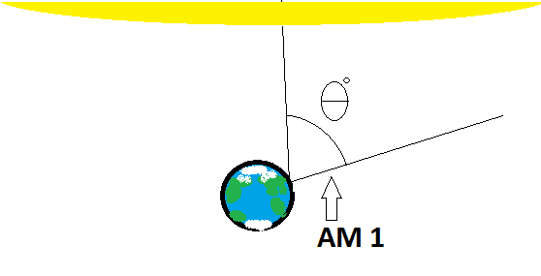
Figure 2 When angle θ goes to zero then the air mass will be 1
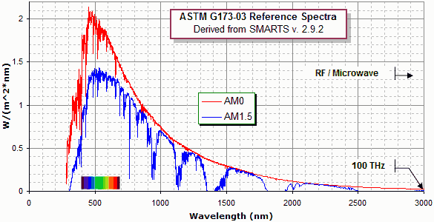
Figure 3 AM 0 and AM 1.5 solar spectrums
Source: [S1]

The design specification for the UCF is based on use in the state of Florida. Information for use outside of this area will be provided for users. At 0 AM, the top of the atmosphere, global radiation is at 1367 W/m² and after absorption has occurred the radiation is reduced to 1000W/m² at 1AM, sea level. The intensity of light is reduced by approximately 30% of its original value. In an equation this would be written as.

$$I=1367{\left(1-.3\right)}^{AM}$$

$I$ is the sun light intensity at the location. When determining the maximum amount of power supplied ($P_{s})$ to the surface of the UCF the following equation was used.

$$P_{s}=I*A$$

A is the surface area which will be exposed to the sunlight. This equation assumes an incident angle normal to the surface of the UCF facing the sun. The angle of the incoming beam radiation, angle of incidence, greatly affects the usable solar energy.

Angle of Incidence

The varying values of light intensity greatly increase the need for maximum use of what is available. The angle of incidence between the light source and the PV cell directly affects the captured solar power. The UCF required a means adjusting the orientation, since the beam radiation component collected is proportional to the cosine of the angle ɣ between the incident beam and the normal to the plane of the collector, as shown in Figure 4.
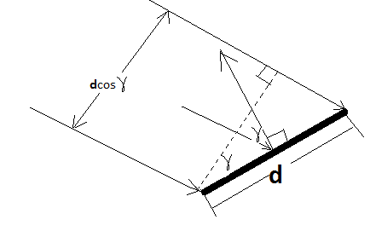
Figure 4 Angle of incidence effect of collector tilt on effective area presented to the beam component of radiation

Several methods are available for the UCF to achieve the optimal angle. A separate stand that would resemble a camera tripod, providing adjustment in two plains of orientation, which would require extra cargo space, is a choice. Another option would be a simple means of propping up one edge, using a stick or attached rod. The latter of the choices requires manual adjustment as the sun moves across the sky. The previous would allow for remote tracking and require little user input and there have a much greater output. In Phoenix, AZ during a dry summer day approximately 50% more energy can be collected with the use of a tracking device in comparison to a stationary device. Of course during the winter there is only a 20% increase energy collection with the use of a tracker. Solar trackers would greatly increase the cost of the UCF and reduce the portability. With the purpose of the UCF being a portable device that is to be carried by user and then set up during a rest from hiking or biking, a manual solar alignment attachment will be the most efficient means of maximizing the angle of incidence on the PV solar panels.

Maximum Power Tracker

Electronic maximum power trackers (MPT) significantly improve the power output of a PV module. The intersection of I-V characteristic of the UCF will depart from that of the PV source during less than maximum light conditions. MPT generally employ pulse-width modulation techniques to switch from an input dc voltage to an output dc voltage of a set value, thus ensuring a constant supply of power even during low light conditions. The MPT uses a feedback loop to sense the output power and change the output voltage accordingly too optimize the power output. The MPT can also be used to maximize the useful power from a small generator producing a DC voltage.

Concentrated Sunlight

This section considers another way to decrease the cost of solar energy conversion, photovoltaic conversion of concentrated sunlight. In the case of concentrated sunlight, the necessary cell area and cost can be decreased in proportion to the sunlight concentration ratio, with the use of less expensive mirrors or Fresnel lenses.

Some easily noticeable obstacles arise in the practical application of converting concentrated sunlight. The first is the increase in current density, which is proportional to the sunlight density, and therefore grows at the same rate, requiring the designer to reduce resistive losses within the solar cell. Second, the temperature of solar cells increases with additional increases in incident solar radiation, requiring a method of efficient heat removal. Third, the mirrors or Fresnel lenses used as concentrators must be developed in a cost effective manner. Fourth, solar concentrators require a much more active and accurate method of tracing the sun. All the above greatly increase the complexity of the solar module design. With a more complex design comes greater need for competent laborers for the installation to ensure maximum efficiency. The operation and maintenance of the complex systems requires a higher degree of supervision than that of the simpler fixed module arrays.

While these complexities are added, due to the application of concentrators, it is possible to use more costly semiconducting materials, for example gallium arsenide (GaAs), for the fabrication of high efficiency, thermally stable, and high current solar cells. Concentrator cells are more efficient than the normal approach of direct sunlight cells, and since a smaller surface area is exposed to radiation there is a lower effect of radiation damage, which frequently occurs in space. On Earth as well the use of smaller cells, in respect to initial solar incidence area, a better protection from hazardous weather conditions can be provided, due to the screening action of the concentrators and heat removal systems.

The means of photovoltaic conversion of concentrated sunlight have evolved, both practical and theoretical, for two basic reasons. One is that the photovoltaic conversion efficiency of p-n junction solar cells can be made higher, since the operating voltage can be increased due to a higher photocurrent density made possible by light concentrators. Especially since the cost of solar cells is not that critical at high concentration ratios, the can be fabricated from more suitable semiconducting materials and have more complex internal designs. The other reason is that the cost of the electrical power generated can be made lower by reducing the area of expensive solar cells in proportion to the sunlight concentration, by way of inexpensive mirrors and lenses. The first case has made concentrating photovoltaic a proving ground for new materials, very similar to what military aviation has done for commercial aircraft production. The outcome has made the concentrating photovoltaic industry a rapidly growing area of science and technology, which has been determined by the trends and methods in many other areas.

Photovoltaic Solar Cells

Single Crystal silicon Cells are produced from the polycrystalline material, the silicon must be melted and recrystallized. The silicon reaches a relatively high purity level, when compared to the polycrystalline starting material, due to impurities being left behind in the melt. The crystal can be doped n-type ore p-type during the growth process if desired. Saws are then used to slice the single crystal ingot, produced from the growth process, into multiple wafers. The ingots are cylindrical when grown and the wafers produced are circular. The circular wafers are then cut to squares to maximize the coverage within a module. The wafer thickness is approximately 0.01 inch and is quite brittle. Chemical etching is required to achieve the textured finish, which enhances the photons chance undergo internal reflection. The appropriate finish also cause incoming photons to change the path of travel of a photon with a normal incidence angle which increases the distance traveled through the junction.

The next step in single crystal silicon cell is to create the p-n junction with associated electrodes. The junctions are created primarily by diffusion, due to the large areas of the junctions. The diffusion process involves impurity atoms, dopents, being diffused into silicon where the dopent concentration is a function of distance from the surface. Fixing contacts to the p-n junction which will allow the current produced in the p-n junction to be used is next. The back contact cover is entirely covered with evaporated aluminum that is annealed by heating the material after evaporation. The use of aluminum also acts a p-type dopent creating a heavily doped p-region, which produces a resulting electric field that accelerates holes toward the back contact. The front contact is considerably more challenging since generally the contacts are opaque and require the area to be minimized to allow for maximum sun exposure. To minimize the contact resistance the area must be optimized and the contacts are annealed to the surface. Antireflective coating is applied to the cell on top of the contacts, and this is performed by evaporation to ensure an even and extremely thin coating.

Multicrystalline Silicon Cells are being produced to reduce the production cost involved with the high energy process of manufacturing single crystal Si cells. The first step involved in reducing cost is growing the Si in a crucible and controlling cooling rate, thus minimizing the energy expended during the pull process of single crystal growth. The crucible is square and thus produces multicrystalline Si with a square cross-section, reducing the amount of wasted material in cutting down the wafers from the circular wafers produced during single crystal Si growth. Very similar processes are used in the multicrystalline PV cell manufacturing process once the wafers have been produced. The multicrystalline silicon cells have a speckled appearance compared to the single crystal cells and are generally of slightly lower efficiency.

Temperature Considerations

The power output of PV cell is temperature sensitive. With a look at the power vs. voltage graph it is evident that the open circuit voltage is directly proportional to the absolute temperature of the cell. Thus with every degree Celsius increase in the PV cell a 2.3mV reduction in output voltage occurs. The location of the temperature in the equation given for cell current describes the relationship. In an effort to reduce the heat of the of the PV cells of the UCF multiple plans for cooling will be discussed. Using heat transfer equations, below, we will see how the variables which can be changed with in the equation effect the cooling of the PV cells. In the discussion of various cooling methods and each specific variable which is effected will be pointed out and how it will ultimately effect the output voltage of the PV cells on the UCF. The Newton law of cooling is shown here.

$${\text{q}}_{\text{c}}\text{=}\text{h}A_{s}(T_{S}-T_{F})$$

Where q_{c} is the rate of heat transferred from a surface at uniform temperature T_{S} to a fluid with reference temperature T_{F}, A_{s} is the surface area and h is the mean coefficient of heat transfer; the units for h are W/(m² Cº). The mean coefficient of heat transfer is directly proportional to the mass flow rate, specific heat capacity of the fluid (c_{s}), and a constant that relates the type of flow fluid flow, laminar or turbulent.

Heat Transfer Equations

There will be several methods in which heat is transferred for the solar panels. The first method will be radiation absorption of radiation from the sun onto the solar cells. The second will conduction from the backs of the photovoltaic cells to the adhesive connecting then to the heat sink. Finally there will be two methods of heat transfer from the heat sink to the surrounding environment, radiation and convection.

Radiation heat transfer involves the transfer of electromagnetic radiation emitted from a body as a result of vibration and rotational movements of molecular, atomic, and subatomic particles. Bodies with higher temperature have higher molecular kinetic energy and thus emit more radiation. Thermal radiation can be emitted through a vacuum or a transparent gas, liquid, or solid. Objects may absorb, reflect, and if transparent, transmit incident thermal radiation. The properties that describe a specific substance interaction with thermal radiation are absorptivity α, reflectivity ρ, and transmissivity t which represents the fraction of incident thermal radiation that a body absorbs, reflects, and transmits. The α is the most concerning factor of the material in use. The radiation emitted is related to α but is called emissivity. The total energy emitted is at a rate proportional to the forth power of the absolute temperature of the surface. The Stefann-Boltzmann law for blackbody thermal radiation is

$$E_{b}=σT_{s}^{4}$$

where E_{b} is the total emissive power for a black body and is the total rate of thermal radiation emitted for a black body, σ is the Stefan-Boltzmann constant $5.670×{10}^{-8} W/(m^{2}K^{4})$, and T_{s} is the absolute surface temperature. For use in a non ideal world the total thermal radiation emitted is determined with the use of the materials emissivity, ε which lies between zero and unity, in the equation below.

$$E=εE_{b}=εσT_{s}^{4}$$

As ε approaches unity the greater the emitted radiation will be and therefore the greater amount of heat dissipated.
Emissivity is the measure of an object’s ability to emit infrared energy, dissipate heat. The surface finish, not facing the sun, decided will be that of the greatest emissivity. While any surface exposed to the sun will be polished to maximize reflection of the sun’s rays. A material with lower emissivity will absorb less heat from the sun, but that material will also emit less heat as well. A flat black paint with a high emissivity will be used to maximize the amount of heat emitted from the surface.

Thermal conductivity k is a thermo physical property of a conducting medium, and will be the mechanism of heat transfer between the photovoltaic cells, adhesive, and the heat sink. K represents the rate of conduction heat transfer per unit area for a temperature gradient of 1 C/m. The units of k are W/(mC) or W/(mK) and the values for various materials that may be used on the UCF vary from several hundred to less than ten W/(mC) for the expected operating temperatures. The simple linear equation that describes the energy transfer during conduction is

$$q=kS(T_{1}-T_{2})$$

Where q is the rate of heat transfer conducted from a surface temperature T₁ to a surface at T₂, and S is known as the conduction shape factor. The units for S is m or ft. For the purposes of the UCF, S=A/L, A being the area and L being the thickness, for the one-dimensional conduction in the flat panel, form the photovoltaic cell through the adhesive to the heat sink.

Forced and Natural Convection

Forced-convection heat transfer is the most widely used, because of its effectiveness, means of heat transfer from a solid to a fluid. Forced-convection processes are determined by the type of geometry of the heat transfer surface. There are three basic types of forced convection systems. First process type is internal flow in tubes, annuli, channels and the like. Second is external flow over surfaces like flat plates, cylinders, spheres or any other external cooling geometry. Third is flow across tube banks like that of a car radiator.

Internal forced convection would use liquid to flow through the tubes of a constant cross sectional area. For these types of systems the flow would enter at a uniform velocity and heating of the fluid, assuming the entering fluid would be cooler than the solar module, would occur at some point from the entrance of the tube. As the fluid passes through the conduits, the velocity is brought to zero at the wall due to the properties of the fluid. Further along the channel the effect of the zero velocity of the wall reaches more towards the center of the channel due to viscosity of the fluid. The zero velocity of the fluid in relation to the channel walls forms a thermal zone of equivalent temperature in the fluid to that of the wall. As the fluid velocity increases from the wall towards that of the center of the channel the temperature drops. In the temperature gradient diagram the center of the channel has the greatest difference in temperature with respect to the channel wall. Chart 2 below depicts the flow rates and temperature gradients in relation to the channel walls.

Chart 2 Channel fluid velocity and temperature graph Source: [S1]

The temperature gradient is largest near the wall is greatest due to the large difference in fluid temperature between the fluid and the wall. The fluid forms a static layer along the wall and adjacent to that layer is a slowing moving layer. As the distance increase from the wall and each layer of fluid is moving proportionally faster than the previous the velocity steadily increases as seen in the above Figure.

Liquid cooling would increase the c_{s}, liquids have a much higher specific heat capacity than air, and the mass flow rate of the cooling medium. By passing a liquid through conduits, thermally coupled to the backs of PV cells, to prevent blocking available light, and then passing through a heat exchanger, the PV cell excess heat will be transferred to the fluid and then expelled in the heat exchanger. A pumping mechanism will be required unless a system that includes natural convection can be engineered. Liquid cooling will have the highest heat removal rate of all the options, but the difficulty with installing the proper system while attempting to optimize power will place it low on the list of choices for heat removal.

Fan cooling would increase the mass flow rate of the cooling medium. As mass flow rate is increased there is a linear increase in the heat transfer that occurs. A separate heat exchanger is not required since the air would pass across the surface of the material and heat would be expelled directly into the surrounding atmosphere. Power from the battery of the UCF will be required to power the fan and several cooling fans will listed with the power usage and associated flow rates.

Increasing the surface area (A_{s}) is self explanatory and can easily be seen how the heat transfer equations are effected above. The h is also affected since it is a function of the geometry, fluid properties, and flow rate. Concentrating on A_{s}, the surface exposed to the fluid can be extended. By use of fins or spines, an example most are familiar with is the fins used on a radiator in an automobile. PV cells are not easily manufactured and therefore instead of directly changing the surface area of the PV cell a thermally conductive bonding agent will be used to couple a heat sink. Most metals have a high thermal conductivity several materials which may be considered will are steel and aluminum. A planar surface would be in contact with the PV cells to ensure maximum contact and therefore maximum heat transfer. The side which would expel the heat would be finned or have a cross thatched pattern to increase the surface area. The different types of fin patterns have different efficiency ratings as seen below in Chart 3 the triangular fin design compared to the rectangular fin design. The dimensions chosen for the fin height and thickness will provide an increase in efficiency over that over that of a flat surface.

Chart 3 Fin type efficiency (triangular and rectangular) Source: [S1]

Figure 19 shows the I-V characteristics of a potential of PV cell to be used on the UCF. Observe that the amount of current and voltage available from the cell depend upon the cell irradiance level. The I-V characteristic equation, in an ideal case is
$$I=I_{ᶩ}-I_{o}\left(e^{\frac{qV}{kT}}-1\right)$$
where $I_{ᶩ} is teh component of cell current due$to photons, q=1.6x10^-19 coulombs, k=1.38x10^-23 j/K and T is the temperature of the cell in K.

Figure 5 shows that the PV cell has both limiting voltage and a limiting current. Hence, the cell is not damaged by operating it under either open circuit or short circuit conditions. To determine the short circuit current of a PV cell simply set V=0 in the exponent. This leads to I_{sc}=I_{ᶩ.} To a very good approximation, the cell current is directly proportional to the cell irradiance. Under standard test conditions, if the cell current is known, G_{o}=1kW/m^2 at AM 1.5, then the current at any other value of solar irradiance, G, is given by

$$I_{ᶩ}\left(G\right)=\left(G/G_{o}\right)I_{ᶩ}\left(G_{o}\right)$$

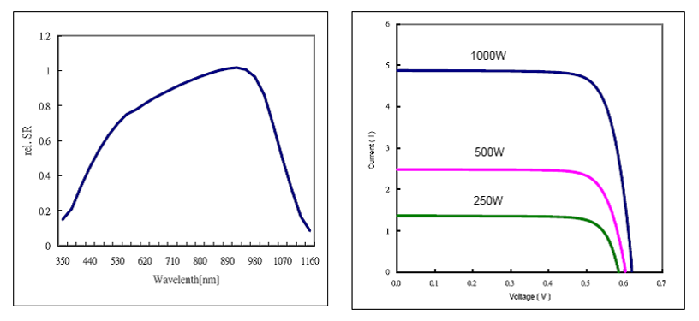
Figure 5 Current-Voltage Curve Source: [S1]

To determine the open circuit voltage of the cell, the cell current is set to zero and the I-V characteristic is solved for V_{oc,} with the result of
$$V_{oc}=\frac{kT}{q}\ln{\frac{I_{ᶩ}+I_{o}}{I_{o}}}≅\frac{kT}{I_{o}}\ln{\frac{I_{ᶩ}}{I_{o}}}$$
since normally $I_{ᶩ}≫I_{o}$. An example is the ratio of photocurrent to reverse saturation current is 10^10, with the thermal voltage (kT/q) of 26mV, results in V_{oc}=0.6 V. Note that the open circuit voltage is logarithmically dependent on the cell irradiation, while the short circuit current is directly proportional to cell irradiation. [S1]

Silicon Thermal Characteristics

Radiation from the silicon surface reduces the amount of heat that is required to be removed with a heat sink. The radiation emitted from a silicon wafer using the emissivity of .65 and radiation equation (above) is seen below in the temperature vs. power emitted graph Figure 6.

Figure 6 Radiated Power Vs. Surface Temperature Source: [S1]

Properties of Steel

Iron is the base element of all steels. Iron, commercially pure, contains only about 0.01% carbon and is relatively weak. The addition of carbon significantly increases the strength of iron. The addition of just .80% carbon can raise the tensile strength from about 40,000 psi to 110,000 psi. [S1] Steel is an alloy of iron and carbon and contains many other elements usually small amounts of manganese. Carbon steel is named so because of the carbon content and the effect that the carbon added to the iron has. Alloy steel is steel which has multiple elements other than carbon added to improve certain characteristics.

Carbon steel meets the necessary strength characteristics desired for the UCF. Low-carbon steel is currently in use for support structures for existing larger photovoltaic systems. Much of the sheet and strip steel is produced in the United States. The low cost of carbon steel products would make it an appealing material for use with the UCF. Steel has a large problem with corrosion and needs to be treated to maintain integrity.

Zinc, a less noble metal than steel, can be used as a sacrificial anode to protect the steel as part of the corrosion process. The protective coating which can be used to on the UCF structure would only work as long as the zinc is able to make oxygen bonds. The thickness of the zinc coating would determine the life time of corrosion free steel. The zinc coating would certainly last for more than a decade in normal operating conditions of the UCF.[S1] The emissivity of different types of steel can be seen in Table 1.

 | Emissivity
Steel | 1.0µm | 1.6µm | 8-14µm
Cold-Rolled | 0.8-0.9 | 0.8-0.9 | 0.7-0.9
ground Sheet | n.r. | n.r. | 0.4-0.6
Polished Sheet | 0.35 | 0.25 | 0.1
Molten | 0.35 | 0.25-0.4 | n.r.
Oxidized | 0.8-0.9 | 0.8-0.9 | 0.7-0.9
Stainless | 0.35 | 0.2-0.9 | 0.1-0.8
Table 1 Emissivity Table for Steel
Source: [S4]

Properties of Aluminum

Aluminum is the one of the most commonly used structural materials coming just behind steel. The reason for Aluminum as a choice of material

- Very lightweight with a density about one third that of steel.
- A variety of fabrication methods can be used for shaping.
- Good corrosion resistance and can be used in a wide variety of climates and weather conditions.
- Available in a wide variety of finishes making it aesthetically pleasing
- High strength-to-weight ratio, thus making it ideal for a portable rugged device such as the UCF
- The rage of alloys available allow for good heat transfer characteristics and in combination as a structural support and heat sync.

The aluminum alloy of choice will contain copper, zinc and other elements which will improve the strength and thermal conductivity. Polished aluminum has a thermal conductivity of 237 W·m⁻¹·K⁻¹.m [S1]

Emissivity is the measure of an object’s ability to emit infrared energy, dissipate heat. The surface finish, not facing the sun, decided will be that of the greatest emissivity. While any surface exposed to the sun will be polished to maximize reflection of the sun’s rays. A flat black paint may also be used to maximize the amount of heat emitted from the surface. The different emissivity values of varying types of aluminum can be seen in Table 2.

 | Emissivity
 | 1.0µm | 1.6µm | 8-14µm
Aluminum
Unoxidized | 0.1-0.2 | 0.02-0.2 | n.r.
Oxidized | 0.4 | 0.4 | 0.2-0.4
Alloy A3003
Oxidized | n.r. | 0.4 | 0.3
Roughened | 0.2-0.8 | 0.2-0.6 | 0.1-0.3
Polished | 0.1-0.2 | 0.02-0.1 | n.r.
Table 2 Emissivity Table for Aluminum
Source: [S4]

Thermal Adhesive

Arctic Silver Adhesive which uses a layered composite of 99.8% micronized silver. The adhesive is a pure electrical insulator and therefore neither electrically conductive nor capacitive, which fits this application perfectly since it is going to be connecting solar cells directly to aluminum plates. The adhesive also features a superior thermal conductivity, greater than 7.5 W/mk. With an acceptable temperature range of -40ºC to >150º

Arctic Alumina uses a layered composite of three unique shapes and sizes of ceramic particles to maximize particle-to-particle contact area and thermal transfer. The consistency is engineered for easy application in a thin even layer During initial use the compound thins out to enhance the filling of the microscopic valleys and ensure the best physical contact between heatsink and heat source. Then the compound thickens slightly over the next 50 to 200 hours of use to its final consistency designed for long-term stability. Arctic Alumina Compound is a pure electrical insulator, neither eclectically conductive nor capacitive. This compound cleans off easily from heatsinks. In most cases removal only requires wiping the heatsink with a dry cloth. Thermal conductivity > 4.0W/mk and temperature limits, peak, -40 C to > 160 C and long term -40 C to > 105 C.

Kinetic Research

Harvesting kinetic energy can be accomplished in many ways. The main idea behind harvesting kinetic energy is to convert the energy stored in mechanical or human movement and transform it into electrical energy. In order to harvest the energy from movement, a transduction mechanism is necessary. A transduction mechanism is what converts mechanical energy into electrical. A few of the most promising and most researched mechanisms which accomplish this conversion are electromagnetic and piezoelectric mechanisms. Other mechanisms are currently being researched as well, such as Thermoelectric Generators (TEGs), micro-wind turbines, electrostatic and electro-dynamic mechanisms. Energy may also be absorbed from RF transmitters.

Aside from the good morale a person might feel from carrying and personally charging a device based on their movement and own energy, there are other great reasons to try and implement a human based kinetic energy harvester. The battery life for most portable electronics is limited and need to be recharged periodically. If this could be done at any time anywhere, the user would feel a much greater sense of freedom and independence. It is important to determine which electronic devices will be charged by the UCF. Several things need to be considered: the typical power consumption of the device; the usage pattern; the device size (and thus the acceptable harvester size); and the motion to which the device is subjected [K5]. An example to explain this concept is laptop computers. Laptops are a poor candidate because they are comparatively large and are most likely not taken on camping trips or hiking trips which is when the UCF will most often be used. Laptops have a high power consumption (10–40 W), and are typically used for longer periods of time (at least 10 minutes). When they are not in use the most likely are not being moved around often which means no harvesting energy [K5]. Alone, harvesting energy purely from human movement will not be able to accommodate a laptops specifications and power needs. Since the UCF will also be implementing Solar Power as a form of energy, there is a possibility that harvesting human power could supplement the Solar Power, but the difference in provided power would be marginal.

Cell phones and other handheld devices such as I-pods are a better choice compared to laptops since they are usually carried on the body anyways. People who use the UCF may likely take a cell phone with them on trips for safety reasons or an I-pod. The power levels during calls are typically a few watts which could further decrease in the future with the advances in relevant technology.

Hence, for the sake of this project, the interest lies with powering low powered electronic devices with the aid a human motion. Electromagnetic, electrostatic and piezoelectric mechanisms have been looked at. Thermoelectric generators will be researched as a possible mechanism which could augment the UCF. Another area of research that could prove to be useful for this project, depending on the vibrations of the UCF unit itself, are mechanisms which could efficiently utilize the vibrations coming from the machinery inside of the UCF. For example, sensors inside the unit could be completely self powered using piezoelectric material. Getting energy from RF transmitters for this project would have been unrealistic due to the fact that a human would not be mobile if a large antenna would were required to be worn in order to take in the radiating source.

Potential Energy from People

A gram of fat contains 9,000 calories. Every calorie is approximately equal to 4.19 Joules. This comes out to be 37,700J per 1g of fat. [Human Generated Power for Mobile Electronics􀀀] If a person weighs 140 pounds and has 15% body fat then:

$$140\left(\frac{0.454kg}{1lb}\right)\left(0.15\right)\left(\frac{1000g}{1kg}\right)\left(\frac{37,700J}{1g}\right)≅359 MJ$$

Of course to maintain our body and stay alive much of this energy is used up as seen in table 3 below, but it is quite possible, with much research, that plenty of wasted energy could be harnessed and used. Experimenting with projects like creating the UCF, is a step in the right direction towards efficiently harnessing as much of this wasted energy as possible.

Human energy expenditures for selected activities:

Activity | Kcal/hr | Watts
Sleeping | 70 | 81
Sitting | 100 | 116
Standing | 110 | 128
Hiking (4mph) | 350 | 407
Mountain climbing | 600 | 698
Running | 900 | 1048
Table 3 Human Energy Expenditures
Source K2

Power from Breathing

If a person weighs 68kg and has an approximate air intake of 30l per min and the available breath pressure is 2% above atmospheric pressure and studies show that the power consumed by pulmonary ventilation consumes anywhere from 0.1 to 40 W [S2], then the maximum available power is:

$$W=p∆V$$

$$0.02\left(\frac{1.013×{10}^{5}kg}{m×\sec^{2}}\right)\left(\frac{30l}{1min}\right)\left(\frac{1min}{60 sec}\right)\left(\frac{1m^{3}}{1,000l}\right)=1.0W$$

Another way to utilize the breathing as a source of energy is to wrap a tight band around one’s chest attached to a stretchable dielectric elastomer generator. There is an approximate 2.5 cm change in circumference of the chest from full inhalation to full exhalation. This number could rise to 5 cm difference during vigorous activity. [S2] At best, assuming a respiration rate of 10 breaths per minute and a 100N force applied over a 5 cm distance, the total power that could be generated is:

$100N\left(0.05m\right)\left(\frac{10 breaths}{1 min}\right)\left(\frac{1 min}{60 sec}\right)=0.83 W$ [K2]

This final power output will possibly be halved due to friction of the parts of the mechanism.

Power from Arm Motion

According to an article, Human Generated Power for Mobile Electronics, a person who is just slightly active, i.e.- frequently uses hand gestures such as waving, is generating 3W of power. Finding a way to capture and use this energy can be difficult because the generator would need to be non troublesome for the user. An idea stated in the same article was to create a pulley system which is attached at the elbow of the inside of a jacket to the person’s hand. The take up reel of the pulley is spring loaded and thus would generate power from the change in potential energy only during the users down stroke movement of the hand and the device would not cause any extra resistance to the user during his or hers upstroke. This generator, along with any other parts, such as the CPU, would be incorporated into the jacket. The downside to this idea is the shear bulkiness and weight of the jacket.

A more practical idea that has been around since the beginning of the 20th century is crank devices, where one just simply cranks it. An example if this is the “Freecharge” produced by Motorola and Freeplay. Motorola and Freeplay claim that with 45 seconds of rotating the crank, the user will have produced enough charge to use a cell phone for 4-5 minutes. Saul Griffith, from MIT, created a generator with a rope attached to one end and the device and a rubber ball on the other was twirled in circles above the user’s head. Obviously, this is a generator that needed to be done in an open area, but produced 3-5 W and swung in the air at a rotational rate of 1-2 Hz. Saul Griffith used a 0.1-0.2 kg cushioned ball and a 0.3-0.5m rope.

Power from Walking

A study done at the Biomotion Laboratory at the Massachusetts General Hospital revealed a time dependent analysis of a typical human walking gait. The graph below, in figure 7, shows the gait of a woman who weighs 52kg for a length of 1 second. The graph below displays the reaction force (% of the body weight) as a function of time.
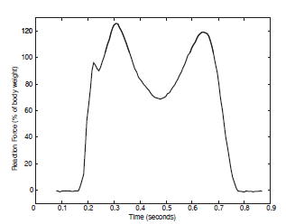
Figure 7 Force vs. Time
Source: [K2]

From the graph, it is apparent that the first major peak is when the heel first hits the ground at just over 120% of the woman’s entire weight and the second major peak is at when the toes push off the ground.

An example shown in the article, Human Generated Power for Mobile Electronics states that a 68kg man who is walking at a speed of 3.5 mph (2 steps per sec) will use 280 kcal/hr which is equivalent to 240 W of power. Judging from the graph above, the man puts up to 30% more weight on the balls of his feet than that of his own body weight. Only calculating for the power that could be generated from the fall of his heel to the ground, 5 cm [W. Braune and O. Fischer. The Human Gait. Springer-Verlag, Berlin, 1895–1904; reprinted 1987] demonstrates that 67 W could be produced. This value, however, is understood to be a maximum possible value.

$$68kg\left(\frac{9.8m}{s^{2}}\right)\left(0.05m\right)\left(\frac{2 steps}{sec}\right)=67W$$

Power may also be generated from walking but due to the knee instead of the heel or sole of the foot. Donelean, a researcher, has done studies on this concept of harvesting energy from the bending of knees. Their research goes in depth and the device he and his group developed covers much of the upper and lower portions of the leg. This has been done to optimize the amount of torque that could be produced. Their results showed that output powers up to 7W while the user maintained a normal walking pace was capable of being obtained. Due to the sheer size of the device and generator, the users had difficulty maintaining the normal pace of walking but were able to do it, however, with little noticeable impact on his gait [K5]. Although it seems apparent that much more power is available when using such a device to harness power from the bending of the knees, it would probably not be practical for the UCF, since it is so large and most likely requires an ample amount of time to assemble and disassemble. Also, the cost alone for all of the parts to build the entire generator would be uneconomical.

Power from Pedaling/Hand Crank

There is much power to be harnessed from pedaling. Many researchers believe that a crank system such as one on a bicycle has enough power output to easily run a cell phone along with any other low powered device and even a laptop. The following chart is a compiled list of power output from pedaling given in an article In an article, [K11], the author states that up to 300 watts at 12 to 25 volts DC could be generated using a crank system on a bicycle. This number greatly depends on the riders’ strength, however. Numerous studies have been done on this for some time now and the output power generator from such devices differs significantly with each study.

Alternative to Bike Pedaling

Since not all UCF users will have a bike with them when using the their charging unit and it would probably be overly complicated to strap the generator to the bike every time he or she wants to use it then a more pleasant alternative may be a hand cranking system where the generator is inside of the UCF unit and all the user has to do is crank the UCF with some sort of lever. The lever created for the UCF folds neatly into the wall of the unit so that it is flush with the surface. This is a great system for rotating the lever and has proven to be robust as well as have the ability to remain attached to the unit at all times and the lever can fold down so it is not protruding from the UCF.

The hand cranking system does not produce as much power as the bicycle pedaling system, but it does prove to be a wonderful emergency backup for when all else fails. If the user’s UCF is drained of power and their target device is dead and there is no wall outlet or sunlight nearby, then the user can easily just crank the lever on the side of the UCF for a couple minutes and accumulate power. This could prove to be a great emergency backup power generator system.

Transduction Mechanisms

There are two categories that micro generators can fall under. One, generators that utilize the direct application of force and two, generators that make use of inertial forces acting on a proof mass [K5]. The generator based on direct force is shown in the figure below, in figure 8.

Figure 8 Direct Force Generator
Source K5

In this figure, the driving force $f_{dr}(t)$ is acting on a proof mass $m$ which is supported on a suspension with spring constant $k$, with a damping element present to provide a force $f(\dot{z})$ opposing the motion. If the damper is implemented using a suitable transduction mechanism, then in opposing the motion, energy is converted from mechanical to electrical form [K5]. Because of the shape and size of the device itself, limits of $±Z_{l}$ are imposed on the displacement of the mass. Direct force generators must make mechanical contact with two structures that move relative to each other, and can thus apply a force on the damper [K5].

The second category of micro generators is inertial generators and is shown in the following figure 9. When dealing with an inertial generator there is only one mass which is suspended. This is the only point of attachment to the mass, hence allowing much more flexibility in mounting of an inertial generator and allowing for a smaller design relative to the direct force generators. Inertia results in a relative displacement of $z(t)$, which is shown in the image below, which occurs when the frame experiences acceleration. The absolute displacement is represented by $y(t)$. As in the last image, the range of $z(t)$ is $±Z_{t}$. When work is done against the damping force $f(\dot{z})$, which opposes the relative motion, energy will then be converted. In order to generate power, the damper must be implemented by a suitable electromechanical transducer [K5]. Different types of transduction methods will be described later.

Figure 9 Inertial Generator
Source K5

Most transduction mechanisms are usually found in areas where high frequency vibration, random displacements, or forces occur. A washing machine could harness kinetic energy due to its constant vibrations. The electromagnetic and piezoelectric mechanisms were chosen as two of the most promising methods for this project because of their unique properties and success in converting random displacement and random forces into usable electrical energy. When dealing with human powered projects, such as this project, the primary actions that are going to take place are walking, running or biking. These actions are all movements that occur over a large margin and are well suited for certain transduction mechanisms and not as efficient when paired with other mechanisms that are more suited to be coupled with machines like the dishwasher or refrigerator.

Generally speaking, electromagnetic transduction is usually the basis for electrical generators. However, when dealing with small scale generators that put out only a small fraction of power there are two other methods of transduction that can be implemented in lieu of electromagnetic transduction. The first is electrostatic transduction. Electrostatic transduction works very well when implements in MEMS (microelectromechanical) devices. This type of transduction is inefficient for large scale machines. Piezoelectric transduction is the second method of transduction. Piezoelectric transduction is usually most efficient when implemented in a generator that is converting natural vibrations into electrical energy. This method, however, is typically impractical for rotating systems. As said before all three of these methods were researched as a possible method of transduction to implement in the UCF. At first glance it seems that some form of electromagnetic transduction is going to work more efficiently than the other two methods. Piezoelectric could work efficiently if it is placed in a prime location on the body, like in the sole of a shoe. If it is placed in the shoe however, the user of the UCF may find this to be a nuisance having to place the generator in the shoe and store enough energy in it, then physically move the generator from their shoe and transfer that energy to the UCF, which would then be charging the users device.

A transduction mechanism works by taking advantage of mechanical strain or displacement in a system. Strain is usually associated with piezoelectric mechanisms while displacement is associated with electromagnetic mechanisms. When a material is deformed, i.e.- bent, stretched, compressed, an active material (such as a piezoelectric crystal) is engaged and generates electricity. When dealing with electromagnetic mechanisms a prime factor to consider is velocity.

Piezoelectric Transduction

The secret behind the success of the piezoelectric transduction are the piezoelectric crystals. These crystals inherit a special property that when they become deformed they become electrically polarized. It is cited in [K5] that there are numerous advantage; that the maximum energy density of piezoelectric materials is higher than either magnetic or electric fields in the air. Also, a piezoelectric generator does not require an initial charge source where as electrostatic transducers do. This is also referred to as priming. The piezoelectric materials may be obtained in numerous forms including single crystal (i.e.- quartz), piezoceramic (i.e.- lead zirconate titanate), thin film (i.e.- sputtered zinc oxide, screen printable thick-films and polymeric materials such as Polyvinylideneflouride (PVDF) [K1].

There are a couple important coefficients that need to be considered when building a piezoelectric generator which represent the level of piezoelectric activity. The strain coefficient (represented by d) and electro-mechanical coefficient (represented by k) are two of them. The strain coefficients represent the strain developed to the applied field. There are two different strain coefficients called $d_{33}$ and $d_{31}$. The subscripts that follow after the coefficient indicate the direction of the mechanical and electrical interactions. For example, $d_{31}$shows that strain is caused to axis 1 by an electrical charge applied to axis 3. It is also true that strain on the axis 1 will cause an electrical charge along axis 3. [K2] The following diagram, figure 10, represents the three axes relative to the material:

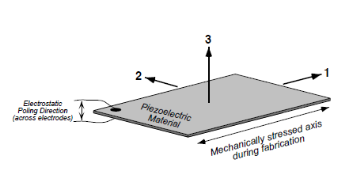
Figure 10 The Axes of a Piezoelectric Material
Source K5

The coefficient, $d_{33}$, is used when a compressive strain is applied perpendicular to the electrodes of a material. When the piezoelectric material is created as a film and adhered to a substrate, the elements are coupled with a transverse strain parallel to the electrodes and use the $d_{31}$coefficient [K1]. The electro-mechanical coefficient represents the ratio of electrical to mechanical energy. The following is an equation which represents k. Also shown is a table, table 4, showing the properties of several different piezoelectric materials. The Curie Temperature is the temperature at which that specific material becomes de-poled.
$$k^{2}=\frac{W_{e}}{W_{m}}$$

Coefficients of common piezoelectric materials:

Property | PZT-5H | PZT-5A | PVDF | $${BaTiO}_{3}$$
$d_{33}$ (${(10}^{-12} C/N)$ | 593 | 374 | -33 | 149
$d_{31}$ ${(10}^{-12} C/N)$ | -274 | -171 | 23 | 78
$k_{33}$ | 0.75 | 0.71 | 0.15 | 0.48
$$k_{31}$$ | 0.39 | 0.31 | 0.12 | 0.21
Curie Temp (C) | 195 | 365 | 110 | 120
Table 4 Piezoelectric Coefficients
Source: K1

Piezoelectric materials are typically layered on top of a metal either on one side (unimorph) or two sides (bimorphs). Bimorphs are commonly used in the industry due to the fact the when a material is bent one side is expanding while the other side is contracting utilizing more surface area of the mass. In practice, these types of elements have an effective coupling coefficient of 75% of the theoretical. This is due to the storage of mechanical energy in the mount and the shim center layer [K2]. Unprocessed PZT is a poor choice to use for human powered generators since it is so brittle and could not withstand the macro movements that a human would carry out daily. PVDF, however is much more flexible and well suited for human powered generators, but does, however, have a much lower coupling constant. Also, shaping the material may lower the effective coupling of mechanical and electrical energies [3].

VIBES (Vibration Energy Scavenging) a generator developed by Steve Beeby and his research team have successfully created a piezoelectric generator which consists of a cantilever shaped material attached to silicon mass and coated with a thin film piezoelectric material. The generator couples the silicon mass and beam. When this mass begins to vibrate, the cantilever beam is forced to sway up and down. The thin film piezoelectric material is active because of the stresses and strains and deformation in its material which produces energy. This model could be useful for the UCF if used inside the unit itself and can maintain a constant vibration.

Below, in figure 11, is a model of a piezoelectric generator used in the VIBES project:

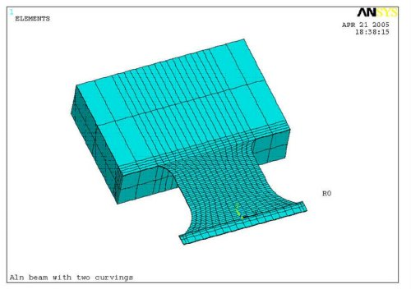
Figure 11 VIBES Piezoelectric Generator
Reprinted with permission
Source K4

There have also been numerous research groups around the world that have been performing studies on modules that can attach to the shoe that make use of piezoelectric materials. One of the labs that partook in a similar experiment is the MIT Media Lab, led by Paradiso. He and his group investigated numerous methods of generating power from wearable electronics. One of these methods was a power harvesting running shoe. Paradiso describes that there are two forms of generators that were studied, developed and tested in their labs that made use of piezoelectrics. The first type of generator was a simple piezoelectric bender which was placed inside the sole of a shoe. While a human walks or runs or any performs any movement what so ever, this material fill flex and bend. Their results from their testing showed that around 2mW was harnessed and converted into usable energy. The second type of generator is a unimorph material attached to a steel curved plate. This plate is placed und the heel of the shoe and flexes under the pressure of a heel strike. The results from testing of this type of generator showed that about 8mW was harnessed. Although, the power output is small, the use of piezoelectrics generators placed on the foot shows a lot of promises since portable electronics are continuously reducing their power consumption needs. It is also reported from these studies that there was little to no effect on the user’s gait.

Electromagnetic Transduction

Electromagnetic induction works be generating an electric current inside a conductor, usually a coil, which is placed within a magnetic field. Electricity is generated due to the movement of the magnet relative to the coil. The magnitude of electricity generated is dependent upon the strength of the magnetic field, the velocity of motion between the magnet and coil, and the number of turns in the coil. There are many different architectures that work to produce electricity. Below is an image, figure 12, illustrating a generic case of an electromagnetic generator.

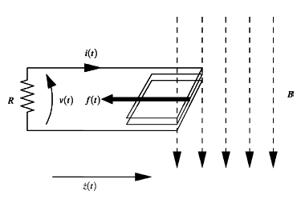
Figure 12 Electromagnetic Generator
Source K5

Rotating electromagnetic generators are in commonly used today. They may be used for a wide range of applications, from a power output of only a few watts to several hundred megawatts. Faraday’s law of induction can be used to implement the damper. The figure below illustrates this principle. A voltage is induced in the coil when there is a change in magnetic flux linkage with the coil and this drives a current inside the circuit. Lenz’s Law states that the force on the moving charges in the magnetic field oppose the relative motion. The mechanical work done against the force is converted into stored energy in the magnetic field. Strong damping forces require a rapid flux change which can prove to be hard to accomplish when dealing with micro-generators due to the size.

The purely self powered wind up watches are good examples of devices that use electromagnetic transduction and a mean of power generation. Mechanical self-winding watches date back to 1770 when Perrelet developed one, but the first to develop an electrically operated self-winding watch was Hayakawa in 1989. Hayakawa worked for Seiko Epson Corporation. He developed a small inertial energy harvester. His development included an asymmetric proof mass which rotated freely around a point some distance from the center of mass. This is attached to a permanent magnet electrical generator. Almost 10 years later in 1996, a more generic version of the inertial generator was patented. Tiemann proposed using the relative movement between magnets and coils in a mass-spring system in hopes of generating electrical energy from linear vibration motion. Seiko Inc. produced the AGS (Automatic Generating System) which procures $5μW$ on average when the watch is worn and around $1mW$when the watch is purposely shaken. Below, in figure 13, displays this watch.

Figure 13 Inside of Seiko Kinetic Watch
Source K5

El-Hami from Copenhagen, Denmark, along with the rest of his research group developed a four pole electromagnetic generator. Based on the fundamentals, El-hami took a simpler approach to in designing an electromagnetic inertial generator. It included four magnetic poles which allowed for two oppositely flowing flux paths. This doubled the rate of change of linked when compared to an electromagnetic generator with only two poles. During the groups testing phase the research group monitored the power output from their four pole design when it was tuned to 102 Hz and found that it was generating 2.5 mW from a source displacement amplitude of 0.4 mm. Below, in figure 14, is a generic model of the generator with four poles:

Figure 14 Four Pole Electromagnetic Generator
Source K5

A project referred to as VIBES which originated in Europe, developed and created a millimeter-scale cantilever beam device using the four pole design which was just described earlier. The intended motion source is an air compressor producing large vibration amplitudes at 50 and 60 Hz. The device volume is 150 ${mm}^{3}$ and the measured output was 17.8W at 89mV, for a frequency of 60 Hz and input acceleration 0.6 m/s2. Even though the intended use of this generator was to be hooked up to an air compressor, it is possible that it could generate a decent amount of power from human motion if it is mounted in such a way that will allow for easy movement inside of the UCF unit.

Below, in figure 15, is an image of the VIBES electromagnetic generator using the four pole design architecture. This architecture consists of a static copper coil which is housed in the base on the left. Attached to it is a cantilever beam. At the end of the beam are eroded tungsten blocks (used for added mass) on either side of the beam along with a magnet which are designed to vibrate vertically causing the magnetic circuit to maximize the flux gradient across the coil, hence maximizing the voltage and power generated.

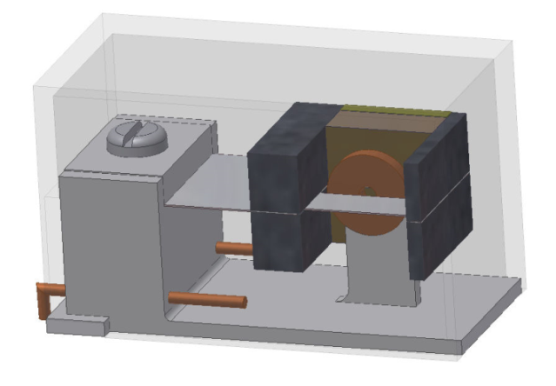
Figure 15 Example of 4-Pole Generator by VIBES
Reprinted with Permission
Source K1

The coil used in this model contains 2800 turns using a 12 micron diameter wire. The coiled wire has an inner diameter of 0.5 mm and an outer diameter of 2.8 mm. This setup for the coil combined with an optimized magnetic circuit yields voltages just over 700mVrms from vibrations of 60 mg at 50 Hz. The power output is just about 50 µW. [K3]

The “Shake Flashlight” is another device which uses a simple electromagnetic generator to produce power from human motion. It contains a single magnetic proof mass that freely slides within the length of the handle of the flashlight. Around the center point of the flashlight handle is a solenoid coil wrapped along the outside of an inner tube which contains the free moving magnet. On either side of the magnet are two rubber bumper pieces that fit snugly into the ends of the inner tube and prevent the magnet from coming out. When the flashlight is shaken by the user, the magnet moves up and down past the coil. Given a steady and consistent shake by the user, the generator will produce around $200mW$at its mechanical resonance, which is about 200 cycles/minute. The entire flashlight weighs about 150 grams.

Electrostatic Transduction

The key principal behind electrostatic generators is the mechanical forces that are induced to work against the attraction between two oppositely charge plates, much like a capacitor. There are two modes of operation in an electrostatic transducer: switched and continuous.

Switched Mode (Type 1 Electrostatic Transducer)

In the switched mode the transducer is operated by switches at different parts of the generation cycle. Switched transducer can be categorized into as either a fixed charge or fixed potential transducer. A fixed charge transducer is structured with two parallel plates separated by a certain distance. The two plates will also overlap one another at all times. The image below, in figure 16, illustrates this concept. If there is a negligible fringing field, the field strength will be proportional to the constant charge. The energy density of the electric field will be independent of the plate separation because of this. If the two plates were to move laterally relative to each other, mechanical work would be done against the fringing field.

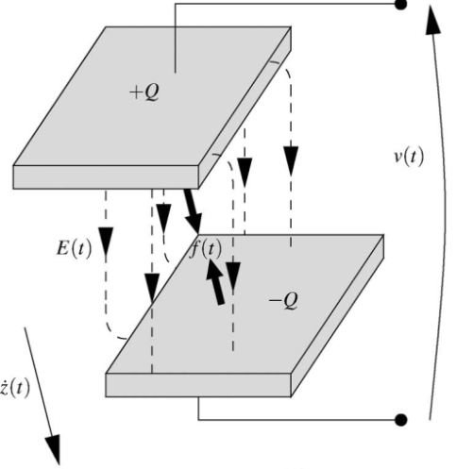
Figure 16 Switched Mode Electrostatic Generator
Source K5

Fixed Charge (Type 2 Electrostatic Transducer)

The second type of operation of a switched mode electrostatic generator is a fixed charge or constant voltage type. An image of this type is shown below, in figure 17. The electric field strength will decrease if the two plates distance from one another increase yet keep a fixed overlap between one another. This will cause a current $i\left(t\right)$in the external circuit that was pushed off the plates due the decrease in the electric field between the two plates. If, however, the two plates move laterally, (change distance between one another and percentage of overlap between one another at the same rate, then the field strength will stay constant and the current will still be forced to flow into the voltage source since the volume of the field decreased. In either scenario, the work done will convert to supplementary electrical potential in the voltage source.

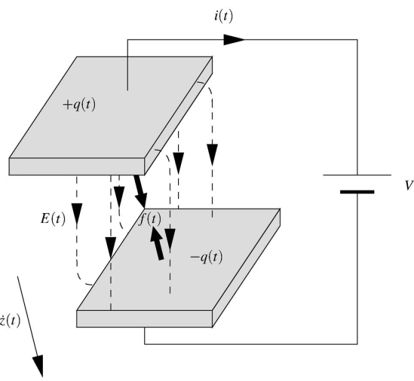
Figure 17 Fixed Mode Electrostatic Generator
Source K5

The charge equals $Q=CV$ (capacitance times potential) and the stored energy equals $1/2CV^{2}$ in either mode. Hence the force is found to be half of the voltage squared times the rate of change of capacitance in the z direction.

$$F=\frac{1}{2}V^{2}\frac{dC}{dz}$$

A constant force is therefore achieved for normal motion when the transducer is in fixed charge operation. A constant force is achieved for lateral motion in the fixed potential case. Electrostatic transducers require a priming voltage in order to operate. A way around this is to use a permanent charge in the dielectric layer (referred to as electret). Since the damping force is dependent upon the initial voltage, an active pre-charging system could possibly optimize the generator to the applied motion.

Thermoelectric Generators

A possible alternative energy that could be used in the UCF that will shortly be discussed is the concept of thermoelectric generators. Two objects adjacent to one another and at different temperatures give opportunity to scavenge energy through heat transfer. The Carnot Cycle exploits the fundamental limit to the amount of energy that can be harnessed due to a difference in temperature. The following equation describes the Carnot efficiency. ($T_{L }$is the low temperature and $T_{H}$is the high temperature, both are in Kelvin.)

$$(T_{H}-T_{L})/T_{H}≡∆T/T_{H}$$

Carnot efficiencies are limited for small $∆T$, for example, the difference in temperature from body temperature (37$°$ C) to a cool room (20$° C)$ results in only a 5.5% efficiency. Because of this, it may prove to be difficult to obtain any amount of power output from a thermoelectric generator since it will most likely be a similar delta T to the example above. However, many companies have produced multiple products that utilize small temperature changes and create thermoelectric generators. One company that did this is Seiko who created the Seiko Thermic wristwatch. This watch contains ten thermoelectric modules that generate enough microwatts to run the mechanical clock movement solely from the small gradient in temperature between the user’s body heat and the ambient temperature. Since the UCF will most likely be used by individuals who will be outside doing some sort of physical activity, they will possibly have a higher body temperature. Some sort of device could be carried on the user’s body like and arm band that and wristband with an attached thermoelectric generator which will somehow be wired to the UCF main unit. Another area on the unit itself that may have some sort of temperature gradient is between the inside of the aluminum casing and the Solar Cells. There will of course be some sort of insulation to prevent damage to the insides of the unit as well as prevent burning the users. Even with this protective insulation, a small temperature gradient may exist between the inside and outside of the casing, which may be an ideal place to mount a thermoelectric generator. Thermo Life, by Applied Digital Solutions is comprised of a dense array of ${Bi}_{2}{Te}_{3}$thermopiles which is deposited onto a thin film. One generator measures ${0.5 cm}^{2 }$in area and $1.6 mm$ thick. This generator can generate $10μA$ at $3V$ with only a $5° C$ difference in temperature. Below, in figure 18, show several views of the Seiko Thermoelectric watch.

Figure 18 Seiko Thermoelectric Generator
Reprinted with permission Source K9

Bike Pedaling Generator

Manually-cranked electronics have been around for many decades and are a tried and true method for generating power independently of the electrical grid. Miniature stationary bicycles that fit under a desk for the use of exercising and power output have been commercially sold for years now. Up to 60W can be obtained in this manner [K10]. This is because legs tend to be a much stronger part of the body, and with deliberate action there is much power that can be extracted. There are areas in the world, such as in India, where it is not abnormal to see personal computers powered by stationary bicycles. “In fact, some Indian schools combine physical education with computer class; one half of the students bicycle to provide the power for the other half’s computers!” –Ben Erikson, Human Powered Energy Generator. The “Stepcharger” is another commercial product created by Nissho Engineering which uses a small stationary pedal coupled with an embedded magnetic generator. It can generate up to 6 Watts when pedaled quickly rotated.

Most pedal powered generators are created by modifying a normal bicycle. The mechanical energy caused as a result from the human pedaling is converted into an electrical current with the help of a DC generator which is connected by a fan belt to the bike flywheel. The energy can be stored in multiple ways, but mostly likely the best choice for storage is a lead-acid battery. The energy that is converted from the pedaling could act as only a supplement to another type of generator such as a wind turbine or photovoltaic systems and be stored in a battery bank. Since this is DC current output is can easily power the low powered electronic devices which are of interest for the purpose of the UCF. In theory, however, the energy could also be converted to AC with the use of an inverter. If the user wanted to power an AC appliance, like a stove, then the 12 Volts of DC current must be converted to the standard 110 volts of AC (standard in USA) before powering the appliance.

About 30 years ago, in 1977, some test were performed at Oxford be Stuart Wilson. These tests showed that about 75 Watts, on average, of power was available and generated by the average rider riding a bicycle on the road. He also found that 200 Watts was possible to achiever if the rider maintained an 18 mph speed and 750 Watts could possibly be achieved for only a moment, under an extreme load. With such high amounts of energy possible most appliances could theoretically be powered and definitely any low powered electronic could easily be powered.

A Completed 12 Volt Pedal Powered Generator

(This project was completed by Ben Erikson- Human powered energy generator.)
The following project will show the steps involved to make a pedal powered generator. It is possible that a generator similar to the one described below could be modified to easily detach from any bike and placed onto another at any time. The power generated could be stored in a battery then later connected the UCF.

Materials Needed:

- A bicycle with a front mounted flywheel and a channel that would allow for a fan belt to be attached. The bike gearing should have a 52-tooth chain ring on the exercise bike connected by the chain to the flywheel, which has a 16 tooth freewheel. The flywheel diameter that has proven effective, is with a solid metal flywheel that is 15.5" in diameter. The generator pulley is recommended at 2.5" in diameter. The pulley diameter can be altered to make the effort required to spin the pulley easier by putting on a larger pulley diameter.
- A Fan belt large enough to cover circumference of flywheel, generator wheel, and distance between each wheel will be needed.
- A 24 volt DC generator which consists of a permanent magnet generator and is rated at 1800 rotations per minute, and a potential of 1/3 horsepower of output. The voltage output is directly proportional to the rpm's and the capability of this system is to rotate the generator at 900 rpm's. This will lead to an output of 12 volts.
- A 10 gauge copper solid copper wire. The electrical resistance value of the wire should be around 0.1 ohm’s for every 1000 feet.
- A voltage regulator. A 20 amp flat automotive fuse that is to be placed in line with the positive electric wire. The voltage regulator limits amount of current flow when battery reaches full charge to prevent damage to battery.
- A diode which is rated at 25 amps and at least 35 volts.
- Lead-Acid Battery: 12 volt marine/trolling battery, 55 lbs., 100 amp hour @ 20 hour cycle, with cycle life of 300 discharges.
- An inverter. Inverters must be able to handle potential peak electrical loads. The loads may be easily calculated by looking at the Watt requirements on the back of the target appliance. This calculation should be used to insure that the inverter can handle the electrical loads. Most inverters vary in their efficiency under electrical loads allowing for 60%-90% of original 12 volt DC current to be transferred into 110 volt AC.
- An Ampere, Voltage and RPF meter attached to the bicycle.
Using the list of materials just described above, the system was completed, tested and yielded the following results given the following example, which determines the wattage needs per day:
- Radio/clock: 50 watts x 2 hours/day = 100watts/day
- Lights: 50 watts x 5 hours/day =250 watts/day
- Total watts/ day = 350 watts, .350kw, or 29 amps/day
- Total watts/hr = 14.6 watts/hr, .0146kw/h, or 1.2 amps/hr
With this information, the rate of recharge can be calculated that is needed to replenish the battery. We are using a battery (as described in the list of materials) with 12 volt, 100 amp/hr and with a 20hr cycle. The daily demand is 29 amps per day, so there needs to be a recharge rate equal to the daily usage. It was stated earlier that an average rider could generate approximately 75 watts of power for an hour. Using the equation of Amps(I)=Watts(W)/Volts(V), we come up with a potential of 6.25 amps/hr. Using this example would mean that it would take 4.64 hours of peddling to recharge the electricity used by the appliances in 7 hours (4.64 hrs x 6.25 amps =29 amp). These equations do not take into account the loss of efficiency that is created when electricity is converted from DC to AC. In this example there would be an increase in the amount of energy needed to be stored for conversion. This is an extremely unpractical number and would only start to make sense if the number of hours to pedal the bicycle were divided between numerous people.

Hand Crank Generator

The hand crank generator is an electromagnetic generator which works under very similar properties as to the pedal powered generator as described above except on a smaller scale. Many designs have already been created and sold commercially for some time now. Turning the hand crank generator handle at a speed of about two revolutions per second generates power that is used to recharge any low powered electronic device. At 1.5 revolutions per second, the unit gives about 5V of power, and at 2 revolutions per second, it gives close to 6.2V. Most regular chargers tend to provide between 4.5V-6V, resulting in a very satisfactory output voltage. These items, however, are usually for powering the LED’s in flashlights. There is no reason though why the power cannot be stored in a battery instead. The following are some simple designs that were created by other companies and have become commercially sold products:

Maxxima EGF-7218 is one device that does more than power just a flashlight. It is an emergency handheld battery-free flashlight and mobile phone charger. It contains an on board internal generator operated by a hand crank and recharges a built-in battery which powers its functions. This product combines an LED Flashlight and a mobile cell phone charger in one main compact body unit. This device does not require external power, or auxiliary batteries to operate. It is solely recharged by spinning the built-in generator using a hand crank, which recharges an internal battery for normal flashlight illumination as well as to make phone calls on your mobile phone. When the battery becomes completely discharged, all that needs to be done is to use the hand crank generator for 3 minutes at no less than 130 revolutions per minutes. Let it rest for 60 seconds and then start to use. For mobile phone charging and function: Hand winding the hand crank generator for 1 min. will provide approximately 2 min. of talk time. This is a very similar project that could be modified and applied to the UCF.

The Datexx SuperBattery is another portable charger that utilizes a hand crank to produce power. On it is also an LED like the Maxxima and a battery to store power for any other low powered electronic device. The SuperBattery should give the user about 2 minutes of talk time for every 6 minutes of cranking. It also contains an AC adaptor which allows the user to pre-charge the unit giving the target device to be charged up to 4 hours of life. The SuperCharger kit includes a hand-cranked 600mA rechargeable battery pack, and adapters for over 1,200 different mobile devices including media players, cell phones and handheld video games. Below is an image, figure 19, of the “SuperBattery” charging a cell phone. This device cost just under $30. Something like this seems like a highly plausible idea that could be implemented in the UCF. The cost is relatively low and most of the cost is probably going towards the casing of the unit rather than the materials inside. The number of minutes required to crank in order to use the phone is high, but still doable in an emergency situation.

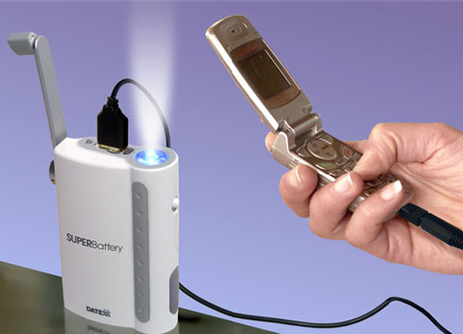
Figure 19 Example Hand Crank Generator, SuperBattery
Reprinted with permission
Source K11

Completed Electromagnetic Research Project

A similar project was recently conducted in Cork, Ireland at University College Cork. The generator was based on electromagnetic transduction which they felt was the most fitting kind of transduction when trying to harvest human actions into electricity. This is because of the low frequency and irregular nature of an individual’s movement. The vibration signal has a tendency to be random and non-sinusoidal in the human body and needs a generator that will optimize the ratio of mechanical to electrical energy and also be rugged and durable to avoid damage from being dropped. The generator is structured around a magnetic spring. The team researched several variations for the structure of the magnetic spring generator. The following figures below show the possibilities the University College Cork found for constructing the generator.

All of the following architectures consist of two permanent magnets facing each other with the same polarization inside of a long tube. In the first figure, figure 20, the two magnets are fixed on either end. A third magnet is placed inside the tube between the two fixed magnets. This magnet moves freely between the two fixed end magnets. A coil is wrapped around the outside of the tube in the center. Whenever the tube shakes, so does the free center magnet, vibrating up and down, hence inducing a voltage in the coil. The suspended magnet acts as the magnetic spring constant. The following equations represent the voltage induced in the coil:
$$V_{coil}=n\frac{dφ}{dt}\frac{dz}{dt}$$

In the equation, n represents the number of turns in the coil; phi represents the average turn flux linkage and $\frac{dz}{dt}$ represents the velocity movement in the z-direction. According to this equation, increasing either the flux gradient or the velocity will result in a higher induced voltage.

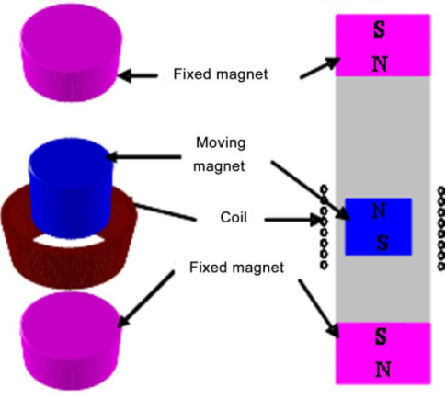
Figure 20 Electromagnetic Generator with 2 Fixed Magnets
Reprinted with permission
Source K4

A second variation of this generator is mostly the same except for the single free moving magnet is replaced with two free moving magnets and a soft magnetic pole piece which is placed between the two suspended magnets. In this configuration, as shown in figure 21, the two free magnets are glued to either side of the soft magnetic pole piece.

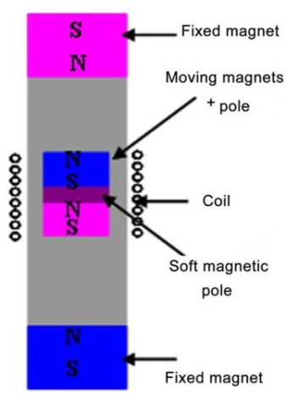
Figure 21 Electromagnetic Generator with soft pole magnet in center
Reprinted with permission
Source K4

The third variation of the generator, as shown in figure 22, is the same as the second variation described above except for the upper end magnet (refer to the image below) is removed. This is done to increase the potential for displacement. However, this variation would in effect lower the resonant frequency since the magnetic spring constant is decreasing.

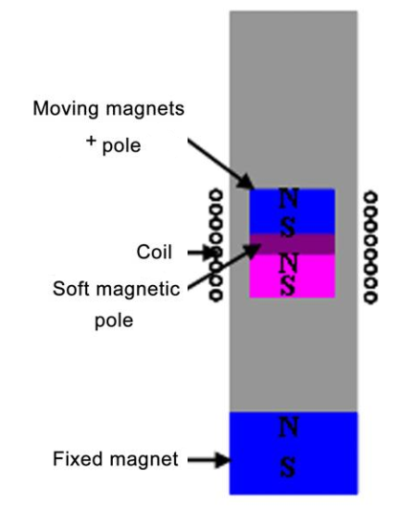
Figure 22 Electromagnetic Generator with one fixed magnet
Reprinted with permission
Source K4

An experiment was conducted at the Tyndall National Institute using the second variation which was discussed earlier, given the following specifications. Two cylindrical magnets were tightly glued to a 3mm thick magnetic pole piece, which was then inserted into a hollow Teflon tube. Two magnets with opposite polarity were then inserted and fixed onto the two ends of the Teflon tube. A 40$μm$ copper wire was wrapped around the outside of the Teflon tube 1000 turns at the midway point of the tube. The inner diameter of the coil after being wrapped around the tube was 17mm and the outer diameter was 18mm. The length of the wrapping extended about 6mm along the length of the tube. The total length of the tube was 55mm, slightly longer than an AA battery. The middle magnets were 8mm thick and 15mm in diameter. The end magnets were 10mm in diameter and 1mm thick. The total mass of the free moving mass inside the tube was 0.027kg. Lastly, the total resistance of the coil was 800 Ω. Using the specifications, the following results were yielded as shown in figure 23. Multiple tests were performed using different parameters. The earlier tests began with the generator being vertically mounted to a controlled electromagnetic shaker. The resonant frequency was found by sweeping the vibration frequency therefore generating the maximum vibration. The following no-load voltage versus frequency curve shows that the resonant frequency was found to be at 8 Hz. The acceleration level used was 0.38259 m/s².

Figure 23 No-load Voltage vs. Frequency Curve
Reprinted with permission
Source K4

The theoretical result for the resonant frequency was 7.6 Hz using the following equation, $w_{n}=\sqrt{k/m}$. The estimated value for k, the spring constant was 61.5 N/m. The maximum load power measured was 14.55µW.

The generator was later tested by being placed in a backpack that a person wore while walking and then again slowly jogging. An ADXL321 bi-axial accelerometer was attached to the body of the generator and connected to a pocket data logger which was used to measure the generator load voltage and acceleration levels experienced by the generator. The following two graphs, figure 24 and figure 25, show the acceleration versus time curve and the associated No-Load Voltage versus time curve, respectively for a 2 second period while walking and slow running.

Figure 24 Measured Acceleration vs. Time while walking and running
Reprinted with permission
Source K4
Figure 25 Voltage Output vs. time while walking and running
Reprinted with permission
Source K4

It is apparent from these graphs that the produced voltage is significantly greater when running versus walking. When the load resistance and coil resistance were matched, 0.30 mW of load power on average was generated while walking. While slowly running, and average of 1.86 mW was generated.

A second variation of the architecture was also tested to compare the output power differences. The tested structure was the generator which only had one fixed magnet at the bottom. The following graph, in figure 26, shows the results.

Figure 26 Voltage output vs. time with generator containing one fixed magnet
Reprinted with permission
Source K4

The average maximum load power that was generated while walking was 0.95 mW and while at a slow running pace 2.46 mW was generated. From this, it was apparent that much more power was produced from the generator with only one fixed magnet than the generator with a top and bottom fixed magnet. However, only a 32% increase in power level outputs during running occurred versus a 300% increase in power level outputs while walking. This result was due to the fact that a larger displacement was occurring while running and the free moving magnet inside the tube slid past the coil wrapped around the outside of the tube (since top fixed magnet is no longer there) and while the magnet is not within the coil no voltage can be generated. If more turns were added to the coil and the coil expanded over a larger area of the tube and could have been optimized with the expected displacement of the free moving center magnet.

Limitations

A few studies and tests have been performed multiple times by different research groups to verify results. Niu et al. presented a comprehensive study of biomechanical energy harvesting in [K6]. They proposed that about 1 W is produced and obtainable from the heel strike of a shoe, and that a previous estimation by Starner [K7] was overly hopeful. As described earlier in the portion of this paper, Power from Walking, some researchers believe much power can be obtained by the bending of the knee during walking and is identified as one of the more promising opportunities to harvest energy from the body. The leg muscles work against the motion of the leg for part of the gait cycle (while the leg is falling), during which time energy is turned into wasted heat. The authors estimate that up to 50 W could be harvested this way with little impact on the gait. To harness this wasted energy, however, a big device would be necessary with well divided attachment points. [K5]

Another researcher, Von Buren, studied the available power from a specific implementation of an inertial micro generator which would be powered from human walking motion. He and his group collected acceleration data from male test subject who were walking on a treadmill. The data was fed into a time-domain model of the generator to determine to output power available. They found that for a proof mass of 1 g and 5mm’s available for internal displacement, the power outputs were as high as 200W were calculated. The proof mass is the mass that is mounted to the spring inside of the actually generator.

Ways to store the harvested energy

Choosing the optimal way of storing the converted power depends on which type of transduction method is utilized for the project. One choice for the UCF was to have a separate unit aside from the main box which could be attached to the users shoe or wrist or another high movement area on the body, where more power is accessible, then periodically attach it to the main UCF unit. In this case, a capacitor might be useful in order to store the harnessed energy, and then when attached to the main unit the stored power is transferred to another capacitor which could solely power the MCU. Sensors would have also been a necessary part of this project in order to allow the display on the main unit to accurately relay information about the unit’s power consumption and current battery capacity. These sensors could have been charged with MEMS devices. This would have allowed the sensors to be independent of the battery and not consume extra power which would take away from the focus of the project of charging the user’s electronics. If it was determined that a separate unit that attaches to the shoe is overly complicated for the user to use and doesn’t supply a significant difference in power compared to a transducer that could be place in the main UCF unit itself, then an Electromagnetic Transducer would have been the most promising and optimal choice. Most likely it could trickle charge a battery but it may also charge a capacitor. The following paragraphs cover these different alternatives specific to this project and weigh the pros and cons of each.

There are several choices that had to be made for the electromagnetic generator to be implemented inside the UCF. One of these major decisions was deciding how to store the energy. First, if the generator had been placed inside the unit, it could have either been wired to the main battery or in a separate battery that is solely powering the PIC, LCD and ADC’s. If it were determined that the kinetic power output was capable of powering these components (the PIC, LCD, and ADC’s) then having a separate power supply for them would have seemed to be a better choice. If it were determined that it would not accomplish this task, then the kinetic power output would have been wired directly to the main battery. If the power output was found to be able to power the PIC, LCD and ADC’s, but not continuously, then a switch would have been needed to be implemented between the two batteries and switch from the sub battery (kinetic output) to the main battery when the sub battery has insufficient output to power the components. This can be done through hardware or software.

A supercapacitor would have also possibly been a good candidate for storing the power in lieu of a second battery. This could have lowered the cost of each UCF unit if the cost of a capacitor is significantly cheaper than a battery. There are a couple disadvantages to using a capacitor, however. The energy density is considerably lower than that of a battery. Also, wiring and building the design would have been far more complicated to build and contain many more switching controls which could have even eaten up and waste energy. Capacitors also have a higher discharge rate than batteries. A few pro’s to implementing a supercapacitor instead of a battery could have been the longer life span that the capacitor inherits and the lower cost.

Additional Issues to be considered

Another factor that needed to be weighed was the cost of having two batteries instead of just the one main battery. A battery can cost anywhere from $20-$60. Also the weight and size of the batteries would have needed to have been considered. A battery only weighs about 170g. This seemed to be a feasible number and the user wouldn’t have had a problem carrying the extra weight. The battery would have been about 76mmx 73mmx 24 mm in size. This would have been able to fit inside the main unit along with the rest of the components that make up the inside of the unit.

Microcontroller

A microcontroller is used to incorporate all the devices on the board. It gathers input from various sources, processes the information, and then outputs the data to an LCD display. Using a microcontroller provides the flexibility to change the software when necessary, and any design changes in the future can be easily implemented.

This section discusses the research achieved to filter through many different microcontrollers and find the most suitable candidate. The criteria for choosing the microcontroller are listed in the specifications section.

The microcontroller that was chosen for the Universal Charging Friend was selected among a few relevant microcontrollers, and is compared in the following discussion. The companies were narrowed down to Microchip, Atmel, and Texas Instruments, and all provide chips that could be easily implemented into the project. After doing research on each company’s 8-bit chips, it was realized that there is no “best” company or chip. Table 5 below shows advantages of PIC and AVR chips according to various sources:

PIC vs. AVR
Small instruction set (less instructions to memorize/work with) | Arduino boards appear to be easy to use for beginners
Low power consumption | Brownout detector has low power consumption
Fast conversion speed for ADC | Wide range of RC oscillator speeds
Can wake up from sleep on short pulses | Has separate PORT and PIN registers which avoids read-modify-write issues with pins loaded with capacity
Counters can still count while the part is in sleep mode | Broad range of devices
Good availability from Microchip, with short lead times, and rare shortages | Very C-friendly
Good programming tools and many sample codes available
Table 5 PIC vs. AVR Advantages

After much research, it became obvious that there is no “best” microcontroller, but that it all depends on the specific design and application. For the Universal Charging Friend, it was decided that Microchip’s PIC series would work sufficiently, and many local people are available for support with PICs. After deciding to go with a PIC microcontroller, there were still many choices among these that would work for the project.

Microchip’s PIC16 Series Microcontroller

One microcontroller series that was explored was the PIC16F series. These chips can come with 18, 20, or 28 pins and most have low power consumption, while some even have Microchip’s new nanoWatt XLP technology. This technology will be discussed later in this document.

One specific PIC16F series chip that was looked at was the PIC16F690. The reason for doing so was because the PICKit2 demo board was purchased and used to practice programming the PIC, and the chip that comes with the demo board is the PIC16F690.

The specifications of the PIC16F690 match the requirements for the UCF, which is shown in Table 6 below. Having 7 kilobytes of memory should be adequate for the amount of programming used in the project. The CPU speed should be sufficient enough to handle displaying data to the LCD display in real time. Having two 8-bit timers is useful for both ADC conversions and handling interrupts, and the 16-bit timer is available if the code requires the PIC to wake from sleep mode after a predetermined amount of time. The twelve channels for ADC is helpful, because some of the ADC ports are used for things other than conversions, and by having twelve channels there will still be enough channels left for actual ADC. Also, 10-bit resolution will provide accuracy when calculating ADC values. The operating temperature works for this project, although the ideal range for marketing purposes is 32 to 150 degrees Fahrenheit. The PICF16F690 contains 20 pins which will be the right amount for the project, and allows a few extra pins of headroom to add on more requirements if necessary. Some of the key features of the PIC16 series are discussed in the following section to compare to the PIC18 series.

Parameter Name | Value
Program Memory Type | Flash
Program Memory (KB) | 7
CPU Speed (MIPS) | 5
Timers | 2 x 8-bit, 1 x 16-bit
ADC | 12 ch, 10-bit
Comparators | 2
Temperature Range (C) | -40 to 125
Operating Voltage Range (V) | 2 to 5.5
Pin Count | 20
Cap Touch Channels | 4
Table 6 PIC16F690 Specifications Sources: [M3] Reprinted with permission

Microchip’s PIC18 Series Microcontroller

The second microcontroller looked at was the PIC18 series, and more specific, the PIC18F13K22, which also uses the XLP technology. Microchip boasts that its PIC18 family has “introduce[d] design enhancements that make these microcontrollers a logical choice for many high-performance power sensitive applications.” Although the Universal Charging Friend does not demand high-performance, it is a power sensitive application. Even though this series of chips provides more than enough features, power consumption is not sacrificed while using extra features.

XLP Technology

One of the reasons for considering the PIC18F13K22 is because Microchip boasts of its nanoWatt XLP technology. This technology is supposed to significantly reduce power consumption during operation. According to one source, there are three main advantages to the nanoWatt XLP technology. One benefit is sleep currents have been lowered to 20 nA, which beats competing chips by about one fifth. Another advantage is the real-time clock current, which can go down to 500 nA. This will especially be helpful for charging applications with the Universal Charging Friend. Not only will the clock consume just 500 nA, the heat dissipation will be very minimal—almost non-existent. Lastly, the watchdog timer currents use about 400 nA. In addition, many wake-up features are available, and power reduction options exist for USB peripherals on the board and capacitive touch sensing peripherals. This low-power technology can be used for many different applications, such as security systems, thermostats, timers, digital photo frames, and portable electronics such as the Universal Charging Friend. Microchip offers its nanoWatt XLP microcontrollers from the range of one to three dollars, which certainly competes with other microcontrollers. The fundamental element from this chip that makes it appealing for the Universal Charging Friend is its sleep currents. This is because when the LCD display is not being used, it can be put to sleep with such a low current that power consumption should not be noticeable. At the same time that the PIC is sleeping, the battery could still be charged, thus preventing unnecessary power to be drained. Sources: [M4]

Table 7 below shows some features of the PIC18F13K22. The program memory is similar to that of the PIC16F690, and the amount of timers would more than satisfy the group’s requirements. The PIC18 also contains the same ADC, comparators, temperature, pin count, and capacitive touch specifications and operates with a very similar voltage range as the PIC16 series.

Parameter Name | Value
Program Memory Type | Flash
Program Memory (KB) | 8
CPU Speed (MIPS) | 16
Timers | 1 x 8-bit, 3 x 16-bit
ADC | 12 ch, 10-bit
Comparators | 2
Temperature Range (C) | -40 to 125
Operating Voltage Range (V) | 1.8 to 5.5
Pin Count | 20
Cap Touch Channels | 4
Table 7 PIC18F13K22 Specifications Source: [M3] Reprinted with permission
The data provided below in Table 8 shows a comparison of the features between the PIC16 and PIC18 series:

PIC16F690 | PIC18F13K22
C Compiler Optimized Architecture | C Compiler Optimized Architecture
Direct, Indirect and Relative Addressing modes | Up to 16 MIPS Operation
Interrupt Capability | Priority Levels for Interrupts
Power-on Reset (POR), Power-up Timer (PWRT) and Oscillator Start-up Timer (OST) | Power-on Reset (POR), Power-up Timer (PWRT) and Oscillator Start-up Timer (OST)
Programmable Brown-out Reset (BOR) | Programmable Brown-out Reset (BOR)
In-Circuit Serial Programming (ICSP) via five pins | In-Circuit Serial Programming (ICSP) via two pins
Power-Saving Sleep mode | Power-Saving Sleep mode
Wide operating voltage range (2.0V-5.5V) | Wide operating voltage range (1.8V-5.5V)
Industrial and Extended Temperature range | Industrial and Extended Temperature range
Standby Current:  - 50 nA @ 2.0V, typical  Operating Current:  - 11 µA @ 32 kHz, 2.0V, typical  - 220 µA @ 4 MHz, 2.0V, typical  Watchdog Timer Current:  - <1 µA @ 2.0V, typical | Sleep mode: 34 nA  Watchdog Timer: 460 nA  Timer1 Oscillator: 650 nA @ 32 kHz
17 I/O Pins and 1 Input Only Pin:  - High current source/sink for direct LED drive  - Interrupt-on-Change pin  - Ultra Low-Power Wake-up (ULPWU) | 17 I/O Pins and 1 Input-only Pin:  - High current sink/source 25 mA/25 mA  - Programmable interrupt-on- change  - Three external interrupt pins
Three Timer modules:  - 1 16-bit timers/counters with prescaler  - 2 8-bit timer/counter with 8-bit period register, prescaler and postscaler | Four Timer modules:  - 3 16-bit timers/counters with prescaler  - 1 8-bit timer/counter with 8-bit period register, prescaler and postscaler
A/D Converter:  - 10-bit resolution and 12 channels | Analog-to-Digital Converter (ADC) module  - 10-bit resolution, 12 channels  - Auto acquisition capability  - Conversion available during Sleep
Table 8 PIC16 vs. PIC18 Specs Sources: [M3]

Some of the key features that are desirable for this project are the extreme low-power currents, the C compiler optimized architecture, and the enhanced low-voltage programming. Another nice aspect of both chips is the ability to expand the requirements because of added features.

When compared, both microcontrollers have very similar features. They both contain the same amount of pins, and the power consumption only differs a little. For the UCF, the power consumption difference between the two PIC chips is negligible. The pricing for both chips was under two dollars, so price is not a huge concern for buying just one or two chips. However, with marketing aspects in mind, even the thirty cents difference in price between the two chips can have a huge impact monetarily. Some of the engineers who have experience with PICs have suggested the PIC18 series for beginners on PIC programming, while others suggest the PIC16. Clearly there is no correct choice between the two—just matters of personal preference and experience. Sources: [M3]

Atmel ATmega88PA

Atmel is one of Microchip’s biggest competitors, if not the top competitor. As so, the group looked closely at Atmel’s 8-bit microprocessors and compared it to Microchip’s 8-bit processors as previously discussed. On Atmel’s site, www.atmel.com, they list some key benefits of their 8-bit processors:

- High performance
- picoPower technology
- High code density
- High integration and scalability
- Complete tool offering

picoPower Technology

Atmel’s picoPower technology is the competitor to Microchip’s XLP technology, both boasting about low power consumption features. picoPower technology allows power consumption as low as 650 nA while having a real-time clock running, and power-down sleep mode only consumes 100 nA. Some of the main features of the picoPower technology are:

- True 1.6-volt operation
- Minimized-leakage current
- Ultra-low power 32 kHz crystal oscillator
- Sleep modes
- Sleeping brown-out detectors (BOD)

Functions such as analog-to-digital converter and flash memories can operate at a true 1.6-volt operation, which means a power supply can give 1.8V ± 10% and maintain safety without damaging any parts. Another benefit of this operation is battery life enhancement due to deeper battery discharge. The minimized-leakage feature cuts down power consumption for applications spending the majority of time in sleep mode. AVR microcontrollers have a Digital Input Disable Register, which can halt the digital input stage if a pin is connected to an analog source. The leakage current occurs in the digital input stage if voltages applied are around V_{cc} / 2, because the cascaded pair of transistors will become partially opened, allowing for current to leak out. The Digital Input Disable Register solves this problem, and all the digital input buffers are designed to self-disable when sleep mode is activated. The ultra-low power crystal oscillator can keep a real-time counter up to date and accurate while only consuming around 650 nA. To reduce power usage, the AVR microcontrollers have sleep modes that allow unused components to be shut off. To increase the wake-up time from sleep mode, the software can choose a sleep mode that keeps the relevant oscillator running while the CPU and peripherals shut down—this way the CPU doesn’t have to wait for the chosen clock source to start up. Through Atmel’s picoPower technology, they have kept the high performance and high current of the BOD and saved power by disabling the BOD when it’s not required. Using this method, results in overall power consumption and possible performance are extremely good, and with accurate detection at levels of 1.8V, 2.7V, and 4.5V, as shown in Figure 27 below.

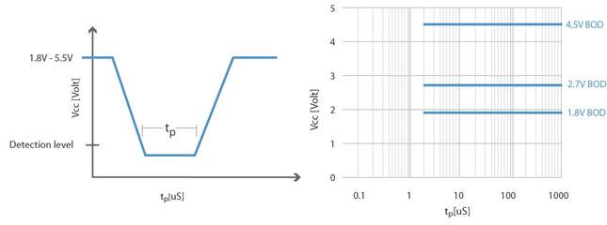
Figure 27 Response Time Versus Detection Level AVR Brown-Out Detector
Source: [M5]

For evaluation purposes, the data provided below in Table 9 on the ATmega88PA was taken from Atmel’s datasheet found on www.atmel.com, and is in a similar format to the previously discussed PIC16 and PIC18 microcontroller for easy comparison:

ATmega88PA Features
Up to 20 MIPS Throughput at 20 MHz
Data retention: 20 years at 85°C/100 years at 25°C
Two 8-bit Timer/Counters with Separate Prescaler and Compare Mode
One 16-bit Timer/Counter with Separate Prescaler, Compare Mode, and Capture Mode
Temperature Measurement
6-channel 10-bit ADC in PDIP Package
Interrupt and Wake-up on Pin Change
Power-on Reset and Programmable Brown-out Detection
External and Internal Interrupt Sources
Six Sleep Modes: Idle, ADC Noise Reduction, Power-save, Power-down, Standby, and Extended Standby
23 Programmable I/O Lines
Operating Voltage: 1.8 – 5.5V
Operating Temperature Range: -40°C to 85°C
Power Consumption at 1 MHz, 1.8V, 25°C
  - Active Mode: 0.2 mA
  - Power-down Mode: 0.1 μA
  - Power-save Mode: 0.75 μA (Including 32 kHz RTC)
Table 9 ATmega88PA Features Sources: [M5]
Some of the key features on this chip desirable for this project are the 20 MIPS speed, 3 timers, temperature measurement, interrupt and wake-up on pin change, power-on reset and programmable brown-out detection, sleep modes, 23 I/O lines, operating temperature range, and power consumption. Speed is relatively important, and 20 MIPS will be plenty fast enough for the Universal Charging Friend. The ability to measure temperature and display it to the LCD display would be a good end-user feature. The interrupt and wake-up on pin change, power-on reset and programmable BOD will come in handy for efficiency purposes of this project. The amount of sleep modes provides more options than the PIC chips, but the number of ADC channels is only half. The 23 I/O lines should give us some extra pins in case the group decides to expand the project. The operating temperature is very pleasing, as temperatures in Florida can get very high, and it’s important not to get close to the max temperature. Finally, the overall power consumption of this chip satisfies the requirements for the Universal Charging Friend. Sources: [M5]

Texas Instrument’s MSP430

One microcontroller manufacturer that was not overlooked is Texas Instruments, who pride themselves on their MSP430 chips. According to their website at www.focus.ti.com, “The MSP430 family of ultra-low-power 16-bit RISC mixed-signal processors from Texas Instruments (TI) provides the ultimate solution for battery-powered measurement applications.” Indeed, ultra-low-power is the biggest requirement for this project, so the MSP430 will be looked at closely to see if the chip’s specifications really have unmatched low power. The following are some key features of the chip:

- Ultra-low-power (ULP) architecture and flexible clock system extend battery life: 0.1-μA RAM retention, <1-μA RTC mode, <230 μA/MIPS (flash), <110 μA/MIPS (RAM)
- Integrated intelligent peripherals including wide range of high-performance analog and digital peripherals that off-load the CPU
- Easy-to-use 16-bit RISC CPU architecture enables new applications with industry-leading code density

The flexible clocking system allows various clocks and oscillators to be enabled and disabled, meaning that the device can go into low-powered modes. In other words, optimization will take place by only using the clocks when necessary. Another nice feature the MSP430 series provides is the ability to instantly wake up from low-powered modes. This is important because in applications such as this project that are low-powered, the microcontroller can use the CPU in efficient bursts and use additional time in low-powered modes. The brown-out reset (BOR) for the MSP430 is always active in all modes of operation to guarantee the best performance possible while still consuming ultra-low power. The BOR circuit senses low supply voltages and resets the device when power is applied or removed, which can be very significant in battery-powered applications such as the Universal Charging Friend. The Figure 28 below, provided by Texas Instruments, shows the ultra-low-power activity profile for the MSP430:

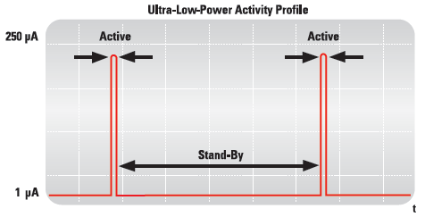
Figure 28 Ultra-Low-Power Activity Profile for MSP430
Source: [M6]

Microcontroller Decision

No specific microcontroller seems to outperform the others by a large margin, so the decision came down to availability and familiarity. Some of the group members’ coworkers have experience with PIC chips, so it was decided to use a PIC so that additional resources would be available when necessary. The PICKit2 demo board was purchased and used to practice programming the PIC. The chip that comes with the demo board is the PIC16F690, and because it meets all the requirements for the project, the group decided to stick with it because of familiarity.

ADC Requirements

After much brainstorming, it was decided that the group would need to convert four required measurements from analog to digital, and two extra measurements if time allowed. The PIC16F690 chip contains twelve channels of ten-bit resolution, which more than satisfies this requirement. The six measurements are:

- Battery voltage
- Solar voltage
- Kinetic voltage
- Wall adapter voltage
- Battery charge current
- Battery discharge current into loads

The ADC ports on the PIC can only handle a maximum voltage of 5V, so it is necessary to create voltage dividers for all the voltage sources. The voltage dividers will scale down the input sources between 0 and 5 volts. The designing of the voltage divider is covered in the design section.

Interrupts

The group realized it would be necessary to have multiple interrupts in order to accomplish certain tasks. One of these interrupts would have to be caused by a timer overflow. The PIC16F690 has an 8-bit timer/counter module called Timer0 (TMR0). The Timer0 module will increment on every rising and falling edge of the T0 clock pin. Each time the TMR0 register overflows, the interrupt flag bit is set. When the flag bit is set, the interrupt is triggered and the code can execute for that interrupt. The Timer0 interrupt code is used as a counter for the main function, which will sample the ADC ports every time the counter gets to a designated number of 1000 (this number was arbitrarily assigned).

Another interrupt required by the UCF is a button interrupt. Although it is possible to use an interrupt on change, it was easier to make an interrupt based on the logic state of the button pin. To do so, every time the main function loops, it checks if the button port goes high and then low (button is pressed and released), and if so then executed the button interrupt code. Both interrupts are very useful in the design of the UCF and will be discussed in more detail in the design section.

LCD Display

Touchscreen vs. Segment

Choosing between a touchscreen or segment display was not a difficult option. The advantages for choosing a touchscreen display are aesthetic appeal and ease of use for the user. The disadvantages are the harsh environments (such as direct sunlight at the beach, sand, etc.) our product will be exposed to and the cost. For the segment display, the advantages are the ease of control, the cost, and the durability compared to touchscreen (i.e. no sensors to damage). The disadvantages seem to be negligible. Therefore the Universal Charging Friend will use a segment LCD display. Source: [M7]

Color vs. Monochrome

For LCD screens, the power consumption difference between color and monochrome seems to be very minor, if any at all. Since the Universal Charging Friend will be used mostly in the sunlight, the use for a color screen is negligible. Therefore, LCD display will be monochrome.

Alphanumeric vs. Graphical Display

When deciding which type of display to use, many options were available. The two choices for the LCD display were alphanumeric or graphical, both having their advantages and disadvantages. Alphanumeric displays are best used for text and special characters, and have a wide range available from as little as 8 characters x 1 line displays up to 40 characters x 4 line displays. Also the size of the characters can be varied from small to large. These displays are lightweight and have low power consumption, which is appealing for a solar powered display. For charts, tables, and other images, graphic LCD displays make for a good choice. They tend to be more popular in high-end industrial equipment, medical equipment, etc. where graphs need to be displayed. Although it sounds appealing to display graphs for the Universal Charging Friend, the graphic display is not required and it would be less power efficient than the alphanumeric display. Since it is only necessary to display text characters and bar graphs for users, alphanumeric will be sufficient, and it will consume very minimal power as well as cost less than the graphical display. Source: [M8]

Passive-matrix vs. Active-matrix

Passive-matrix LCDs use a grid to turn on pixels by sending a charge to a specific row and column. Integrated circuits are connected to the rows and columns through conductive material and control when a charge is sent to a specified row or column. Pixels are turned either on or off through multiplexing. Sometimes the lingering current that travels down each control line causes crosstalk at unselected pixels, which partly darkens certain pixels and can lower the contrast of the overall display. Source: [M9]
Active-matrix displays, also known as thin-film transistor (TFT), are a newer technology than passive-matrix displays. Instead of using multiplexing to address the matrix of crystals, active-matrix contains a transistor constructed along with each pixel. The transistors act as switches to turn on individual pixels, and can turn the pixels on and off at a very fast rate. Since there is a transistor at each pixel, crosstalk does not occur. Also, the time dependency due to multiplexing displays through addressing each pixel is removed by the TFT process. Source: [M10]
After considering both options, it has been decided that the LCD will use passive-matrix display, since there are so many varieties available, and multiplexing should not be too challenging. Also, crosstalk should not be a hindrance because the Universal Charging Friend will be used mostly in sunlight, so the users should easily be able to see the screen.

Comparing LCD Displays

After searching through many versions of LCD displays, it was narrowed down to a few from Crystalfontz (www.crystalfontz.com), and a generic LCD from eBay. One of the display models from Crystalfontz is the CFA-634, and the features listed below are directly from the documentation provided by Crystalfontz:
- 20x4 LCD has a large display area in a compact 130 mm x 63 mm package
- Large, easy-to-read characters
- RS-232 interface
- Comes in five choices
- Modules are thin
- Software-controlled contrast
- LCD characters are contiguous horizontally to allow the software to display “gapless” bar graphs in horizontal direction
- Software controlled terminal style automatic scrolling and line wrapping
- Unique scrolling marquee feature continuously scrolls a message across the display
- EEPROM capability to customize the “power-on” display settings
- Low power: non-backlight operation will self-power from the DTR and RTS lines of most serial ports
The 20 characters by 4 lines will allow plenty of space to display measurements and bar graphs. If necessary, the scrolling marquee feature can be used. The package size and module thinness are very appealing since the UCF is going to fit into a water-bottle sized pocket. The low power feature is very nice since that is the major goal of the project, and the software-controlled contrast will help assist in the low power consumption. The large, easy-to-read characters could be a good marketing feature as an end-user product. The electrical block diagram and specifications are shown below in Figure 29 and Table 10 (provided by Crystalfontz datasheet). As can be seen, the current consumption without a backlight is 9 mA, which does not consume much power from the internal battery, and will even be charged some from the kinetic component.

Figure 29 CFA-634 System Block Diagram
Source: [M11]

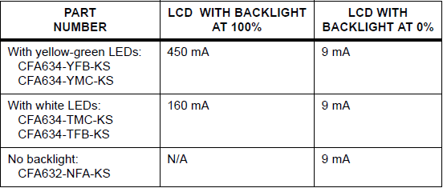
Table 10 CFA-634 Current Consumption
Source: [M11]

The other model that was looked at to compare with the CFA-634 was the Crystalfontz CFA-635, which is similar but has the addition of buttons. Many of the features are the same as the CFA-634 such as direct sunlight-readable, contiguous LCD characters for “gapless” bar graphs, and EEPROM capability. However, some of the different features that could add some excitement to the UCF are:
- Integrated white LED backlit translucent silicone keypad
- Four bicolor (red + green) LED indicators, and the brightness can be altered via software
- ATX power supply control functionality allows the keypad buttons on the CFA635-TFE-KS to replace the “power” and “reset” switches on the system, simplifying the front panel design
- Fully decoded keypad
All of the features are appealing for the UCF design, and have been taken into account in the decision-making process. Another aspect to analyze about the CFA-635 is the typical current consumption for comparison to the CFA-634 series (Table 11 shown below). It is noted that the current consumption is much higher for the CFA-635 because of the keypad lights. The tradeoff of course would be low power consumption for aesthetic display and possibly easier programming. Source: [M11]
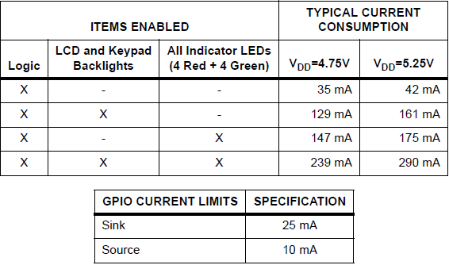
Table 11 CFA-635 Current Consumption
Source: [M11]

The last choice for an LCD was just a generic display from eBay. Using a generic display tends to be cheaper in price than one from Crystalfontz, and it will perform in the same manner as long as it uses the Hitachi HD44780 driver. The LCD that was found for comparison on eBay was a 16x2 display, comes with a backlight, cost $8 and used the HD44780 driver, which meets the requirements for this project.

Final Considerations

Some of the final considerations that were looked at overall were: backlight, cost, environmental temperatures, and functionality/efficiency. The cost consideration was implemented based on all the previous considerations, such as backlight, monochrome, touch-screen, etc. Most of the displays had operating temperatures between 32º and 120º-150º Fahrenheit, which should be sufficient. As far as functionality, it has been decided that the display should not have a keypad due to complication with making the holes in the Plexiglas and the current consumption. The programming will be easier without keypad buttons, and everything can be automated through software (i.e. marquee scrolling and display switching). After much research, the choice of LCD display to be used is the generic LCD found on eBay. As previously mentioned it uses 16 characters by 2 lines, contains a backlight for nighttime visibility, and is very cheap. Although there are more things to display than there are lines, it will be easy enough to switch displays based on a timer. The group decided to order two LCDs since they are cheap, and it is good to have an extra in case one gets damaged. Also, the backlight can be turned on to save battery power.

Best Battery for the Device

There are many factors in the decision of the best battery to use within the charging device. Low cost and optimal performance were atop the list of qualities the device would include. The entire system has an overall low manufacturing cost which would make it easily profitable. The efficiency of the system is of great importance as well. The charging system effectively holds the charge from the solar panels and the kinetic devices as well as discharge properly. There were a variety of different batteries to choose from for the charging system. The energy within the primary lithium batteries are around 200Wh/kg and 400 Wh/L making lithium batteries the premier choice for portable applications. High and flat potentials as well as high power are other positive qualities of primary lithium batteries [C7]. As for lithium ion batteries, other good aspects of the energy source are long cycle life and no maintenance. Both of which are important qualities to the user. They are also one of the reasons lithium ion batteries are so popular in portable applications. Another important feature of the batteries is wide operating temperature. Although the temperature is still monitored using an efficient microprocessor and algorithms for the safety of the user, the batteries can operate under a broad variation of temperatures. On the other hand, some disadvantages of lithium ion batteries are the need of the protection circuit, degradation at high temperature, and lower power than Ni-Cd or Ni-MH particularly at low temperatures [C7]. The Table 12 below lists the best discharge and charge conditions for some rechargeable batteries. So the temperature monitoring is critical for efficient use in the design of the charger. However, most of the disadvantages are not of great damage to the use of the batteries. As specified in Table 12 below, the charging times for the batteries vary however; the time for Li-ion can be under an hour under fast charge. The engineering of the batteries in recent years has significantly reduced the weaknesses.

Other considerations included the complexity of charging the Li-ion cell pack which will be discussed in further detail later. The Nickel-based batteries do represent lower energy densities as compared with those of lithium ion however, for the overall completion of the project and efficiency of the unit the topic must be discussed. Massive research has been done on each type of battery and how it will affect the outcome of the project. Each battery holds its own benefits and disadvantages when it comes to specific areas of importance. The main areas of concern for the UCF are reliability, efficiency and cost. Complexity also plays a role into the design aspect of the project as it concerns the feasibility of the overall unit. Nickel-based batteries have improved over the years however; there are limitations to the use of such batteries. Charge times are a major category of consideration for the UCF. The unit cannot take many hours to charge for a single cycle. So based on the table below the lead acid battery would not be an efficient engineering choice. Also, its weight to energy is higher considering the other options. For the design of the UCF, the decision of the specific battery is based on cost and effectiveness. Below Table 12 compares the characteristics of several different battery types.

Battery Type | Lead-Acid | Ni-Cd | Ni-MH | Li-ion
Discharge | Limited to 80% | 100% possible | Limited to 80% | Limited to 80% due to safety circuit
Charge Methods | Constant voltage to 2.40V. Float charging at 2.25V | Constant current, then trickle charge | Constant current, then trickle charge. Heating when fully charged | Constant current to 4.1-4.2V, then constant voltage
Storage | Stored at full charge | Stored at 40%. Five years of storage possible at room temp | Stored at 40% | Stored at intermediate depth of charge 3.7-3.8V
Charging times (Fastest) | 10 hours | About 1 hour | About 1 hour | Less than 1 hour
Nominal Voltage | 2.0V | 1.2V | 1.2V | 3.7V
Pros | Economical, long term reliability | High mechanical strength, high efficiency charge | No heavy metals, high capacity | No memory effect, high 3.7V voltage, low self-discharge
Cons | Low cycle life, low energy | Low energy, toxicity | More expensive than Ni-Cd | Charge limits, most expensive
Table 12 Comparison of Rechargeable Batteries
Source: [C7]

The main options for the system are lithium-ion and nickel metal hydride batteries. Although lithium-polymer has safer qualities than Li-ion cells, the cost to energy ratio is lower for lithium ion [C1]. Therefore the price would be higher for the Li-polymer cells compared to that of Li-ion. As shown in Table 13 below, the immediate positives outweigh the negatives for the Li-ion batteries. However, due to the complexity of the charging restrictions on the Li-ion batteries, the nickel metal hydride batteries would be more efficient and feasible for the UCF. The more expensive Li-polymer cells are lighter and easier to customize their shape; however one of the main focuses within the battery system is cost efficiency. Since the Li-polymer cells have a lower energy density compared to Li-ion cells the unit would not contain as much energy as possible. The nickel metal hydride batteries also have less memory effect than that of the nickel cadmium so it is not major drawback. Although there are multiple charging considerations when using nickel metal hydride, the algorithms are not as complex as that of lithium ion. The one main feature to Li-polymer cells is the safety aspects of the battery. As for the Li-ion cells, safety measures have to be taken such as protection PCBs and poly switches to ensure a safe trial by the user as listed in Table 13.

Nickel Metal Hydride
Pros | Cons
Good overall performance under a load | Lower energy density than Li-ion
Energy capacity meets project requirements | Memory effect
Charging requirements less complex than Li-ion | High self discharge
Lithium Ion
Little maintenance | More expensive than Ni-based batteries
Energy density relatively high compared to other batteries | Safety circuit to protect user is required
Low self discharge compared to Ni-based batteries | Strict charging method required
Table 13 Lithium Ion vs. Lithium Polymer Batteries Source: [C2]
Li-ion batteries compared to Ni-based have a higher specific energy, which entails that in order to match the energy from the Li-ion battery, the Ni-based set would be heavier in weight [C2]. Therefore, the product would be compromised due to weight. Ideally, the device is to be hand-held and portable which would be difficult if the weight is maximized. The user should not feel the product is too heavy to carry on long hiking trips as an example.

One of the most important aspects in the decision of a battery is the cost of the cells included in the system. Since the energy to cost ratio is lower in Li-polymer batteries as compared to Li-ion, in this project where cost and energy are equally important the Li-ion batteries would be more cost effective. As compared to Li-ion, Li-polymer batteries can be arranged in many ways. They can be manufactured in a variety of ways due to flexible width, length, and thickness values. Even though the Li-polymer cells can be lower in weight, the cost to produce the Li-polymer cells is relatively more expensive than that of Li-ion. Although the Li-ion batteries would have a greater energy density than other types, the charging method is considerably more complicated than that of nickel metal hydride.

The lithium-ion cells pack has a specifically designed protection circuit in case of misuse of the batteries. The safety circuit does not allow the cells to overcharge or discharge at a higher current than the system can handle. The safety circuit is an essential part to the efficiency of the charging unit, especially when the voltage is in the range of 7.2V normal operation.

The design consideration for the change in battery voltage occurred during testing of the kinetic generator when it could not match the 16V max with a load that the 14.8V battery needed for charging. Since the kinetic generator measured about 10V DC at a steady crank with no load it was decided to use a lower voltage battery for the project so that the kinetic generator could be utilized. In Figure 30 below, the overall regulation of voltage is illustrated. Switching regulators are used for regulating the voltage to the proper limits at which the outputs can handle. The 5V output for the USB is sufficient for charging many devices with the given battery. The efficiency of the unit will also increase since the voltage will not have to be regulated all the way down to 5V from 14.8V. As shown below in Figure 30, a basic diagram of the flow of energy through the charging unit.

Figure 30 Basic Charging Unit Diagram Source: [C2]
The charging system for the UCF is the essence of the unit. The UCF has an output USB to charge a wide range of devices. The UCF charges electronic devices via the car cigarette lighter and USB ports. The USB port needs to draw power from the battery which carries more than the necessary 5V for the devices. A DC-DC converter is used to step-down the voltage from the battery to the device for a proper charge. The converter is an optional link so the unit is efficient in the use of voltage and decreases the amount of dissipated heat it would release otherwise. The DC-DC converter can be used in the battery system since the voltage of the batteries is higher than the required 5V necessary to power USB driver devices. As far as efficiency, it is optimal to convert the battery voltage into a minimum supply voltage needed by the load.

Multiple Outputs

After many design considerations the battery top voltage was changed from 14.8V to 7.2V so the 12V load of the car lighter port will not be needed. In general, the universal serial bus is the main load of the battery. Since most devices today can be charged from the single USB port, the construction of the car lighter port would be limited. The car lighter could be used to charge a variety of devices which would be able to charge via car lighter port; however devices such as GPS systems which were the main purpose of this feature can be supported with only a USB powered output. This feature would then be inefficient when considering the extra weight and unnecessary voltage amount the car lighter port would require. Therefore removing the output greatly expands the efficiency of the device. Mostly, any device that could not easily connect to the USB port such as older cells phones, or GPS devices.

The UCF has a USB connection output to charge the more modern technologies such as mp3 players, iPods and cell phones with USB connectors. The USB connection is a pivotal aspect of the design and completion of the project. Basically, if the USB link fails to successfully and efficiently charge theses devices, the project will not pass not only the academic criteria but the project goals and standards. For such devices as technical as the Apple iPhone, the USB charging connection would have to be very efficient since basic charging methods will not charge the complicated device effectively. So, the USB output is one of the more important features for the completion of unit for obviously charging all the typical accessories efficiently. In order to successfully regulate the proper amount of charge through the system to the USB connection, a type of voltage regulator would have to limit the output to 5V accurately. This procedure would be one of the major efficient techniques for the entire charging unit. There are many different methods available to efficiently limit the charge for the USB connection to ensure appropriate charging.

The unit converts the power from the battery which is around 7.2V during normal operation. The unit has to convert the power by way of either voltage regulator or DC/DC converter. The USB female connection must have a voltage of 4.75 to 5.25v in order to charge devices via the USB port. There are many integrated circuits readily available by Microchip, National Semiconductor, and Texas Instruments, to name a few, which provide +5V from a single nickel metal hydride cell. The chips have many features such as safety charge timers, tight accuracy and thermal regulation to present a few. Another important feature to consider is reverse blocking protection to prevent current to discharge or flow the opposite direction. The load power could be controlled by the software incorporated in the system. The MCP73853/55 by Microchip has a low dropout voltage of 200mV at 400mA would be a helpful design for the system. The UCF charging unit for the USB port would be more efficient with such a scheme as the Microchip process described. These evaluations are used to limit the maximum output of the USB so to increase reliability and efficiency.

Voltage Conversions

The reason for converting the voltage is to limit the waste of energy created due to the higher voltage. The options of regulators are linear, capacitive, and inductive. Linear voltage regulators are used mostly when the difference between the battery and load supply is not too high, so the efficiency is acceptable. The advantage to the linear voltage regulators is the cheap cost and small size of the unit. For a larger difference between the battery voltage and the voltage needed for the load, capacitive voltage converters are used. However, the use of inductive converters are more advantageous because energy can be stored in an inductor from a voltage source with 100% efficiency in an ideal case, as opposed to a capacitive converter where $\frac{1}{2}CV^{2}$ will always be lost [C2]. So, the inductive converters would be the most efficient for the UCF. The problem with the capacitive and inductive voltage converters is Electro-Magnetic Interference, which is caused by the voltage ripple on the output capacitor [C2]. A solution is precise parts and faultless printed circuit board. This aspect would have to be considered in the construction of the charging system for the converters. Due to this knowledge, the battery system has to accommodate this minimum voltage in order to optimize the overall product. Linear Technology has a DC-DC converter with adjustable and fixed voltages. This particular converter is an example of such a device that may be required to complete the connection between the battery pack and the output USB port.

There are various methods of converting power to the voltages needed for the UCF. By use of DC/DC converters, the chips are able to provide the necessary voltages from the single Li-ion cell. For the UCF, since a battery pack of four cells is used, a combination of ways may have to be implemented to complete the charging system. One option for the battery pack is Microchip’s MCP7853/55, which harnesses the power of the USB port for charging a Li-ion battery. However, the maximum input voltage is 12V so the system would not perform properly under this condition. Overall, the system converts the power associated with in the battery to the power needed to control the USB output for an accurate charge.

The regulator LM723 from National Semiconductor can have an input maximum of 40V which would be more than sufficient for the entire need as far as voltage. The output of the component is adjustable from 2V to 37V. Based on the exact voltage required for the microprocessor of the UCF, this regulator would be sufficient. The circuit also features very low standby current drain [C13]. The chips can be ordered from onlinecomponents.com with a lead time of 8 weeks. The possible regulators for the USB output port were considered. The LM117 from National Semiconductor offers several features with its component. The LM117 offers higher performance over fixed voltage regulators, and full overload protection. The chip has a current limit and thermal protection as well as a safe area protection. An important aspect is the overload protection circuitry, which remains fully functional even if the adjustment terminal is disconnected Source [C14]. The chips can be ordered from onlinecomponents.com with a lead time of 8 weeks. Another option for a step down converter for the voltage from the battery unit to the USB output port is presented by Texas Instruments TPS62750. The step down converter is rated at over 90% efficient. The converter has an input voltage range of 2.9V to 6.0V, which is sufficient for the USB powered devices. It also has a power save mode when operating a low currents to increase efficiency. The power save mode would be a factor to consider, since the goal of the project is efficiency within the unit. The Texas Instrument step down converter also allows for stable output voltage for load transients source [C16]. The step down converter should be ideal for the design of the conversion from the battery voltage to the output port of the USB which should be 5V and 500mA.

Monitoring the Battery

Batteries which are combined with any technique of monitoring are considered “smart batteries”. The technology is basically the tracking of various bits of information based on the condition of the battery. The UCF has this kind of technology to optimize the performance of the battery pack. The charging component monitors the state of the battery regarding charge times and type of source which is in use. For example if the battery is charging by solar cells or kinetic or by the wall outlet then the system needs to know, and therefore relay the information to the user via LCD screen. Texas Instruments has a battery management solution for the Li-ion battery pack which can help in monitoring the battery pack of 3 to 4 cells. The BQ20Z80EVM-001 Impedance Track(TM) Fuel Gauge for Li-ion Battery Packs can ensure the pack is in working order each time of use. It also tracks the impedance which for Li-ion cell life cycles is critical. The information that can be received from the Texas Instruments Fuel Gauge can be extremely useful and in many ways optimize the performance of the UCF. Some features of the circuitry include [C18]:

- Complete evaluation system for the bq20z80 Impedance Track (TM) SBS v1.1 compliant battery fuel gauge and bq29312A and bq29400 protection IC.
- Populated circuit board for quick setup.
- PC software and interface board for easy evaluation.
- Access to all programmable registers of the bq20z80to configure the module for most 2, 3 or 4-series Li-ion applications.
- Data logging utility.

The monitoring system can be helpful as a full out plan to measure the battery system. However, the UCF uses a separate microcontroller with various processes to relay the user the information of the battery. For this reason the Texas Instruments battery monitoring system would not work for the design of the UCF. However, the UCF should measure and match the impedance of the battery cells in order to maximize the charging rate of the battery system.

The performance of the battery pack can be monitored using electronic circuitry such as a safety device or charge-balancing circuit. Certain microchips are available to monitor the performance of Li-ion cells. One critical area of monitoring is the temperature of the cells. The operating temperature is around 0$℃$ to 60$℃$; however the specific temperature varies with individual cells. One option for monitoring the performance of the battery pack is the DS2438 by Dallas Semiconductor. The DS2438 Smart Battery Monitor has a temperature sensor which is direct-to-digital [C6]. The sensor gets rid of the use of thermistors in the batteries that other ICs might use. The monitor makes use of an A/D converter to measure the voltage and current of the pack. It includes a time meter as a precaution feature so the battery is not charged too long. It also has sleep-mode when charger is disconnected. The monitor allows for multiple battery packs to be charged [C6]. Such a device can greatly benefit the UCF charging system by supervising the efficiency of the charging unit. A basic fuel gauge would need to be implemented within the design of the pack to monitor the battery’s life and health. An integrated circuit to accurately describe the voltage, current, and temperature measurements would optimize the performance of the entire unit.

Sihua Wen at Texas Instruments explains in Power Management Design Line that the more important issue for Li-ion batteries is not the periodical loss in capacity but the increase of impedance after a number of cycles [C8]. So it is understood the maximum storage of the battery is not so much the problem with the batteries as the impedance can double as the number of cycles reaches 100. As a result it is important for the UCF to have some internal device to maximize the performance with all these areas accounted for. The conventional way of measuring the battery includes a certain voltage characteristic strategy. This method is basically used for understanding the state of the battery for reasons such as cost and simplicity.

However, the scheme is flawed in that it does not account for the impedance increase in the system. A change in temperature can alter the reading of the system by up to 50 percent. This would be a huge variation for the UCF if a simple voltage reading was used instead of a more accurate analysis from another design. Some type of measurement of the power associated with the solar panels and kinetic energy would be beneficial as well. Even though the power generated from the kinetic mechanisms might not reach levels of massive charging throughout the charging system it is a requirement to measure the contributions of both the kinetic and solar panels.

Another way the battery unit can be optimized and monitored by way of analyzing the behavior and condition of the battery system by a dynamic modeling algorithm described by Sihua Wen at Texas Instruments. The model would be based on Impedance Track technology that uses the past conditions of the battery to dictate the optimal performance of the system [C8]. The way the technique works is by taking into account the existing parameters of the battery. Some constraints such as the battery’s age can be caused by the modification in battery impedance and the no-load chemical full capacity (Qmax) [C8]. The modeling algorithm can also account for such changes as temperature and aging. The process can ultimately optimize the performance by understanding the physical chemistry changes of the battery due aging especially. The impedance would be taken into account using the information of the load and temperature of the battery. The optimization of the battery lifetime would be the principal benefit of the modeling. Since the main difficulty of the project is maximizing the performance of the entire system, the addition of such a modeling technique could benefit the project. The model consists of a battery shut down mode which would obviously benefit the power life of the unit. The battery’s impedance which would be measured only when discharging is

$\frac{Open circuit voltage-Battery voltage under load}{Average Load Current}$.

As shown below in Figure 31, the charging device would encounter a load; the current changes the characteristic of the battery to a different model. The change imposes the nature of the charge to alter its course in relation to the open circuit voltage characteristic curve shown in Figure 31. The above equation will give the impedance of the cells and consists of the chemistry as well the temperature when it is measured. In the figure, the remaining capacity can be found by Rm = |$SOCfinal-SOCstart$|$×Qmax$; the product of the remaining state of charge and the maximum battery capacity would describe the remaining capacity of the cells [C8]. For the project since the battery pack should hold a charge of about 4 cells, these equations would help optimize the performance by understanding the chemical and aging structure of the cells individually. The full charge of the cells can be represented by the available energy under the given load of the battery. The full capacity can be calculated FCC = Qstart + Passed Charge + Rm$×$Qmax [C8]. Since one of the main areas is accounted for, aging, the battery’s total capacity would have to be repeatedly measured. The basis of these equations is the previous charges will change the overall capacity of the batteries due to aging no matter the max charge.
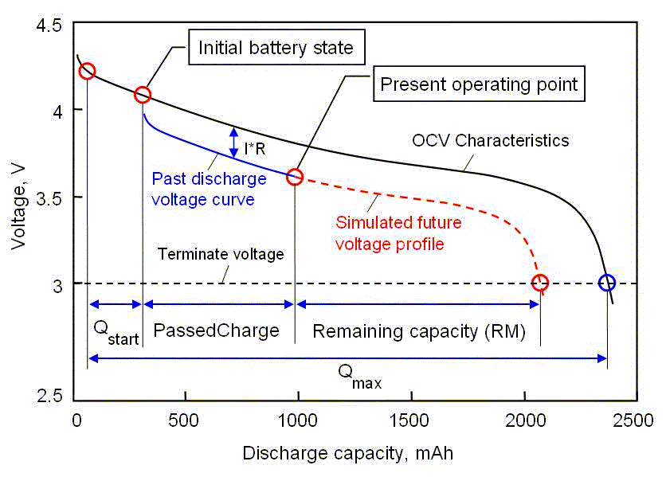
Figure 31 Open Circuit Voltage Characteristics (Texas Instruments Source: [C8])

Specific individual cells have to be selected and the exact measurements would have to be known in order to configure such a maximizing process to work. The chemistry of the specific Li-ion cells will also have to be known for the impedance tracking to accurately analyze the behavior of the cell pack. The UCF battery unit would be able to dictate performance of the battery pack extremely accurately with the knowledge of the past and number of cycles the battery has undergone. The analysis would assist in the effort to correctly monitor the efficiency and state of the cell pack by an IC system and algorithm.

Charging the Battery

In order to ensure reliability and a safe operation of the system, an electronic safety switch can be included within the battery pack. The switch can prevent the system from operating within unsafe values. It can also prevent the battery from failing and causing injury to the user. Most battery packs come with a specific printed circuit board for overcharge protection of the batteries. The protection PCB is another vital element in the safety of the user. The specific voltage range, maximum current and maximum temperature regions which are defined by the manufacturer, must be modeled and optimized by the circuitry for efficient use of the battery. Another way to safely charge the batteries within the pack is by use of supervisory ICs and charge-balancing ICs.

These ICs can be vital in the reliability of the product by preventing major disparity between the cells in the pack. The supervisory IC measures the individual cells and interrupts the charge or discharge current when one of the voltages exceeds or drops below a certain level. A charge-balancing circuit distributes the charge applied to or drawn from a cell with a high state of charge to a cell with a lower charge [C2]. This technique is important in the design of the charging system as a whole. The addition of such circuits can be advantageous, since it can optimize the performance of the individual cells. Since this circuitry can be used, the addition of microchip and computer software can be used to monitor the performance of the battery pack. Monitoring the temperature of the rechargeable battery is critical to the overall performance of the device. The amount of energy that the battery can withstand is a limited amount based on the battery selected. So, the battery cannot be charged too rapidly which would effectively increase the internal temperature and therefore compromise the performance and reliability of the product. Hence, a dependable integrated circuit that will monitor the total performance and temperature of the battery is critical to the design of the unit.

Another important aspect of the battery is the lack of charging and draining the battery to an unsafe state. A single cell should not be drained below 2.5V. An additional task of the specifically designed safety circuit within the battery pack is to prevent the current to pass when the battery is discharged to a point below the given voltage [C1]. Overall, damage to Li-ion batteries is not difficult and very dangerous due to the amount of charge or energy the cells pack. In case of damaging the cells in the pack, Li-ion manufacturers design the case of the shell so that preventing it from exploding [C4]. Likewise the voltage cannot exceed the peak voltage due to dangerous conditions. The protection circuit also prevents such a case however; extreme caution should be taken with the handle of the cells regardless. Various levels of safety could be implemented within the structure of the cell pack for added user safety with the UCF. A level can basically protect the user by temporarily disabling the unit when over charge is reached. The problem of temperature which would slowly decline the efficiency of the battery can also be another safety feature that would be incorporated. A max temperature of 60°C could be the threshold for charging and discharging for the system.

As discussed in previous sections, there are numerous techniques of implementing the portable charger. Similarly, there are ranges of ways to charge the Li-ion batteries using circuitry with many features that maximize the efficiency as well as the reliability of the unit. One option of efficiently charging the cells is by using the Maxim IC MAX745 for a Switch-Mode Lithium-Ion Battery-Charger. The MAX745 offers a list of features that could benefit the project such as [C9]:

- Charges 1 to 4 Li+ Battery Cells
- Provides up to 4A without Excessive Heating
- 90% Efficiency
- Uses Low-Cost Set Resistors and
- Up to 24V Input
- Up to 18V Maximum Battery Voltage
- Stand-Alone Operation—No Microcontroller Needed

The charging system of the UCF can be maximized by using such a battery pack regulation tool. The scheme can be used to regulate between voltage and current within the battery pack. Each cell is limited to a certain voltage range and it uses 1% resistors. The overall unit would lower cost and maximize efficiency. The total voltage accuracy is 0.75%. The Max846A could be used for a linear regulator in Li-ion pack instead of the MAX745. The idea would rely on separate set charge voltage and current by external resistors-dividers. The circuit has a current mode PWM controller for regulating current as well as regulating voltage. While discharging the battery charger, the current limit is reached which would mean the IC has to regulate the current of the system. The voltage limit would be reached after the current regulation limit. While the battery charges, the voltage regulated limit can be reached which would make the IC have to regulate the voltage at this time. The UCF charging unit would need such regulation for the safety and maximized efficiency of the system. The voltage control of this system is another important feature. The 1% resistors can be expected to have no more degradation than 0.1% affecting the output voltage accuracy.

One of the featured outputs on the UCF is the use of solar energy to charge the variety of electronic devices the user may need to charge. The way the unit can implement the power from the solar cells is to regulate and monitor the voltage to the battery pack by an integrated circuit. The importance is to optimize the energy generated by the solar cells. The IC can be vital for the UCF to efficiently relay energy from cells to battery with as much power as possible. So the specific IC that is used is obviously an important decision. There are many integrated circuits available for monitoring the power, time, and temperature of battery packs for efficiency. The cost of most of these ICs can vary. One is chosen that will optimize the performance of the charging system. As far as output power, which is the product of the voltage and current is identified as the maximum power point (MPP) in solar technology. The MPP must be calculated and recognized in order to maximize the power from the solar cells. The difficulty in numerically gathering information on the MPP is that the value is related to the angle and intensity of light from the sun. So the design of the solar cells and its detection of the highest MPP value are critical to detect the power possible to the battery pack.

There are many ways the battery pack can be efficiently charged by the solar panels. One way Texas Instruments maximized the power from the solar cells was displayed by using a battery management integrated circuit bq24071. The result was based on single Li-ion cell and low current USB mode. Texas Instruments used dynamic power path management (DPPM) technology to track the MPP [C5]. By regulating the system bus voltage around the MPP, it was possible to maximize the power from the solar cells by means of charge current reduction [C5]. Overall, the concept of power maximization was based on the power control architecture of the charging unit and solar panel. A similar design can be achieved with the UCF for maximum power to the battery pack. For the charging unit, there is a specific voltage regulator to manage the power entering the batteries. In order to maximize the efficiency of this operation the regulator must not dissipate more heat than necessary.

In order to successfully charge the nickel metal hydride batteries, a specific circuit must be constructed to charge such a battery type efficiently. The batteries are not as complex as the lithium ion substitutes, however they cannot be simply charged without certain monitoring of their state. The nickel metal hydride cells can be slow charged which is essentially charging the cells with a much lower current than it would normally charge. The cells can damage at a high current if not monitored and correctly charged. So if the current is limited to a certain level which is not high enough for the cells to damage then the battery can charge simply at that rate. This method is basically a trickle charge that can be based on the battery and its specific chemistry and capacity.

Nickel metal hydride cells can build up unwanted gases within the cell which will deteriorate the cell and ultimately reduce the life of the battery [C11]. Overall, the newer models of batteries allow for such a method of charging however, the necessary precautions should be noted when handling and charging such battery chemistries. This then means that the nickel metal hydride cells can permit for simple trickle charger and it will not damage the battery. The cells also allow no end of charge detection, so in terms of the project, the other sources can be trickle charging the cells with no interference from a circuit. The battery would take much longer to charge from the kinetic and solar power generation solely however, the battery will allow it to charge regardless of the current and not block the charge. Slow charge rates will vary depending on battery chemistries and cell capacity. The slow charge rate is between C/40 and C/10, where C is the capacity of a given battery [C11]. So an 1800 mAh battery would have a trickle charge or slow charge at 180mA which would take over 10 hours. In order to fast charge the nickel metal hydride batteries, some precautions and monitoring is still required for an efficient, successful charge. A fast charge is considered to take an hour or less, which is based on the charge current that enters the battery. The fast charge rate is considered to be around 1.2C [C11].

The main area of charging is determined by the cell temperature. While the cell temperature is between 10-40°C, the cells can be fast charging. In figure 32 below, the schematic of a temperature detection circuit is shown. The ambient temperature of the battery as well as the temperature of the battery is measured using the circuitry. The signal of the battery sensor is compared to the level-shifted ambient signal by the second amplifier, which is connected as a comparator [C11]. So when both signals are equal, the battery temperature is measured at 10°C above ambient temperature which would trigger the S/D line to go high in figure 32. The high read on the S/D line would be the trigger to shut down the high current charger and signify that the battery is fully charged.

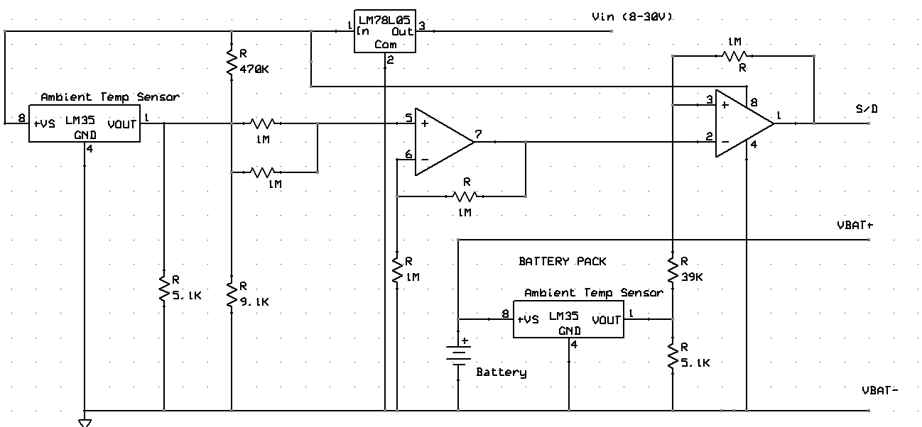
Figure 32 Temperature Detection Circuit (C11)
The temperature will also aid in determining the capacity of the battery as far as its fully charged state. It can also help in knowing when the cells are overcharging based on the temperature too high since when charging nickel metal hydride cells heat up with its exothermic reaction [C11]. A fast constant current source is used in charging the nickel metal hydride cells, and the time it takes to fully charge will depend on the amount of current as well as the capacity of the battery. A buck converter can be the constant current source in order to charge the battery. It is critical to charge the batteries safely and in the appropriate manner. In order to charge the batteries safely an end of charge circuit will be implemented to detect when the battery system is fully charged. The main ways to detect such a state would be by voltage, temperature and a timer. Obviously the voltage of the battery can be obtained and assist in determining the state of the battery. Likewise, as discussed earlier, the temperature of the battery will aid in determining that the battery is fully charged based on a certain temperature range that can be triggered by either a temperature sense resistor configuration or a digital one pin temperature integrated circuit. The timer is implemented within the programming of the PIC so that if one of the previous checks fail, either voltage or temperature detection, then the timer would kill the charging of the battery so the battery will no damage.

Efficiency of Unit

An integrated circuit that can manage the power throughout the charging system and safely run the batteries is a fundamental element in the construction of the system. Especially for this portable device the optimum use of the battery is critical. Multiple functions might have to be implemented to ensure efficient use of power from the battery unit. The essential power generated from the solar panels has to optimize as well to charge the unit. An example of the functions the system will implement is Switched-Mode Power Supply (SMPS), which is applying zero voltage and zero current switching to reduce the switching losses and increases the efficiency of the system by transferring the energy to the battery.

The UCF runs a variety of elements to effectively power electronics for the user. The Figure 33 below describes in better detail the level of construction included in a battery pack to maximize the battery system. The figure depicts the basis for the layout of the circuitry necessary for the battery unit to detect the impedance of the cell pack. The specific integrated circuits for the entire system are discussed in a later section. An example was discussed in the design by Sihua Wen at Texas Instruments which included three integrated circuits. The example is a great reference point for the use of impedance tracking based system for the unit for increased efficiency.

The Figure 33 below uses three chips from Texas Instruments, a fuel gauge, analog front end, and secondary voltage protector IC, to complete the design. The design is based on a battery pack of cells three series, and two in parallel. The capacity is 2200mAh for the cells. Certain parameters were considered such as charging current is 4A, the termination voltage is 3V, and maximum discharging 4A. The figure also has a fuse which would blow if a secondary voltage is above 4.45V [C8]. The layout would benefit the design of the UCF for measuring efficiency of the unit. Figure 33 below has the analog front end receives power from the battery unit and powers the fuel gauge by way of the low-dropout regulator. The fuel gauge IC would be the leading chip with all the protection firmware. The over voltage protection IC would have a fast response time to speed up the process and work with the fuel gauge and analog front end ICs. The lead chip would arrange the analog front end for fuel gauging scenarios. The fuse would blow if given the voltage becomes higher than the allowed 4.45V within the circuit from the over voltage protection IC.

Figure 33 Li-ion Battery Pack
Source [C8]

There are many battery management system (BMS) integrated circuits available for battery packs. Many work with only a single Li-ion cell however. A few issues have to be addressed for the completion of the device. One issue is the regulation of power in and out of the battery pack efficiently. Microchip technology introduced a bi-directional Flyback power train in order to regulate the power entering and leaving a Li-ion battery pack of 3 or four cells. Using a charging algorithm the system would charge the battery pack with constant-current, constant-voltage, and charge termination capabilities. The system would also include an uninterrupted power source for the use of disconnecting the input power [C10].

The basic principle of charging Li-ion batteries is a constant current/constant voltage process. The battery manufacturer will specify the values of the current I_{cc} and the maximum voltage V. The charge rate in CC modes ranges from 0.7C to 1C, which is related to the allowed current density [C2]. The value of V_{max} depends on the Li-ion battery. In this case, the maximum voltage is 16.8V. It is important for the voltage to be as tightly accurate as possible. For a single Li-ion cell the value of the minimum current is chosen between 0.05C and 0.1C [C2]. In order to terminate the charge two parameters can be used. The use of the charge time (t) it takes to end a charge can be used. However, it is beneficial to use the minimum current to terminate the charge so that the battery is charged to the same capacity at the same temperature and internal impedance.

It can be expressed in percentage of the battery at full charge. It also reduces the time the battery is in constant voltage mode which can improve and extend the life of the battery. This can be an efficient technique of operating the battery pack. The current that flows into the battery in constant voltage mode is determined by the difference between the externally applied V_{max} and the battery’s equilibrium potential. This difference equals the total over potential including the ohmic voltage drop [C2]. As charging continues in constant voltage mode, the equilibrium potential rises based on the state of charge (SOC) of the battery and since V_{max} is fixed the current will drop. When the battery’s temperature and internal impedance remain constant, the total over potential depends on the current and state of charge. So when the charging is always stopped at the same minimum current this will always occur at the same state of charge under the condition of constant temperature and internal impedance. These conditions are significant to the configuration of the batteries properties and performance of the unit. These design indicators are also essential to the algorithm to characterize the performance of the battery and to increase the efficiency of the UCF. In order to regulate the different voltages essential to charging the system, converters and regulators with the necessary breakdown circuits are required. A few ways the design of the portable charger can be optimized is improving the maximum power point technology (MPPT) within the circuit and using an efficient way of capturing all the power generated from the panels with a DC/DC converter or switch mode power supply. Another way to optimize the battery’s performance is by pulse width modulation technology (PWM).

Another aspect of the charging system that can be optimized is the technique of charging the Li-ion battery in the unit by way additional circuitry in order to charge the system faster and with more stability. One way to achieve this is by accounting for the internal impedance within the batteries to maximize the efficiency of the unit. The impedance of the battery can greatly reduce the lifetime inevitably. The basic idea is to increase the constant current mode to the battery in order for the charging time to be reduced. Since Li-ion cells are so greatly affected by undercharge and overcharge problems, the idea for an efficient and quicker charging system would improve the characteristics of the unit. There is a voltage drop between the external voltage and the voltage of the Li-ion battery. So to speed up the charging process, the internal impedance can be matched in order to lengthen the charging the time at the end of the constant voltage mode [C12].

In order to increase the efficiency of the battery system if nickel metal hydride is chosen, the battery pack has to be efficiently charged. The charger could be more efficient by the use of a fast charger controller. Maxim has a NiCd/NiMH Fast Charge Controller IC that would charge from a DC source such as a wall wart. The MAX712/MAX713 requires a DC source of at least 1.5V higher than the maximum battery voltage of the battery pack that will be charged. The chip has a voltage slope detecting analog to digital converter, timer, and temperature window comparator in order to determine charge completion of the battery. The DC source powers the MAX712/MAX713 by the on-board +5V shunt regulator [C19]. The MAX712 ends charging by a triggered zero voltage-slope, while the MAX713 uses a negative voltage-slope trigger method [C19]. The current-sense resistor allows the battery charge current to be regulated while supplying the battery’s load, which is useful for the project. The Maxim can charge 1 to 16 cells, which is plenty for the project. The chip can also supply the battery’s load while charging, which would be the USB load or any device to charge. The project can charge the device as well as the battery from the DC source or wall wart. It can automatically switch from fast charging to trickle charging which increases the efficiency of the unit. Another effective feature of the MAX712 is the very low current draw when the battery is not charging. The current is 5uA at max current draw when the battery charger is not charging, which makes the entire battery system efficient. The MAX712 is an efficient option for the battery charging unit using nickel metal hydride cells.

Other Battery Options

In investigating the best available battery unit for the UCF, individual cells as well as battery packs were considered. As shown in Table 13 below, the websites onlybatteries.com, and batteryspace.com were compared. In order for the battery unit to hold a significant amount of energy it was decided that four cells of the 18650 Li-ion purchased individually or within a pack would be best for the project to charge a variety of devices sufficiently. The voltage of four cells in series would range from 10.8V to 16.8V. The availability was not an issue for onlybatteries.com, in fact overnight shipping was a possibility on the website. As far as individual batteries, cells made by Samsung, LG, Panasonic, and Sony are available with 2200 and 2600mAh. The cost of a 3.7V cell with capacity 2600mAh is $14, so four cells would cost $54 which would be greater than the pack offered on onlybatteries.com. The individual cells would not come with a protection circuit to prevent over charge or over discharge to the battery. A protection circuit could be purchased at an additional cost. Flat cells are also offered online, which would be best for devices that would need a slimmer battery for the housing.

Website | Onlybatteries.com | Batteryspace.com | Batteryspace.com
Battery Type | Li-ion Battery Pack (4 cells) | NiMH Battery Pack (6 cells) | Li-polymer Battery Pack (4 cells)
Voltage | 14.8V | 7.2V | 14.8V
Capacity | 2200mAh | 1200mAh | 2500mAh
Availability | Active | Active | Active
Cost | $50, charger $35 | $16, $15 charger | $65, charger $35
Protection IC | Yes | No | Yes
Fuel Gauge | No | No | No
Table 13 Comparison of Battery Packs

The flat cells however, only have a capacity of 800 mAh and lack the circuit protection as well. Based on the cost and lack of circuit protection, a battery pack would be best for the unit. As compared in Table 13, the battery pack at onlybatteries.com has a slightly lower total cost, yet lacks a fuel gauge which would be beneficial to see if the unit is actually charging. So based on the comparison of the two units, the value of the entire unit compared to that of batteryspace.com is less as shown in Table 13. The nickel metal hydride batteries can be found on these websites for around $20. The NiMH battery pack of 6 cells was found to cost $16 on batteryspace.com, which was significantly less than that of li-ion. The nickel metal hydride battery is less expensive than that of lithium ion for the battery as well as the charger. The charger can also be made using simply a DC wall wart which is discussed in detail later. In general, the nickel metal hydride design consideration benefits both the cost and engineering aspects of the project.

Design

After careful design considerations and countless hours of research on the topic of the best batteries for the project, it was decided that the NiMH battery pack would be the most effective of the choices. Even though the research has been very extensive into the topic of li-ion, the decision to change the battery to nickel metal hydride benefits the project. The complete design consisted of a thorough consideration between complexity and efficiency toward the overall project. The project is still made efficient by use of fast-charge controllers and efficient voltage regulation.

Batteries

It was decided to use nickel metal hydride components for the system for a lower cost, lower maintenance and good energy density which will all be beneficial to the project. Some reasons as to the decision to use nickel metal hydride instead of the lithium ion battery system options are cost of materials, complexity of circuit precautions, safety, and efficiency. Li-ion batteries do offer higher energy to weight ratio than nickel metal hydride however; the other main issue was the voltage generation of the kinetic generator. Under testing conditions the kinetic generator could not match the voltage levels necessary for the larger of the batteries. The decision was then to lower the capacity of the battery as well as change the battery cells due to the strict charging procedures associated with lithium ion.
Even though there could be addition measures in order to proceed with the lithium ion chemistries, the overall benefit of the batteries are eliminated when dealing with less peak voltage. There is little weight issues with such a change in design. The weight is not a concern with the design since the solar cells are light in weight, and the kinetic generator is not heavy. The hinges along the ends of the project makes up most of the weight along with the battery system. Since the circuit protects the cells from overcharge and over discharge, it can reduce but not eliminate the danger in working with such components. The project is now more efficient as well as safer since, if the lithium ion cells were not charged properly, the threat of a cell exploding could not be an option. The overall design of the charging circuit helps take into account such methods of safe charging as temperature, voltage detection, and a safety timer interrupt will disconnect the charging of the battery if necessary. A 2A fuse is included in the design of the UCF, which will add another layer of safety for the circuit and user. The battery which was chosen for the UCF internal battery is a 7.2V 1200mAh NiMH which is shown below in Figure 39. The battery pack measures a little over four inches and is mounted below the circuit of the UCF. The battery pack fits on the opposite panel of the LCD screen when the UCF is opened.

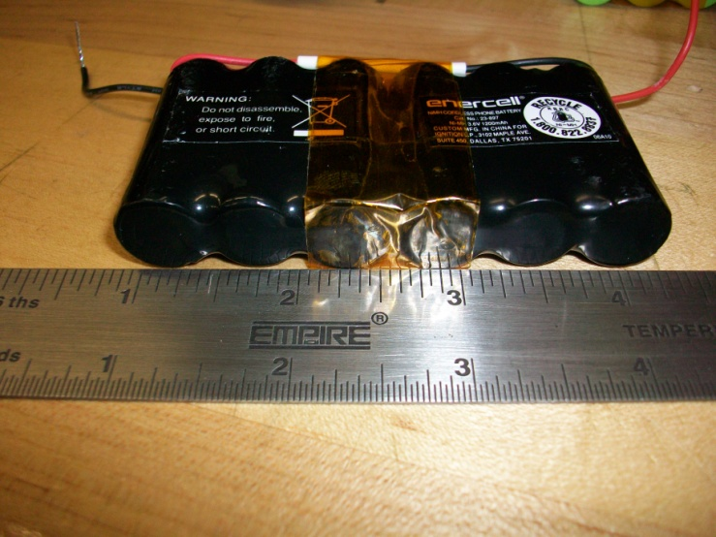
Figure 34 Internal NiMH Battery

The internal battery chosen for the UCF came at no cost thanks to coworkers. The battery which is 1200mAh is estimated to charge in three hours while the UCF is in fast charge mode. Since the UCF will take over three hours to charge the 1200mAh battery, a 600mAh NiMH battery pack will be tested to prove the fast and trickle charge modes of the charging circuit. The testing of the batteries will be discussed later.

Optimizing Performance

The overall design of the product is to be efficient not only in the power generated from the solar panels but also the energy from the battery to be sufficient to the output USB port. In order to optimize the performance of the power to the devices via the USB, certain mechanisms must be considered. One component that is critical to the design of the battery charger is a converter of power to make sure the port is receiving the necessary 4.75-5.25V required for the USB driven devices. Preferably, the battery should power 5V exactly out to the devices. The DC converter is a switching regulator for the 5V output of the USB. The battery will hold a charge of around 6-8V which is higher than the 5V necessary. So an efficient way of stepping down the voltage is required for the design of the UCF. Various DC converters can be purchased which are linear and are sufficient for voltage levels which are not much higher or lower than the needed output. However, the excess energy is given off as heat and will not be efficient using such a high initial voltage. So another design of the converter is essential to the product. Given that the power efficiency is

Efficiency = $\frac{Psystem}{Pconverter+Psystem}$,

and some converters can have as much as 10% to 40% inefficiency, it is crucial to the project that the entire system be as proficient as possible.

Since it was decided to use nickel metal hydride cells place of li-ion, the MAXIM 712/713 Fast-Charge Controller for NiMH batteries was chosen for its efficiency and many advantageous features. The charger could be more efficient by the use of a fast charger controller. Maxim has a NiCd/NiMH Fast Charge Controller IC that would charge from a DC source such as a wall wart. The MAX712/MAX713 requires a DC source of at least 1.5V higher than the maximum battery voltage of the battery pack that will be charged. The chip has a voltage slope detecting analog to digital converter, timer, and temperature window comparator in order to determine charge completion of the battery. The DC source powers the MAX712/MAX713 by the on-board +5V shunt regulator (C19). The MAX712 ends charging by a triggered zero voltage-slope, while the MAX713 uses a negative voltage-slope trigger method [C19].

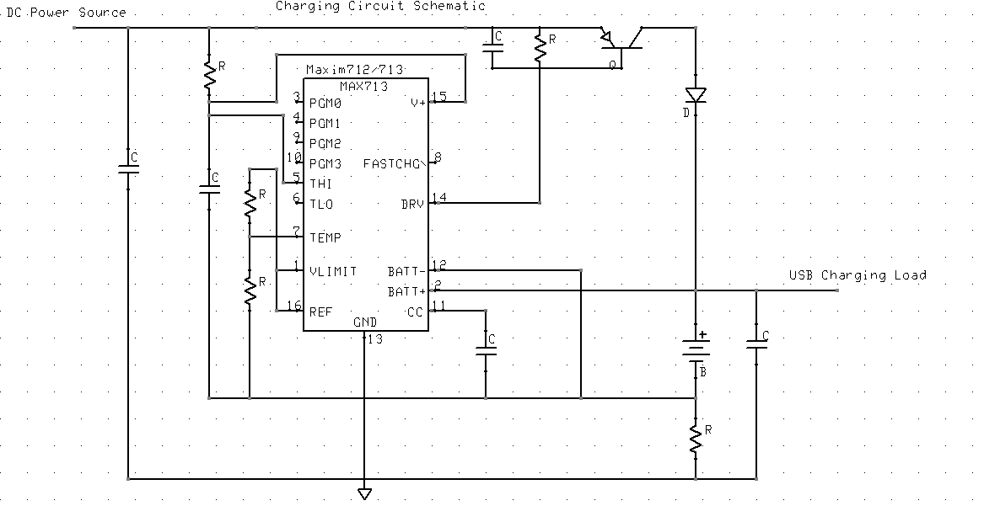
Figure 35 Charging Circuit Source [C19]

The current-sense resistor allows the battery charge current to be regulated while supplying the battery’s load, which is useful for the project. The Maxim can charge 1 to 16 cells, which is plenty for the project. The chip can also supply the battery’s load while charging, which would be the USB load or any device to charge. The project can charge the device as well as the battery from the DC source or wall wart. It can automatically switch from fast charging to trickle charging which increases the efficiency of the unit. Another effective feature of the MAX712 is the very low current draw when the battery is not charging. The current is 5uA at max current draw when the battery charger is not charging, which makes the entire battery system efficient. The MAX712 is an efficient option for the battery charging unit using nickel metal hydride cells.

A fast constant current source is used in charging the nickel metal hydride cells, and the time it takes to fully charge will depend on the amount of current as well as the capacity of the battery. A buck converter can be the constant current source in order to charge the battery. It is critical to charge the batteries safely and in the appropriate manner. In order to charge the batteries safely an end of charge circuit will be implemented to detect when the battery system is fully charged. The main ways to detect such a state would be by voltage, temperature and a timer. Obviously the voltage of the battery can be obtained and assist in determining the state of the battery. Likewise, as discussed earlier, the temperature of the battery will aid in determining that the battery is fully charged based on a certain temperature range that can be triggered by either a temperature sense resistor configuration or a digital one pin temperature integrated circuit. The timer is implemented within the programming of the PIC so that if one of the previous checks fail, either voltage or temperature detection, then the timer would kill the charging of the battery so the battery will no damage.

Voltage Regulator

An extremely efficient way of utilizing the energy from the solar panels is a critical portion to the design of the battery charger. The energy generated from the solar panels must be completely stored by the battery system. One way of maximizing the power of the energy generated by the panels is to regulate the voltage from the panels. Since at different points in the day the panels are generating different voltage levels, it becomes important to feed the battery system with energy to store. An efficient voltage regulator can be useful in the design of the battery system to optimize the power to the battery. The regulator assists in the effort to maximize the performance and limits the safety hazard from the battery system. By not allowing the battery system to overcharge or drain too much energy at one time, the regulator improves the lifespan also of the battery pack. Efficient use and reliability from the product is important to the user.

The charging unit ensures that optimum use is made of the energy inside the battery to power the portable products. It also has to minimize the risk of damage to the electronic device, hence reliable. The inputs of the system are wall charger and solar and kinetic energies. The system has a USB connector which is used to easily connect an mp3 player, camera or any such device for charging. The cigarette lighter could be used to power a variety of electronics such as GPS navigation units and any cell phone with a cigarette lighter adapter. The output is connected to the top of the unit while the input is located on the bottom of the device. In order to ensure an efficient and reliable product, the right battery is critical.

USB

The charging unit outputs the necessary 5V required to power a USB port to many devices. The circuit necessary consists of the 5V output as well as the sufficient current of between 100mA-500mA in order to successfully charge a device. A prototype layout of the USB output port is shown below in figure 41. The 5V regulator is supplying the voltage needed for the circuit and the resistors are specific values in order for the data lines D+ and D- to be around 2.5V and 2V respectively. The data lines are D- and D+ for the USB which has voltage lines of 5V, 2.5, 2 and 0V. On the UCF, the output of the USB has only the power and ground ports which were successfully used in charging many USB devices.

In order to better improve the design of the USB port, the data pins could have been connected with four resistors of a certain resistivity in order to power the data pins of the USB port for other electronic devices which require power to the pins. Other modern electronics such that require a computer USB power with power on the data pins will rarely work without such a design. The USB port is a single female adapter that has the four pins associated with the housing of the component along the back of the housing. The pins were soldered from the back of the USB port to the power and ground wires that were designated for the USB on the circuit board. As shown in Figure 41 below, the USB port is mounted flush on the bottom of the UCF near the LED and DC adapter. Any place else would not have been ideal since all the input and output ports enter from the bottom of the UCF. The USB port is lightly glued in order to secure the component to the housing of the UCF. Figure 41 below shows the UCF prior to completion however, the USB port is shaped. The connection and the placement of the USB component are very secure and have been thoroughly tested.

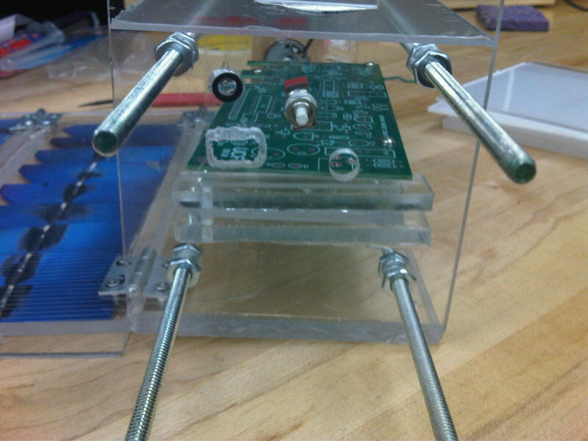
Figure 36 Bottom view of UCF

The USB port is securely mounted onto the bottom housing of the unit for easy access and for the visibility of the LED once the UCF is plugged in. The LED is mounted above the USB port near the push button of the UCF for ease in noticing when the unit is fast charging or trickle charging. The construction of the USB port was tedious. However, the end result proved to be worth the time and effort.

Solar-Cells

The PV Module

Photovoltaic systems are built around the photovoltaic cell. The average photovoltaic cell produces less than 2 watts and close to .5 volt dc, therefore cells must be connected in series or parallel configurations to produce enough power for high power applications. Cells are configured into modules and modules into arrays. Modules can have peak output powers from a few watts, which will be close to the UCF PV output power, to more than 300 watts, depending on the intended purpose. Array outputs are in the range of hundred kilowatts to megawatts. The cells in UCF will be arranged in series to maximize the output voltage. The desired battery voltage will be 12V-14V to reduce the need for a DC to DC converter for the 12V output.

The design goal for the UCF solar module is to connect a sufficient number of cells in series to keep V_{m} within a suitable range for the battery voltage under conditions of average irradiance. Matching the output voltage of the PV module to the battery voltage will allow for the output of the module to can be maintained close to maximum as possible. In a full sun environment, V_{m} should be near the battery voltage of 12-14 volts. Since V_{m} is about 80% of V_{oc}, this indicates that the design of the module should have a V_{oc} of about 17.5 volts. Using single cell silicon PV, the open circuit voltage is in the range of .5 to .6 volts. With this module design approximately 36 cells would be needed. With contact resistances and diode back flow protection an additional loss of 1 volt should also be included. The series design with reverse current blocking diode, DIODE TVS 18V 500W AXL UNI 10%, is shown in the Figure 38 below. The circuit shown uses a 20V source is approximately %10 greater than the ideal voltage which is achieved.

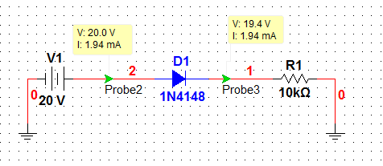
Figure 37 Circuit Diagram

Due to size considerations the maximum available space for PV cells will occupy an area of approximately 800 cm² and therefore have a max power potential of 80 watts with 1AM. The maximum efficiency of the current technology PV cells is in the 30-40% range and a commercially available PV cell is in the 10%-25% range. The amount of current and voltage available from the cell depends on the amount of light available. For the ideal case, the I-V characteristic equation is

$$I=I_{l}-I_{o}(e^{\frac{qV}{kT}}-1)$$

Where $I_{l}$is the component of the cell current due to photons, q is 1.6x10⁻¹⁹ and k=1.3x10⁻²³ j/K and T is temperature in K. The I-V characteristics of actual PV cells can differ somewhat from the ideal version the real may be compared to the ideal determine the performance limits on the PV cells.

When the carriers are produced in semiconductor material, the p-n junction separates them. The buss bar contact is on the light side of the wafer and can be seen below. On the opposite side of the wafer is a solid contact. During transit the photo generated carriers overcome the sheet resistance of the p-n junction top region (image below), then the contact resistance between the n-type semiconductor and the busbar and the resistance of the metallic contact strip The resistances of the strip, the base region, and the contact resistance are in series with the external load. It is intended in this type of solar cell for the resistances of the busbar and back contact not to impede power production and is kept to a minimum to maximize current flow. Each system of p-n junctions and contacts can be considered a voltage source, and when the entire cell is viewed, the multiple systems are voltage sources connected in parallel. This is useful when considering the wiring of a solar module.

Due to the construction size limitations of the UCF, it will be necessary to trim down the solar cells purchased in order to fit the desired form. The available solar cell dimensions are greater than the available area which individual cells will be placed. The solar cell below, Figure 39, can be considered as a multitude of solar cells connected in parallel. As a rule, the distribution of illumination within the solar cell considered uniform and therefore each cell will produce relatively equal current from cell to cell. The change in cell size will reduce the current output, but voltage output will remain that of a whole cell. Cells will be also cut down to fit around hardware devices such as hinges or locking mechanisms.

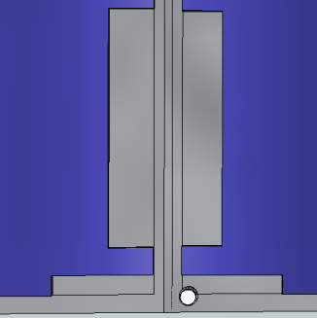
Figure 38 Cut-out Section of PV Cell Source: [S2]
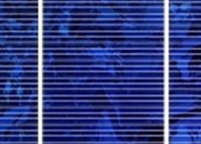
Figure 39 Multicrystalline Solar Cell with 2 Bus Bars Source: [S2]
There will be a total of six separate surfaces which will be available for placement of solar cells for the construction of the UCF module. The six panels will consist of approximately six equally sized solar cells connected in series. The six-panel assembly is shown below.

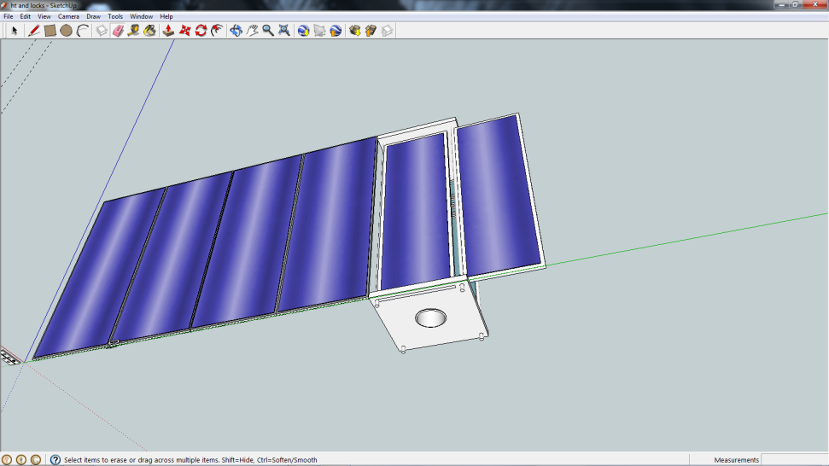
Figure 40 Six Solar Panels Fully Deployed

Physical Construction

Attempting to maximize the surface area available for the PV module will be the basis for the physical design of the UCF. The protection of the PV cells during transportation will need to be considered to prevent damage. The material used as a backing/heat sink for the PV modules will need compromise of strength and thermal conductivity. Enclosure will need to have proper ventilation to prevent overheating of circuitry and allow for a light sprinkle of rain without damage of the unit. Cost along with the ability to fabricate parts will also be a factor in choosing the design. Shown below in Figure 41 is the original conceptual rendering of the UCF.

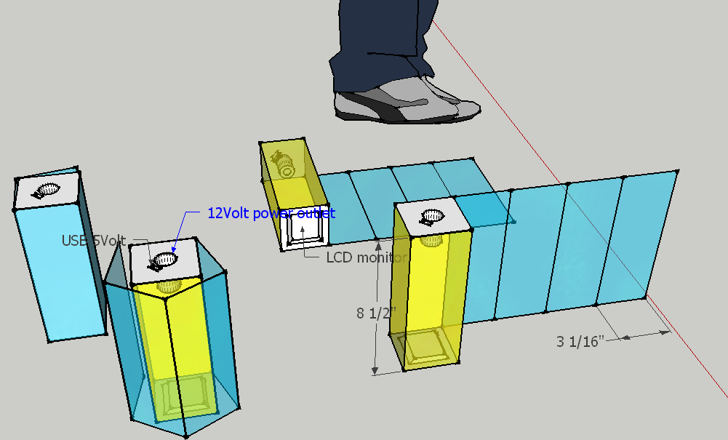
Figure 41 Conceptual Rendering
The design is based on an elongated box of dimensions 19cm x 7.5cm x 7.5cm. All power connections would be on the 7.5cm x 7.5cm square face on one end while the LCD would be on the opposite 7.5cm x 7.5 cm face. The longer surfaces would be covered by the folded or retracted solar panels facing inward. While in storage mode or traveling mode the user would see the backing to the PV cells which would be a durable protective material. The cells will wrap around the enclosure that houses the other electrical components. When the PV cells are opened up and away from the enclosure, 1 of the 4 surfaces of the enclosure will have a PV cell surface as well. Hinges will connect the PV surfaces together. A locking mechanism will be needed at each hinge in order to allow for all surfaces to face the direction required for maximum solar absorption.

The external surface and backing to the solar panels will be a finned heat sink chosen for its durability and heat transfer characteristics. The heat sink would be the connecting point for the hinges, to minimize the stress on the PV cells.

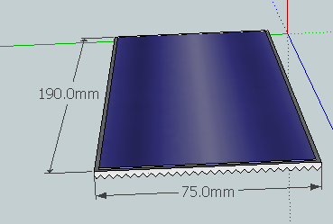
Figure 42 Solar Cell Size
The hinges that connect the 4 PV panels together and to the housing will need to be small and sturdy. Having one long hinge along each joint may increase the difficulty of installation, but may become a make it easier to lock into place. A multiple smaller hinge per joint configuration would allow for easier alignment when connecting the wires from one panel to the next. The hinges will be attached with either threaded fasteners or rivets. Rivets are used widely with thin aluminum in aircraft, but removal is more difficult than the threaded. Threaded fasteners have a tendency to back out if a locking device or locktight is not used. The hinges below are an example of what will be used.

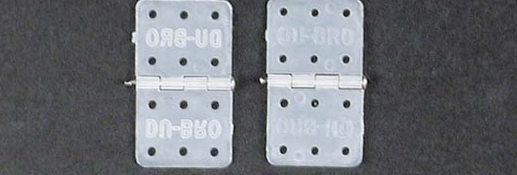
Figure 43 Hinges
Similar hinges to those shown would have to be cut down to use only the holes closest to the lynch pin, otherwise the second set of holes if connected with fasteners would interfere with the PV cell. Hinges with only 4 holes were found for use.

To connect one photo voltaic to the next by flat copper strips rolled copper 20 x 500 mm. The strip will be soldered along the length of the bar collector of each photovoltaic cell and then be soldered to the bottom electrode of the next cell. After each panel is assembled a test of the resistance will be made to ensure all contacts are sufficient to meet the desired level of conductivity determined by design specifications. At the start and finish of each column of cells an insulated 16 gauge braided copper wire will be electrically connecting the individual panels together. Finally the cells will be wired into the base unit and connected to the battery.

Each panel will have solar cells arrayed in a manner that will allow for the top or bottom of the panel to act as positive or negative. The six panels will be placed side by side similar to the layout as would be displayed to the sun. The starting panel positive and negative choices are not specific as long as the next panel in series is the opposite. This arrangement will minimize the need for excessive wiring and thus added unwanted resistance. The figure below depicts the six individual panels as voltage sources which will be connected in series as required. Wire, 16 AWG, will be attached the underside of the last cell on each panel to connect to the first cell on the next panel. The photovoltaic solar cell polarity alignment is shown below in Figure 44.

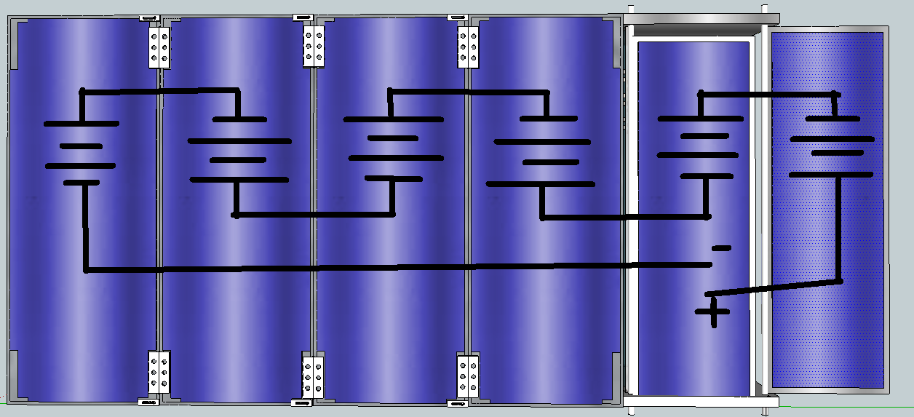
Figure 44 Solar Cell Polarity Alignment Source: [S2]

To allow for the ridged structure required for maximum solar absorption the hinges will have to lock into place. This can be done by a backstop hinge or some added locking mechanism. With the goal of the UCF being portable, a minimal amount of external devices should be attached. If any locking device is able to catch on fabric or a strap then it increase the possibility of becoming a hazard. Below are various mechanisms which would be useful in locking the hinges into place.

To improve the user friendliness of the device, the locking devices should be attached in such a way as to minimize the operation time. When setting up the device there will be no hurry in engaging the locking mechanisms, since solar power is not immediate as something like power from the wall. Collapsing and stowing the UCF may need to be performed in a timely manner if the need arises. The current design of the UCF does not require or desire a feature of water resistance and there for in the event of rain a rapid removal of that environment would be required. The locking devices below would be disengaged by sliding them away from the base. To collapse the solar panels it would be required to hold the base and slide finger and thumb along the panel edges, which would disengage the locking devices, then fold the panels around the base. The locking devices and hinges are shown below in Figures 45 and 46.

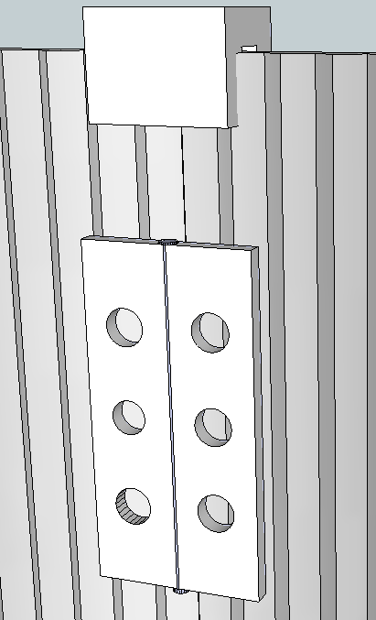
Figure 45 Hinge and Locking Clip
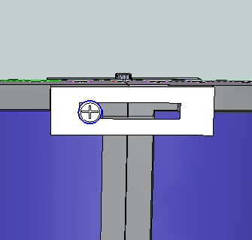
Figure 46 Sliding Lock

A clip that slides back and forth to bridge the gap between panels would lock them into place. The slide which is attached with the same fastener that the hinge is connected with could be slid into place when the panels are in the proper position for solar collection. The sliding lock will only work if the hinge is on the same side as the PV cells.

The sixth panel which will not be attached to another cell with hinges but attached to the UCF base with a hinge will have a spring loaded hinge. To prevent unwanted release of the sixth panel a clip will be attached to the base and fasten the non-pivoting for storage. The spring in the hinge will be a simple coil with extended ends similar to that of a clothes pin which will force the panel out and away from the base while pivoting next to the adjacent panel.

The retaining clip will be on the end of an elongated metal strip which will allow a spring like action, thus allowing for ease of deployment. The clip can be disengaged with the press of a single finger.

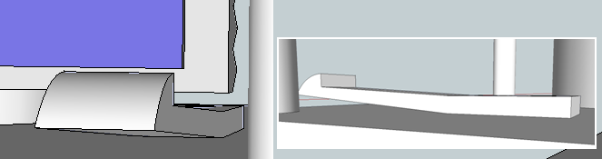
Figure 47 Panel Retaining Device

The base of the UCF will provide structural support, contain and protect all the wiring and electrical components. It will consist of (4) 7/16 inch threaded bolts connecting (2) 7.5x7.5 cm plates. Each plate will contain different components of the UCF. Seen below is the connection for the hand crank and the power I/O’s in Figure 49.
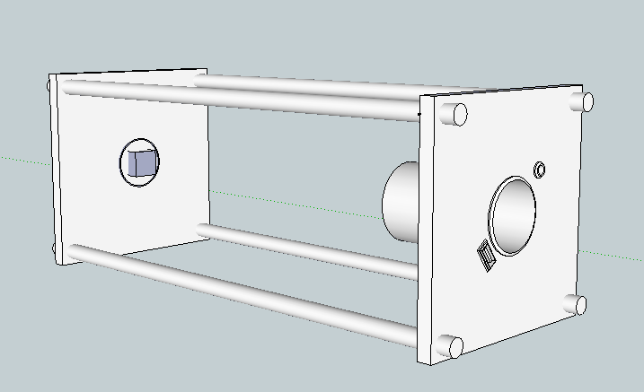
Figure 48 Base Unit of the UCF

Heatsinks

Below are two choices of heatsinks which are currently available. These choices were determined, from a list of more than a dozen from each company, by the desire to have the fin height as small as possible while maintaining a good thermal performance. The companies were chosen for colors, anodized black and gold chromate, available for the heat sinks, since plain metal does not have as high an emissivity as the coatings available and black and gold are already known as the colors for UCF. A chart below provides technical specifications of the two heat sink choices. Cross sections of the individual heat sinks with dimensions are provided below in Figures 49 and 50.

Company Available (Y/N) | C&H Technology, Inc. (Y) | AAVID Thermalloy (Y)
Part Number | CHEH3040 | 61585
Width | 3.932 in | 3.86 in
Height | 0.590 in | 0.300 in
Base Thickness | 0.160 in | 0.060 in
Weight | 1.41 lb/ft | 0.70 lb/ft
Thermal Performance | 2.30 ºC/W/3in | 3.47 ºC/W/3in
Perimeter | 22.56 in²/in | 20.2 in²/in
Table 14 Heatsink Technical Specifications
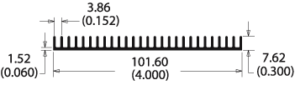
Figure 49 AAVID Thermally Heatsink Source: [S3]

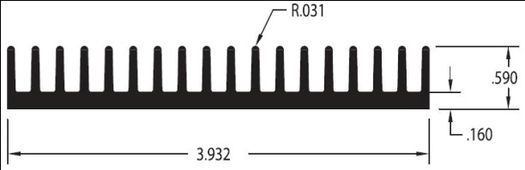
Figure 50 C&H Technology, Inc. Heatsink Source: [S3]

The strength of both choices for the photovoltaic backing heat sink will meet the desired ruggedness characteristics of the UCF. With the goal of maintaining a low profile and minimal size the heatsink made by AAVID Thermolly will be chosen. The low profile of this heatsink meets the desired heat removal capabilities. The temperature gradient diagrams of AAVID Thermolly heatsink part number 61585 are shown below. The maximum power delivered to the surface of the photo voltaic cells, assuming an ideal scenario in which the entire surface is covered with PV cells, on one panel will be 14.25 watts. The amount of that power which is converted to electricity will be 2.4 watts with a 17% efficiency. Using the emissivity of silicon, the amount of radiated heat from the surface, 5 watts at 312 K, will reduce the power required to be transferred to the heat sinks. The approximate amount of power which will require dissipation from the solar panel will be 7 watts. Looking at the graph in Figure 51 below the Heat Sink Temperature Rise is within acceptable limits for the difference of temperature, 12 C, for power dissipated, 8.5 W.

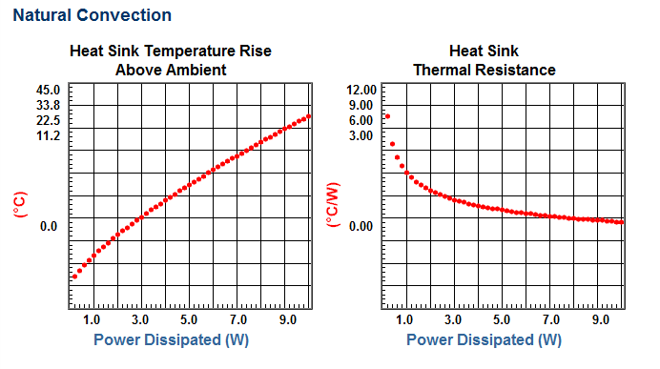
Figure 51 Heat Sink Performance Graphs Source: [S3]

Protecting the Solar cells

The cells mounted onto the panels will be protected from scratching, cracking or contact with an abrasive or corrosive, material. The protective shield must be chosen for long life in the presence of ultraviolet radiation as well as possible corrosive substance from the environment. A thin clear anti reflective material will be attached to the panels, with the use of the hinges as retaining devices. The material will be plastic or vinyl and easily replaceable.

Solar Cell Options

Monocrystalline and Multicrystalline are the solar cell options. Both cells have 156 mm widths which will allow for separating them into 2 equal pieces which will fit on the panels. Each PV cell has 2 buss bars which will be used to provide contact points for the conductors to be soldered. Each type of silicon photo voltaic has different performance values as seen in Table 15 and 16.

Model | Efficiency Eff (%) | Power Ppm (W) | Short Circuit Current Isc (A) | Open Circuit Voltage Voc (V)
156-18.0 | 17.9-18.1 | 4.28-4.32 | 8.79 | 0.624
156-17.8 | 17.7-17.9 | 4.23-4.28 | 8.71 | 0.623
156-17.6 | 17.5-17.7 | 4.18-4.23 | 8.67 | 0.622
156-17.4 | 17.3-17.5 | 4.13-4.18 | 8.64 | 0.620
156-17.2 | 17.1-17.3 | 4.09-4.13 | 8.60 | 0.619
Table 15 Monocrystalline PV Cells by source: ARTIsun Series Source: [S3]
Model | Efficiency Eff (%) | Power Ppm (W) | Short Circ. Current Isc | Open Circuit Voltage Voc
CISF195SB4075SP | 17.2 | 4.075 | 8.37 | .624
CISF195SB4025SP | 17.0 | 4.025 | 8.33 | .623
CISF195SB3975SP | 16.8 | 3.975 | 8.29 | .622
CISF195SB3925SP | 16.6 | 3.925 | 8.24 | .621
CISF195SB3875SP | 16.4 | 3.875 | 8.20 | .620
CISF195SB3825SP | 16.2 | 3.825 | 8.15 | 618
CISF195SB3775SP | 16.0 | 3,775 | 8.10 | 617
CISF195SB3725SP | 15.8 | 3.725 | 8.09 | 616
CISF195SB3675SP | 15.5 | 3.675 | 8.08 | 615
CISF195SB3600SP | 15.2 | 3.600 | 8.07 | 615
CISF195SB3500SP | 14.8 | 3.500 | 8.06 | 614
Table 16 Multicrystalline PV Cells By Isofoton Solar Cells Source: [S3]
With the comparably high efficiency of multicrystalline photovoltaic solar cells the added expense or purchasing single crystal photovoltaic, for an increase of less than 1%, solar cells cannot be justified.

Build-Photovoltaic Module

There are several steps which can be performed in parallel and several that will require series assembly. The first step should be cell preparation to be placed on the heat sync. Second the heat sync preparation for receiving the photovoltaic cells and the connecting hinges and locks. Third process will require placing the photovoltaic cells on the heat syncs. Fourth assembly of the base with placement of some of the internal components and fixed photo voltaic cell, no hinges. Fifth step will be to connect the hinges to the heat syncs and test each panel followed by connecting all wires to the adjacent panels and to the base unit.

First cell preparation, the collector bar will need to connect to a conductive strip. The photovoltaic cell surface and collector bar is covered with anti reflective and corrosion resistant film, which needs to be removed to allow for connection of the conductive strip. To remove the film from the conducting bar and only the conduction bar special precautions will need to be taken. To protect the film on the silicon surfaces a rigid covering will be placed over them. To remove the film sandpaper can be placed on the end of a flat head screw driver or the sand paper can be folded to create an abrasive edge which is fine enough to grind or sand away the film in unwanted areas. After the surface has been sanded the dust should be removed using the acetone, methanol, and de-ionized water method. Wearing latex gloves to prevent further contamination, over a sink acetone should be applied liberally to remove any unwanted oil or debris from the desired contact surfaces, followed by methanol, and finally by de-ionized water. It is important to thoroughly dry the surface prior to soldering, which will greatly improve the contact. The copper strip should also be cleaned using the acetone, methanol, and water method. Using a soldering iron and solder, the copper strip should be placed along the length of the conducting bar with and equal length plus 5 cm hanging out over the edge of the cell. This process will need to be performed for every photovoltaic cell that is to be used in the module. This method not only ensures a good contact, but also ensures that the Arctic Silver Adhesive, which will be used to attach the photo voltaic cells to the aluminum heat sync, will have a clean surface to adhere to. A measurement of the resistance will be taken and recorded, with an ohm meter, to determine if any of the cell contacts are below standard.

Second the heat sync preparation will be required after cell preparation. The aluminum heat syncs will come in a in a single sheet of aluminum. A table saw or a band saw will be used to cut the aluminum to the desired dimensions, (4) 190 x 75mm and (2) 179 x 60mm. When all the panels are cut, they will be fitted together without fasteners ensure all tolerance is within acceptable limits. With the panels laying on a flat surface, arranged in the module layout, the hinges, mounting and locking devices will be placed onto the panels and outlined with some type of marking device, preferably erasable. Once all of the layouts are mapped onto each of the six panels, holes will be drilled as necessary. With the holes drilled for attaching the various items, the aluminum heat sync will be painted with a flat black paint on the finned surface. The holes will need to be freed of any interference that may have accumulated from the painting or debris. Cleaning of the flat polished aluminum surface will be done with the acetone, methanol, and de-ionized water method in preparation for the Arctic Silver Adhesive. The hinges, locks, and mounts will be attached to the panels with metallic or nylon fasteners as appropriate. The panels which will be folding around the entire UCF, four 190X75mm aluminum heat syncs, will be attached to one another. The complete panel assembly with locks disengaged is shown below in Figure 52.

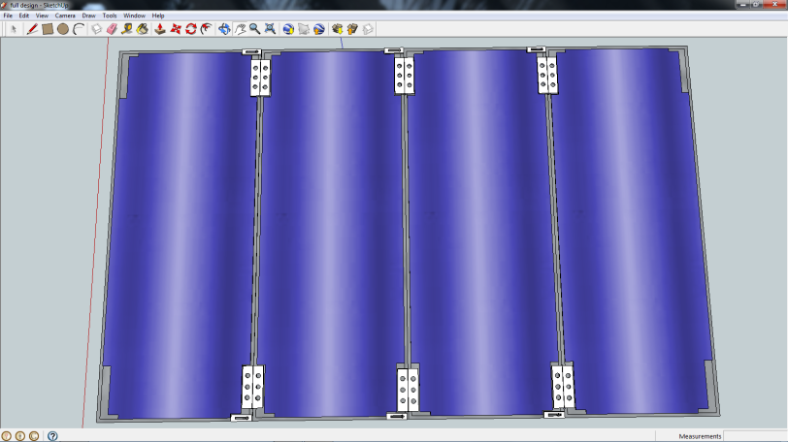
Figure 52 Complete Panel Assembly

Third process will require placing the photovoltaic cells on the heat syncs. A dry run and fitting will be performed on all panels to ensure that the maximum amount of available space is used.

Caution: The PV cells will need to be arranged as to alternate the positive (+) and negative (-) ends of each panel to minimize the amount of wire needed to connect each panel in series. See figure in the design section.

The photo voltaic cells, which require trimming in order to fit around the locks and hinges, will be marked as necessary. A scribe or similarly sharp metallic device should be used to etch the lines along which the cells will be broken. If a saw able to make the appropriate cuts is available then that should be used, otherwise the photo voltaic cells will be placed along the edge of a flat surface with the undesired material hanging off. Application of pressure downward on the entire surface will cause the cell to fracture along the line etched into the surface. The cell will then be re-fitted on the panel to ensure a proper fit. The copper strips which are attached to the bus bar will need to be soldered to the backs of the photo voltaic cells, where the electrical contacts are. The cells are connected in series so the bus bar of one cell will be connected to the back of the next cell, positive to negative. All cells which will be placed onto each panel should be connected in this manner. The excess material from the copper conducting should be cut away to avoid overhangs, minimizing any possible shorting occurrences.

Negligible electrical conductivity: Arctic Silver Thermal Adhesive was formulated to conduct heat, not electricity.

NOTE: Even though Arctic Silver Thermal Adhesive is specifically engineered for high electrical resistance, it should be kept away from electrical traces, pins, and leads. The cured adhesive is slightly capacitive and could potentially cause problems if it bridged two close-proximity electrical paths.

Prior to any application of the adhesive it, a dried drop of adhesive, will be tested with voltages that will exceed, within reason, any values which the UCF will be exposed to, thus ensuring safety of the device and the user. Once the cells are determined to be ready for attachment the Arctic Silver Thermal Adhesive will be applied to the back of all the cells. Multiple dry runs of cell placement should be performed, since the use of the adhesive implies the desire to permanently attach the cell where it is placed.

Fourth step will be assembly of the base unit. The base will consist of 2 square plates with pre-installed electrical components. The plates will be connected with 4 threaded rods approximately 20 cm in length. There will be hex nuts threaded on to the bolts followed by lock washers. The plate will be placed on top of the 4 nut/washer and then on all 4 bolts additional lock washer and nuts will be placed. The single panel which rotates and is connected directly to the base by side swinging hinges, with springs, attached to the square plates at each end. The retaining clip will then be aligned for proper storage of the single swing panel. The four panels connected together which make up the outer housing of the UCF will be connected with similar hinges the square plates as well. The single fixed panel will use L-brackets to secure in place. One L-bracket will be placed near each corner (4) in order to improve over all rigidity. The 4 threaded bolts connecting the square plates with panels in place can be seen below in Figure 53.
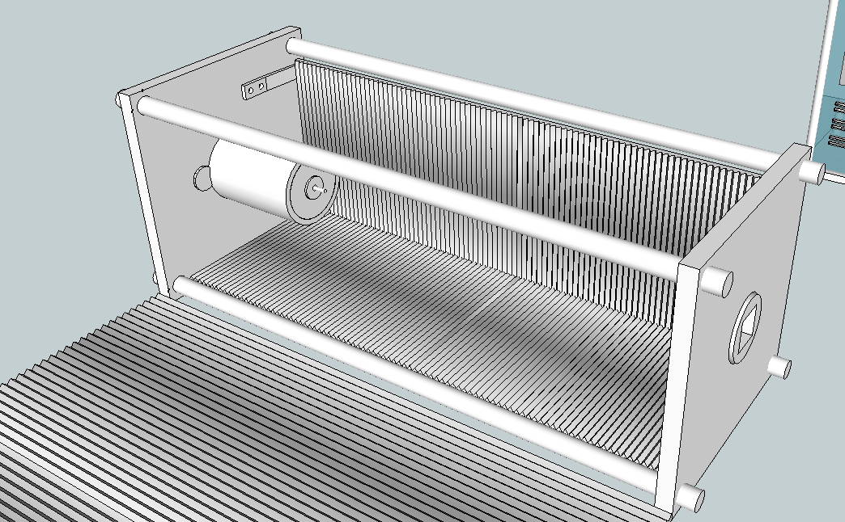
Figure 53 Base Assembly
Mounting of the LCD onto the side plexi glass panel will allow for easy reading and protection of the LCD. Instead of cutting out a section of the plexi glass for the screen to extrude, the LCD will remain behind the glass for protection. Careful fitting will be required to ensure that no wiring is comes into contact with moving peaces or is pinched during tightening of fastening devices. The plexi glass will be connected to the base similar to the fixed solar panel, with L-brackets at each corner. Vents are cut in the plexi glass at available locations to proper ventilation to prevent overheating of the device, which are shown in Figure 54 below.
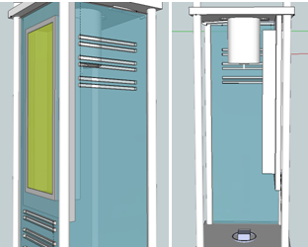
Figure 54 LCD Mounted with 12V Outlet & Side Panels with Vents

Kinetic Generator

Having researched many ways to produce power through human motion or machine motion, a decision on which type of generator to use in the UCF needs to be made. As stated earlier in the Goals and Objectives the ease of use to the user is going to take a slight priority over the actual power output. This is because the main output of power is going to be coming from the solar cells and the kinetic generator is only going to supplement the solar cells. The goal of creating a unit which can be easily used has narrowed down the possibilities of generators which can be used. The piezoelectric generators that were attached to the soles of shoes were promising with articles showing excellent results for power output, but the ease of use to the user would be forfeited and in violation of our goal. The same goes the bicycle pedaling generator which showed extremely promising results, but the fact remains that the generator must be attached to the bike, assuming the user has a bike (if camping or hiking). Some generators that were researched were found not to adapt as well as others to meet the UCF’s goals and needs. There are, however, still a few types which will be further investigated and tested. These generators are: 1) The basic electromagnetic generator consisting of a magnet sliding through a coil in a tube (similar to generator created at Cork University). 2) A modification to number 1, where the enclose for the magnet is in the shape of a circular tube instead of a vertical tube and may contain multiple free moving magnets and 3) a hand crank generator which will be a part of the UCF unit and produce higher amounts of power through the users deliberate action (this is designed as an emergency system for the user in case there are no other current means of producing power).

Hand Crank Generator Implementation

Creating a hand crank generator was a simple alternative to the bicycle pedaling generator. The hand crank was easier for the user to use and the cost per UCF unit was significantly less since only one module needed to be built bypassing the second module that would have been needed to in order to attach to the bicycle wheel, which proves that the hand crank was a better choice for the UCF. The hand crank generator was perfect for emergency situations when no other power sources, such as sunlight or a 110 AC wall outlet, were available.

Final Design of Hand Crank Generator

Many ideas were researched to decide on which type of kinetic generator should be used for the UCF. The simple hand generator, making use of Faraday’s law, proved to be the most efficient and economical choice. The main components needed to construct such a generator are a small DC motor, a gear system working together to jump up the rpm’s of the motor, and a handle so the user can spin the network of gears.
The gear ratio of the kinetic generator is 12.6. It consists of a handle which connects to a network of four gears. The DC motor is a scrap motor obtained from a surplus store. The final crank produces around 8 to 10 Volts when it is spun clockwise and (-)8 to (-)10 Volts when spun counter-clockwise. In order to power the battery when the generator is spun in either direction, a series of Schottky diodes were added to form a full wave rectifier. Below, in Figures 55 and 56, are two images displaying the sketch up of the kinetic generator and an actual image of the built generator.

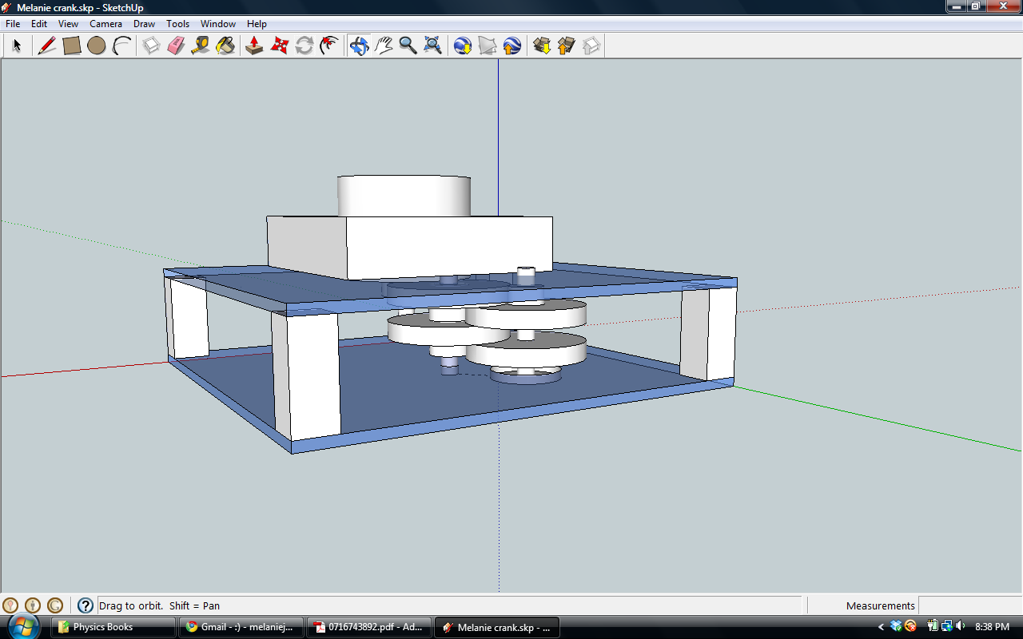
Figure 55 This is a simplified sketch of the design for the kinetic generator using Google Sketch Up Software

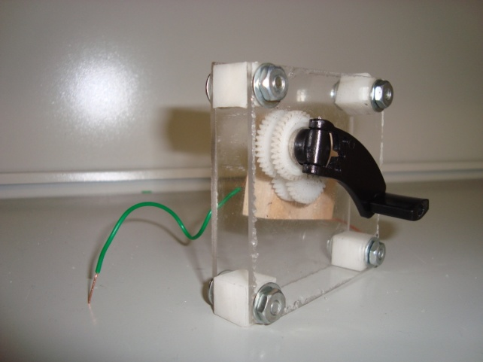
Figure 56 This is the final device used for the kinetic generator on the UCF which was based on the sketch shown in the previous figure.

Microcontroller

As mentioned in the previous sections, the microcontroller of choice is the PIC16F690. A single chip has been implemented into the design, and it will do the following:

- Monitor all three input voltage sources
- Monitor the battery voltage
- Perform analog-to-digital conversions
- Send data to the LCD driver for display

The PIC16F690 operates at 220µA, and in standby it only consumes 50nA. It can operate in ambient temperatures up to 125°C, and was programmed with the mikroC compiler using C code and the PICKit2 software by Microchip to write to the chip. The microcontroller contains functions that perform the following:

- Sample ADC ports and perform conversions
- Send converted values to the LCD driver
- Turn off the backlight after ten seconds
- Read interrupts to turn back on the backlight
- Detect a press-and-hold for the push-button for power down
- Detect a low battery and if so then automatically power down

Display System

The requirements for the LCD display, which were all met, were:

- Low power consumption
- Affordable price
- Clear and easy to read character display
- Sunlight readable
- Minimum of two rows for displaying different values
- Backlight for nighttime visibility

The connections from the MCU to the LCD are shown in Figure 57 below:

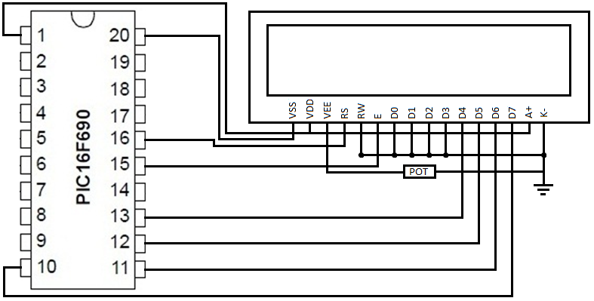
Figure 57 PIC to LCD Connections
As can be seen, only six pins are needed to interface the LCD. Pins D4-D7 are the data pins, which are used to send the data from the PIC to the LCD. The enable (E) and Register Select (RS) pins are the LCD control pins. The Read/Write Not (R/W) pin is grounded because it is not necessary to read from the LCD, only to write to it. And finally, pins D0-D4 are grounded because they are not used in four-bit mode. Four-bit mode is being used because it requires fewer pins, leaving room for future expansion. In four-bit mode, data is sent in nibbles, which is half a byte. First the higher nibble is sent; next, the lower nibble is shifted up four bits and then it is sent.

Interfacing the Board Components

A plan to interface the board components was constructed to conceptually identify how each component will be connected. The solar panel and internal and external power supplies are the sources for power, the 12V automobile accessory port and 5V USB port are the application destination, and the LCD is the data destination. The microcontroller will be receiving the three inputs from the ADCs and using them to display on the LCD either the solar panel voltage and current or the external power supply voltage, and calculate and display the remaining percentage of internal battery life.

The power to charge the user’s device will come from either the solar panel or an external power supply (i.e. wall wart). Both of these will feed into a switch that powers the 12V internal battery. This battery will then go into a switch that goes either to the 12V automobile accessory port or the 5V USB port. The internal battery will also go to a voltage divider (potentiometer) so that it can feed into an ADC, and finally into the PIC microcontroller. The MCU will use the input from the ADC to display the internal battery voltage on the LCD. The solar panel will connect to a voltage divider that will step down the voltage to go into an ADC and then into the MCU to display the solar panel voltage on the LCD. Similarly, another output from the solar panel will go into a two-input ADC that will feed into the MCU for displaying solar panel current on the LCD display. Lastly, the internal power supply leads into a 5V regulator which powers the three analog-to-digital converters, the microcontroller, and the LCD display. Figure 58 below is a block diagram of the previously discussed interfacing.

Figure 58-Interfacing the Board Components

PCB Design

The group will be designing a custom printed circuit board for this project. Whether the PCB will be made or ordered professionally will be decided next semester. Either way, the group has decided not to use a prototype for the final project. The following are some of the key advantages to using custom design PCBs instead of a prototype board:

- Size
- Durability
- Cost
- Appearance

Considering the Universal Charging Friend will be made to fit into a water bottle size side pocket of a backpack, size is an important factor in choosing the manufacturing process. If the group decides to use a custom-printed PCB, the size will be exactly what is needed, and no more. The group can determine the desired size of the board, even odd-shaped boards if necessary, in order to fit the enclosure. With a prototype board, sizes vary, but they cannot just be cut to whatever size is needed. When considering durability, the physical structure of the custom-printed PCB seems to be better-quality than a prototype board. One reason is because on a custom-printed PCB, the copper conductors are bonded to the board, while prototype uses point-to-point wiring. With vibrations, which is bound to happen with the UCF, the point-to-point wiring can become loose. Also, circuit board components are soldered in, which makes it very sturdy, and any add-on holes for screws can make it easy to mount. When considering cost, it depends on the complexity of the design and the quantity as to which method is cheaper. Typically the more boards one needs, the more efficient PCBs seem. If the group goes with a PCB, more than likely two boards will be ordered, just in case one fails. For a prototype board, only one will be necessary because they are more easily accessible. The final consideration is appearance, which may or may not be a big factor considering the board will be mounted inside the device casing. However, tagging along with appearance is optimization, which with a software-designed PCB allows for the best performance and optimization, along with a nice slick look. If a PCB is used, the parts will be equally spaced and the traces symmetric. The overall slick appearance makes the board look very professional, which in a marketing mindset is a big feature. Source: [M12]

The advantages of using a prototype board are:

- Ease of use
- Familiarity
- Ease of repair / design change

Prototype boards are easy to understand and use, and no software is required in designing the board (although it may be used). All of the group members are very familiar with using a prototype board, considering it has been used in all the electrical engineering labs. Also, if wiring needs to be changed or an area gets burned, usually another area of the board can be used instead. With a PCB if a certain area gets burned or damaged, a new board would be needed. Any design changes can also be made after the prototype board has been setup. However, after a PCB has been designed and printed out, it’s too late to make any other design changes.

When looking at making or ordering a PCB, the one benefit of creating the board from scratch is the experience, but the downside is the possible mess-up boards, the time fixing mess-ups, as well as possible reliability problems if even one part is erroneous. This is why the group feels it would be best to not risk a board with possible subtle failures that might present problems later on. However, although some research has been done, more will be done before making the final decision between making and ordering a PCB. The actually PCB design will be completed next semester after more of the project has been completed.

Surface-mount vs. Through-hole

It is important when designing the printed circuit board to choose between surface-mount and through-hole. Therefore it is necessary to consider the advantages and disadvantages of each. Most people who work with electronic boards know that surface mount technology (SMT) has provided many benefits both in the design and manufacturing process for printed circuit boards (PCB). The key element that stands out with SMT is the fact that less space is taken up on the PCB, since the components mounted are both small and can be mounted on either side of the board. Some other benefits of SMT are the weight and electrical noise reduction. Surface-mount components can significantly reduce the total weight of the surface mount assembly, which can weigh as little as one-tenth of through-hole parts. A few more advantages of SMT are reduced propagation delays and package noise from shorter lengths of leads, and increased resistance from shock and vibration due to lower component mass. However, there are some known disadvantages for SMT. Due to the small sizes and lead spacing, manual assembly and repair of surface-mounted boards can be very challenging—especially without proper tools. Also, surface-mounted boards can’t be used with breadboards, meaning each prototype requires a custom PCB. Source: [M13]

The other choice for the printed circuit board is through-hole technology (THT). Some advantages of THT are ease of assembly and soldering. It has been suggested by other experienced engineers that through-hole boards are best for beginners because they are easier to repair mistakes as compared to SMT boards. Through-hole leads have proven to be much more durable than the joints for surface-mount boards. Breadboards can be used with THT, which is what the group members are used to working with, and any design changes can be easily made to the breadboard. Also, the availability and pricing of components for through-hole seem to be better than surface-mount. Some disadvantages of THT are of course real estate on the board because the parts are not as small, and the board will also weigh more. After considering the two technologies, the PCB for the Universal Charging Friend will be a mixture of both surface-mount and through-hole technology. This is because both provide certain advantages and disadvantages over the other.

Final PCB Design

The main objectives of the PCB were size, durability, cost and appearance. The board needed to be small enough to fit inside of the UCF enclosure and be safely mounted to a side panel of the UCF to prevent damage to either the board or the enclosure unit. We also wanted the board to look professional, so it was decided to design a PCB (instead of using a prototype) and have it manufactured by ExpressPCB. The two pieces of software used to design the schematic and the PCB were ExpressSCH and ExpressPCB, both are free and readily available to the public.
It was decided that all the circuitry for the entire project would be placed on one main PCB and mounted safely inside the UCF enclosure unit to consolidate on space. Four large holes can be seen in Figures 59 and 60. These are the holes that will be used for mounting screws. Compromises were necessary when designing this board. An example of this was the fact that an inner main ground plane and +5V power plane were necessary to reduce the number of traces and required space, but the trade-off was paying an increased price on the board. Thicker traces were necessary in many parts of the design due to the high amperage running from the power sources to the battery.
Designing the PCB given the amount of space to work with was a challenge. As stated earlier, an inner ground and power plane needed to be added to the design, which significantly dropped the number of traces needed. Also, the top signal layer of the PCB was used as a separate ground for the battery. The bottom signal layer of the PCB was divided and a section of this bottom layer was used as another separated ground for the wall charging circuit. The final size of the board is 6.50 inches by 2.60 inches. Almost all of the components used on this board are through-hole, and only two components are surface- mount. These two components, the INA-193 current shunt monitors, were only available as surface mount parts. The group decided to use primarily through-hole components since these parts are much simpler to solder onto the board.

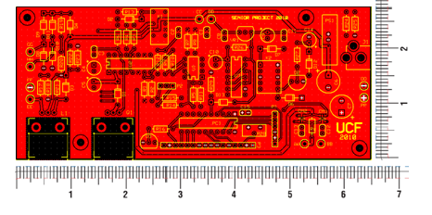
Figure 59 This is the top signal layer of the UCF PCB design as seen in ExpressPCB. This top copper plane is also used as the ground for the wall charging circuitry.

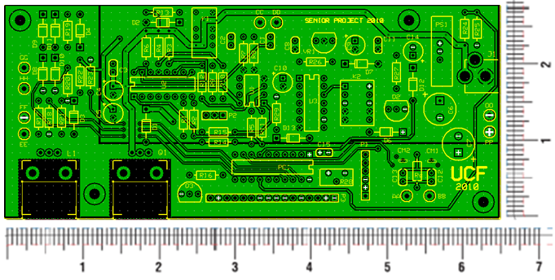
Figure 60 This is the bottom signal layer of the UCF PCB design as seen in ExpressPCB. Note the division of the copper plane used for the Battery ground.

Mounting the LCD

The LCD can be mounted in multiple areas of the device, but some locations are more beneficial than others. The drawing in Figure 61 below shows the desired location of the LCD display on the UCF. If this location does not house the display well enough, then it will be moved to a side panel that can still be viewed by the user without opening the solar panels. To mount the LCD, four holes will be drilled into the corners of the case, and a rectangle will be cut out for the display. A plastic transparent sheet protector or a thin Plexiglas will be used as a cover, which will be wedged between the LCD and the case. This should protect the screen from getting sand or other debris inside, as well as protection from rough terrain and hard surfaces/impacts.

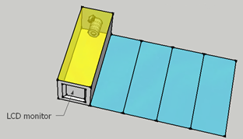
Figure 61 Mounting the LCD

Software Environment

PIC microcontrollers can be programmed in assembly, C, or BASIC. The language of choice for this project is C, because most of the group members are familiar with C, and it tends to be easier to program in C than in assembly. There is also an abundance of sample code and resources regarding C code for PIC chips, so this will greatly assist the ease of programming. The programming environment that was chosen to program the PIC16F690 chip with is the mikroC compiler. This is because it is free, has pre-written functions and libraries to assist with code writing, and has support forums to help with coding issues. This will reduce the amount of time spent troubleshooting, as well as the potential costs of other software environments. However, the discussion below shows all the considerations between the different IDEs.

MPLAB IDE

Microchip’s MPLAB IDE comes free on their website, and is a great toolset for developing embedded applications for Microchip’s PIC microcontrollers. The IDE environment is a unified graphical user interface (GUI) for Microchip and other third party software and hardware tools. It’s easy to move between tools and advancing from the software to hardware debug and programming is quick and easy since MPLAB has the same GUI for all tools. The following are some of the great features the MPLAB provides:

- Flexible customizable programmer’s text editor
  - Fully integrated debugging
  - Tabbed editor
  - Recordable macros
  - Context sensitive color highlighting (code readability)
  - Ability to set breakpoints and trace points
  - Graphical project manager
  - Version control support
- Free components
  - Full featured debugger
  - Powerful plug-ins
  - MPLAB SIM (software simulator for PIC)
    - Has peripheral simulation
- Simple but powerful source level debugging
  - Mouse-over variable inspection
  - Drag and drop variables to watch windows
  - Watch variables, structures, and arrays
  - Mixed source code/disassembly view
  - Automatic single-step “animate” feature
  - Custom hot keys
  - Trace to source correlation (compares real-time data collected with original source code)
- Built in support for hardware and add-on components

As can be seen, MPLAB offers many features that are desirable for programming the microprocessor. The ease of use, cost (free), and support makes MPLAB the likely choice for this project. Figure 62 shows what the MPLAB IDE looks like:

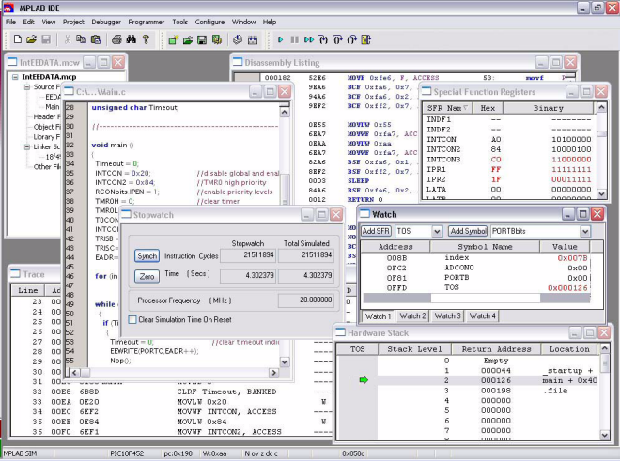
Figure 62 MPLAB IDE Source: [M14]

One alternative to MPLAB is the HI-TECH C compiler for PIC16 MCUs. This compiler has a benefit that was appealing for this project: it employs the optimizations of Omniscient Code Generation (OCG). OCG is a whole-program compilation technology that provides denser code and better performance for PIC16 MCUs. The following are some optimizations provided by OCG:

- Optimizes the size of each pointer variable based on its usage
- Reduces overhead required for interrupt switching
- Pointer optimizations based on knowledge of target
- Optimizations for rapid runtime startup and memory clearing

Some of the regular features of the HI-TECH C compiler are:

- Supports all PIC18 MCUs
- Unlimited memory usage
- Includes Microchip-compatible peripheral library
- Automatically analyzes user assembly and object code files
- Fully integrates into MPLAB IDE

As can be shown in Figure 63 below, HI-TECH C compiler is a nice environment to work in, and the group members are familiar with using IDEs like this.

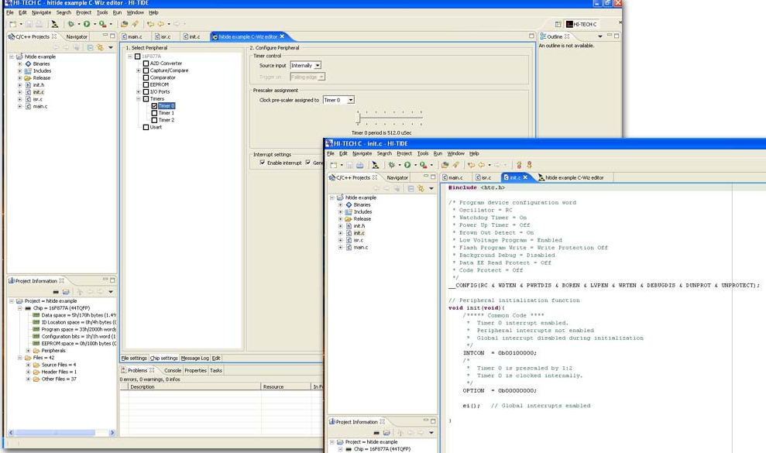
Figure 63 HI-TECH C Compiler IDE
Source: [M15]

The final option for a software IDE was the mikroC compiler by MikroElektronika. According to their website, www.mikroe.com, mikroC compiler “is designed for developing, building, and debugging PIC-based embedded applications. This development environment has a wide range of features such as easy-to-use IDE, very compact and efficient code, hardware and software libraries, comprehensive documentation, and numerous ready-to-use examples to give you a good start for your embedded projects.” Figure 64 below shows the nice environment of the mikroC IDE. As can be seen, this compiler is great for beginners, and the pre-written libraries can save numerous hours of coding time. Since one of the group members already had this compiler in addition to all the beneficial features for beginners and support forums available, it was decided to use the mikroC compiler to program the microcontroller.

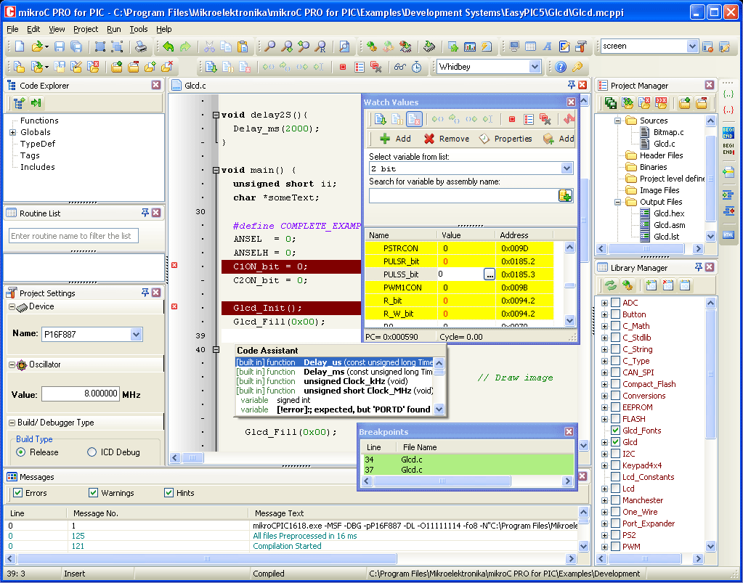
Figure 64 - mikroC Compiler IDE
Source: [M18]

Software Code

The code used for the Universal Charging Friend contains the following functions:

- Main
- Interrupt
  - Timer
  - Button
- ADC
  - Battery
  - Wall
  - Kinetic
  - Solar

Main Function

The main function is what gets executed when the PIC is first powered on. The main function declares most of the variables, configures the chip setup, initializes the LCD, and then loops forever, calling all the other necessary functions in a permanent while loop. Figure 65 below shows a snippet of the main function. As can be seen, the function calls the Config function, initializes the LCD, and turns the backlight on.

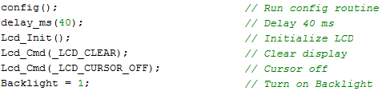
Figure 65 Main Function Code Snippet

Interrupt – Timer and Hold

The timer interrupt is used as a clock for the ADC counter and button hold counter. As can be seen in the code snippet in Figure 66, if the Timer0 (T0) interrupt flag is set, the loop for that interrupt is executed, which increments a counter and resets the T0 flag. A similar situation occurs when the Timer2 (T2) interrupt flag is set. The button interrupt is used as a hold counter to detect how long the button is pressed down.

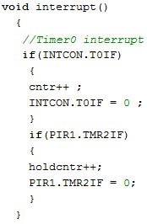
Figure 66 Interrupt Function Code Snippet

ADC

Four ADC functions are called by the main function: battery, wall, kinetic, and solar, as shown in figure 67 below.

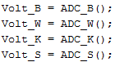
Figure 67 - Voltage ADC Code Snippet

Since the max voltage into the ADC ports of the microcontroller is 5V, it was necessary to use voltage dividers to perform the calculations. Four voltage dividers, one for each ADC, are implemented into the design. Each voltage divider uses the same values for R1 and R2 for simplicity and to save program space by using only two variables instead of eight. A sample of the battery ADC voltage divider is shown in figure 68 below.

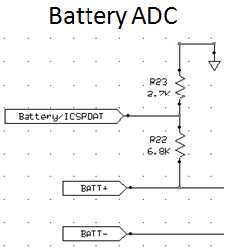
Figure 68 Battery ADC

The ADC function code performs the following steps in order to achieve an accurate value for display to the LCD:

- Read a raw value of the analog port.
- Multiply the raw value by the reference voltage (+5V) and divide by 1023 because the PIC uses 10-bit resolution (2¹⁰ = 1024).
- Divide by the voltage divider factor V_{out} / V_{in}
- Compare the result with a minimum reference value (i.e. 2V) to ensure that the reading is not noise; otherwise, set the value to zero.

Figure 69 below shows a code snippet of the battery ADC function, as previously described:
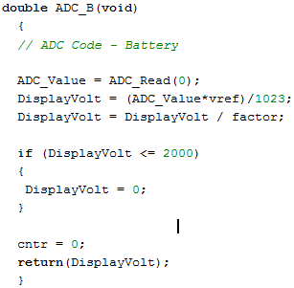
Figure 69 ADC Function Code Snippet

Final Design Schematic

Overview Block Diagram of Entire System
The Universal Charging Friend consists of several power supply options for charging the battery. A PIC and an LCD have also been added to the design (shown in Figure 70 below) to give the user an interface to the unit so the user understands what is happening with the charging process real time. The unit also includes a USB port to allow discharging of the battery to any 5V electronic device.

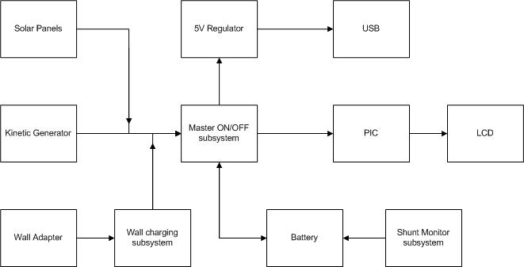
Figure 70 Simplified block diagram of the UCF design.

Power Control Schematic
The power control schematic consists of the main push button used to turn on and off the UCF unit, a linear regulator, an inverter and a latch (Figure 71 below). When the push button is first pushed in order to turn on the unit a pulse is sent through (from the battery) the inverter and into the latch. This will switch the latch down and connect the main power ground to the battery ground and power up the PIC and LCD and any other components in need of a power supply. If the button is pushed for more than three seconds an interrupt will be sent to the PIC and then the PIC will send a pulse through to the latch in order to reset the latch and shut down the unit. Also, if the UCF unit is already on and the push button is pressed and released an interrupt will be sent to the PIC telling the PIC to light up the backlight of the LCD for ten seconds. The LCD will then dim out again to conserve power.
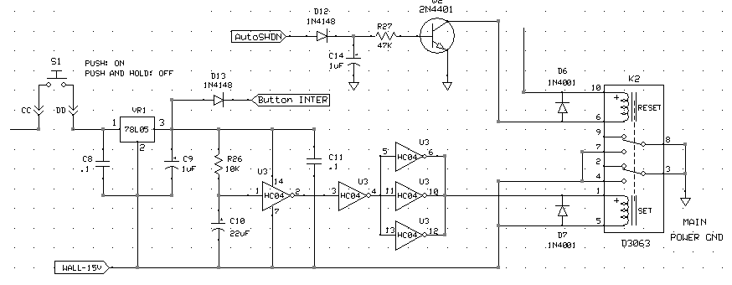
Figure 71 This is a section of the full UCF schematic. This section is displaying the Main Power system.

Wall Charging Schematic
The wall charging schematic is centered around the MAXIM chip. The design is very closely related to what is found in the MAXIM713 datasheet. A dual LED has been added to the design as well to provide an interface to the user showing whether the wall adaptor is trickle charging or fast charging the battery (Figure 72). If the battery is being trickle charged, the battery is nearly full and the LED will be blue. If the battery is fast charging, the LED will be red.
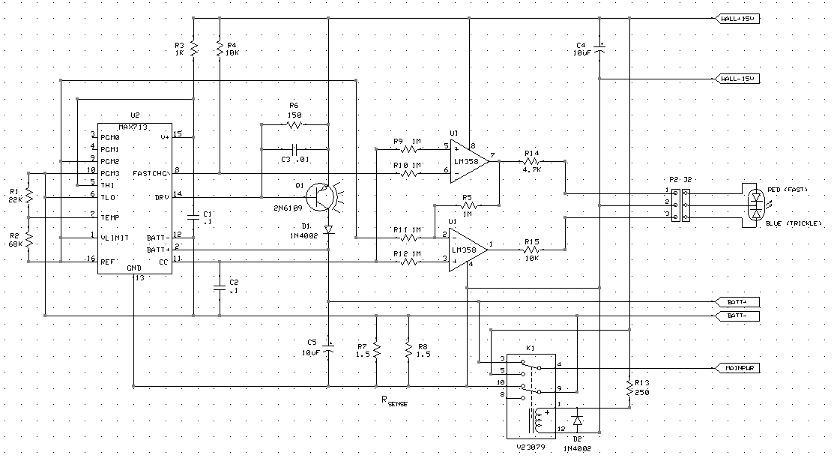
Figure 72 This is a section of the full UCF schematic. This section is displaying the Wall Charging system.

I/O Schematic
The PIC and the LCD make up the I/O portion of the schematic (Figure 73 below). The PIC’s main function in the UCF is to use its internal ADC’s to sample voltages from the solar power, kinetic power, wall adapter power and battery Voltage. The PIC is also wired to many parts of the system to wait for any interrupts including the two current shunt monitors and the push button interrupts. Also, the PIC will automatically shut down the unit if the battery gets too low by sending a pulse through to the latch which in turn shuts off the UCF. The LCD was added to display all of this information to the user.
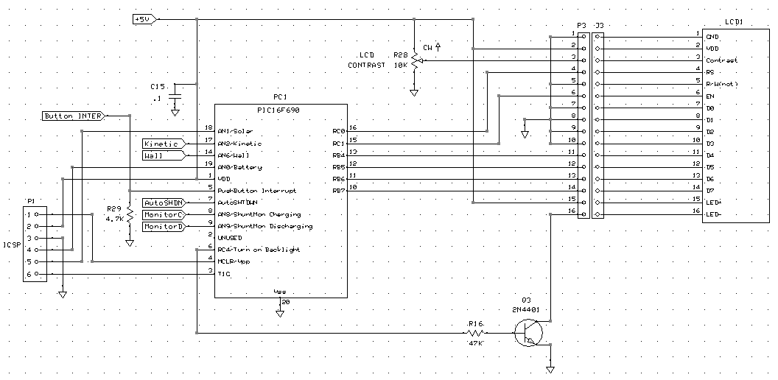
Figure 73 This is a section of the full UCF schematic. This section is displaying the I/O system.

ICSP Header
The ICSP header was also added to the schematic so that it would be included in the PCB design. This would allow the group to program the PIC chip directly from the board instead of having to move the PIC chip back and forth between the PIC development board and the UCF printed circuit board.

Current Shunt Monitors
The current shunt monitors were added to the design in order to accurately measure the current going through the shunt resistor and into or out of the battery (Figure 74 below). The shunt monitors measure the voltage across the shunt resistor and then amplify the voltage fifty times. This measurement is sent to the PIC where the current can then be calculated using Ohm’s law since the shunt resistor value is known and the voltage across the resistor is known.

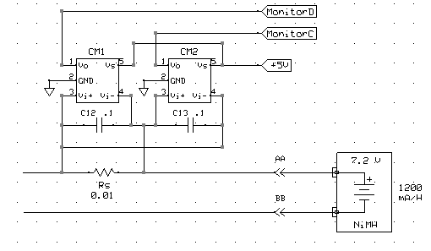
Figure 74 This is a section of the full UCF schematic. This section is displaying the Shunt Monitor system used for measuring the current.

Testing

Power Generation Testing

Introduction to testing Kinetic Generator

It was decided that one form of an Electromagnetic Generator would be implemented in this prototype of the UCF. The generator which has been implemented in the UCF is a hand crank generator which was added to the unit primarily for emergency cases and used as a back-up energy source. Almost all of the materials used to create this generator were easy to come by and cheap. This in turn drove the price of the UCF down.

Possible testing Environments/Procedures for Electromagnetic Generator

Testing was a critical component in choosing a system which will yield optimal results for the UCF’s specific goals. The UCF was oriented towards users who would be camping, hiking, biking or soldiers. This meant that it needed to be tested thoroughly and the generator used to harvest the associated movements that occur during these various activities needed to be optimized for these specific actions. Every modification in the physical structure of the generator yielded different results in power output for each specific action. As stated earlier, the loss of one fixed magnet place at the upper end of a tube in a generator created a much higher output power while walking or slowly jogging than if the fixed upper magnet had always been there. However, there was only a significant increase in output power while walking and not much of an increase while walking when the magnet was taken out. This is because the magnet which had been placed at the end of the tube was obstructing the way of the inner free moving magnet causing a much smaller displacement for the free moving center magnet. With the end magnet hindering the potential displacement of the free magnet, it proved to be a poor choice and should not be implemented in the UCF, since it is assumed that highly active movement (vertical movement in this example) will occur. There are many other modifications or variations that could have been implemented which would have yielded much better results and through testing the necessary modifications become apparent. Many different motors were tested for efficiency for the crank generator.

Solar Power Generation

Testing of solar panels will require a multimeter, contact probes, gator clips, a small incandescent lamp, a clear and sunny day, thermometer, and an oscilloscope.

Mechanical Testing

- All panels should be fully extend and then folded back in to storage mode several times with close observation (Figure 75 below). During cycling ensure that each surface or joint does not come into contact with any electrical wiring. Check for binding or misalignment along all seems and joints. Any misalignment or binding could cause a mechanical failure from the extra cyclic.

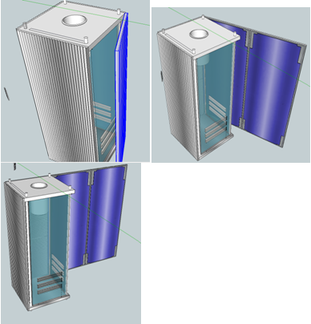
Figure 75 Cycling of Solar Panels for Stress

- With panels all fully deployed all locks should be engaged (Figure 76). Using the hand crank as a lean-to and adjust the angle of the photovoltaic panels. Observe the locking mechanism for excessive flexing and overall effectiveness.

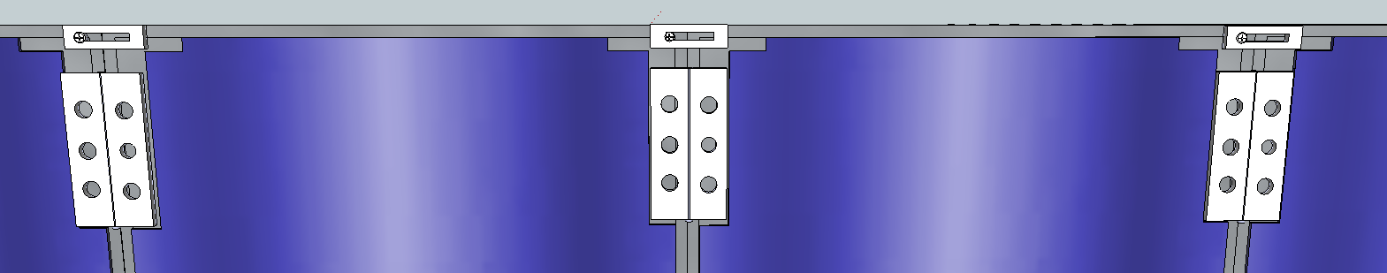
Figure 76 All Locking Mechanisms Engaged

- Disengage the locking devices test. While holding the base in one hand, slide thumb and forefinger pinched along the top and bottom edges to disengage the locking devices, from the base towards the panel farthest from the base. If the locking devices seem to disengage too easily, tighten the fatteners which retain the locking devices in place. If the locking devices require unnecessary effort to disengage them, loosen the fasteners and then return to step 2.

Measuring of voltage produced from the photo voltaic module

- Fully deploy the solar panels
- Position the lamp over the solar panels.
- Measure and record the voltage and current, open circuit, across the solar panels with the multimeter before and after the lamp is turned on, by connecting to positive and negative terminals of the PV module. See Figure 77 below.

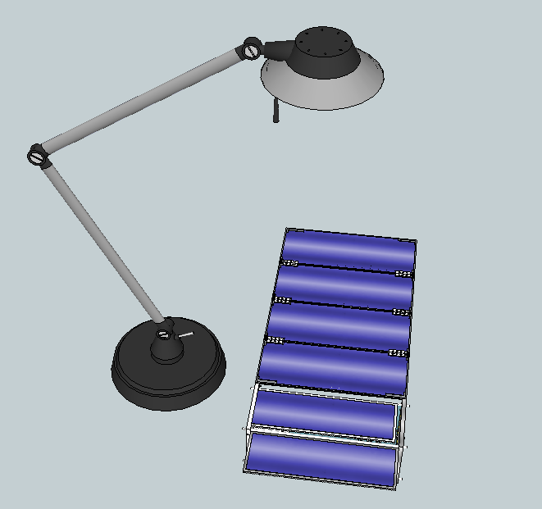
Figure 77 Lamp and UCF During Testing

- Perform the same measurements outside on a clear and sunny day.

Solar Cell performance in the Sun

- Place UCF in the sun with panels fully deployed. Take panel temperature, on the silicon side, and open circuit voltage and current measurements.
- Wait 5 min and repeat measurements. Continue to perform this process of measurements every 5 minutes for 30min.
- If after 30 minutes there is little change of temperature, voltage or current, continue measuring every 15 minutes.
- This process should be repeated on 2 separate days with similar weather conditions.

Power Storage Testing

In assembling the battery system components, one of the necessary steps is to connect the USB step down converter circuit, with minor adjustments, to the battery unit itself. This can be done by simply merging the wires; also the circuit of the microcontroller needs a supply voltage. So the output of the step down converter can be merged with an additional LDO to ensure the right amount of voltage enters the microcontroller. The output of the step down converter would obviously be the USB connection as well and the USB female connector would have to be attached to the end of the wire so that it is flush along the UCF encasing. Figure 78 shows the basic circuit for the USB step down converter that will be similar to the process which will be used for the UCF.

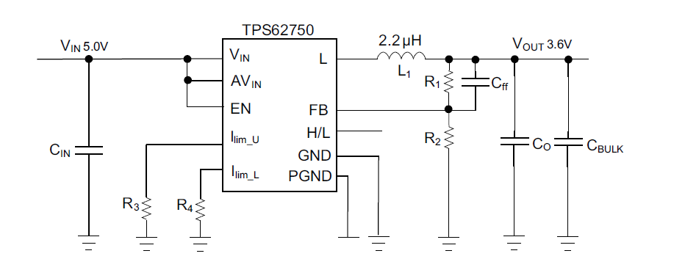
Figure 78 USB Step Down Converter
Source: [C16]

Features from datasheet:
- Efficiency > 90% at Nominal Operating
- Programmable Average Input Current Limits 50mA to 300mA for Low Current Limit
- Range 300mA to 1.3A for High Current Limit Range– ±10% Current Accuracy • Stable Output Voltage for Load Transients to
- Minimize Overshoot at Load Step Response
- Hot Plug and Reverse Current Protection • Automatic PFM/PWM Mode transition (TPS62750)
- Forced PWM for Noise Sensitive Applications (TPS62751 • VIN Range From 2.9V to 6V
- Adjustable VOUT From 0.8V to 0.85×VIN
- Soft start for Inrush Current Prevention
- 2.25 MHz Fixed Frequency Operation • Short Circuit and Thermal Shutdown

Protection

The unit is tested after simulation of the microcontroller and assembly onto a breadboard. The charging circuit was tested by charging a 7.2V nickel metal hydride 600 mAh battery, which is shown below in Figure 79, that was given to the group by a coworker. The smaller capacity of the battery chosen to test will help prove the idea of charging the battery faster and therefore proving the fast and trickle charge modes of the charging circuit. The dual LED mounted onto the UCF will light red when the device is in fast charge mode and will light blue when the device is in trickle charge mode.

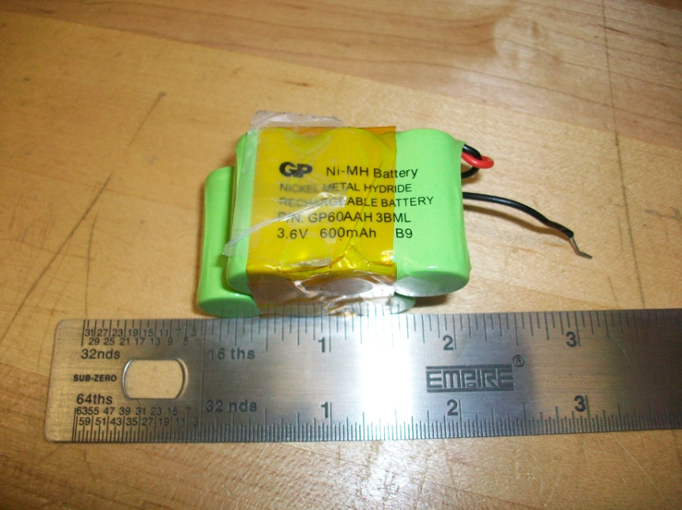
Figure 79 NiMH used to test UCF

The USB port, after construction, was tested using a Garmin navigation device that charges through a USB outlet. The device did not properly charge at first attempt. Although all the circuit components looked to be connected, the navigation device was not charging when the UCF was not connected to the wall adapter. The device charged once the UCF was plugged into the wall outlet. The trouble was a loose connection where the positive terminal of the battery connected to the designated pin on the PCB. Once the connection was soldered, the UCF was tested and operated successfully. The UCF then performed the charge on the navigation device with and without the wall adapter effectively.

The solar panels of the UCF were also tested. The output voltage was 15V as expected and the current varied as anticipated however, on the battery charging circuit the current limiter properly limited the current from the solar panels to around 120mA which is around 1/10C for the battery chosen for the UCF. The kinetic generator also performed properly by presenting a charge to the battery. The charging circuit produces a 340mA current when the device is in fast charge mode. The fast charge mode represents the charging mode using the wall adapter. The trickle charge mode is implemented when the battery is fully charged. A trickle charge current will enter the battery in order to top off the battery pack. The trickle charge current was measured to be around 30mA.

The UCF was tested using a Garmin navigation device which it charged successfully from both the wall charger adapter of the UCF and by the internal battery of the UCF. Basically, the UCF is designed to charge a device both via wall and by the internal battery of the UCF. The Garmin navigation device was charged from the USB port of the UCF. The estimated time to fully charge the Garmin navigation device via the UCF is around three and half hours. Charging a cell phone from the USB connection was also tested and the phone was successfully charged. The solar panel was estimated to charge the 600mAh battery in five hours. In fast charge mode, the 600mAh battery that was used to test the UCF could be charged in an hour.

Software and Message Display Testing

The first thing that was tested once the LCD arrived was power-on and text characters. A “Hello World” message was put on each line to make sure all the lines were working. Each subroutine was tested as it was created to keep the program clean and easy to troubleshoot. The ADC functions were tested with a multimeter, and then the microcontroller also displayed that voltage to the LCD display. When the voltages matched, it was deemed a successful function. When the functions did not work nominally, more tweaking and troubleshooting followed until the desired outcome was achieved. Multiple online sources were pursued as a means to troubleshoot problems as they occurred.

Administrative

Milestone Chart

The milestone chart for the UCF is as shown below in Figure 80. Figure 80 below describes in a timely fashion the dates of importance concerning the completion of the project. The research of each aspect of the project was done prior to the purchasing of any components. As shown in Chart 4 below, the prototype of the UCF was completed on the 15th of October, as well as a completed project by the 1st of December. The chart also describes the dates when individual tasks were done such as the building of the solar cells and testing of the LCD and microcontroller.
Figure 80 Milestone Chart for Senior Design Project

Budget Analysis

This project was not sponsored, so the overall cost of the project was split among the group members. The overall budget as shown in Table 17 below outlines the items that were used as well as spare items. The overall cost of the project was less than the group had anticipated. This was in large part due to the help of friends and coworkers for the majority of the parts associated with the project. One of the more expensive components of the project was the solar module. The solar cells came to a total of $80 for the 60 cells however; extra cells were needed due to the fragile cells breaking apart. The project was not sponsored however the total cost of the UCF did not break the bank as shown in Table 17 below.
Project Budget
Items | Required | Acquired | Estimated Cost | Actual Cost
DC Motor | 1 | 1 | $10 | $7
Gears | 1 | 1 | $5 | $4
Generator Handle | 1 | 1 | $5 | Free
AC-DC wall adapter | 1 | 1 | $30 | $30
DC-DC converters | 3 | 1 | $70 | $70
LCD | 1 | 1 | $20 | $10
Battery | 2 | 2 | $25 | $20
Solar Cells | 27 | 60 | $100 | $80
Project Housing Material | 1 | 2 | $25 | $50
PCB | 1 | 4 | $100 | $55
Miscellaneous |  |  | $100 | $65
Total |  |  | $490 | $391
Table 17 Estimated Project Costs

Conclusion and Project Summary

The overall development of the Universal Charging Friend (UCF) has been challenging yet motivating. Since the general task of a solar battery charger can be assembled rather easily, the goal for the UCF is maximum efficiency of the kinetic and solar energy generated. The UCF combines multiple charging sources such as solar power and kinetic energy to a portable battery system in order to maximize the power for a variety of handheld devices. The UCF has similar dimensions to that of a large water bottle holder for ease in transport within backpacks. Included in this document are the necessary steps involved in constructing such an efficient, portable battery charger via solar and kinetic alternatives. The main goals for the project of designing an efficient portable charger have been met. The goal of efficiently designing such a unit that would store the energy generated from both solar cells and a kinetic energy system as well as display the efficiency of the unit in terms of charge time has been met.

The solar panels of the UCF are attached along each side of the device maximizing the useable area. The solar components consisting of multiple sets of photovoltaic cells attached around the charging device, measure 19cm x 9cm x 9cm in order for the UCF to be transported without much hassle. The sensitive cells are carefully managed and maximized in order to optimize the performance of the charging system. The limited use of size for the solar cells was a challenge for the design. In this case, optimization is critical for the device to successfully meet the set goal. The maximum power output for PV cell, at a given temperature, is predetermined from design, therefore it is necessary provide the best environment possible for the PV cell to operate.

The NiMH charging system receives the power from the “green” energy sources with efficiency as a main concern. The voltage and current from the solar cells is maximized and regulated at a rate which will optimize the charging of the battery system. The battery unit also stores the important power from the kinetic source, which is vital in such situations as needing power right away for an emergency phone call as an example. The kinetic source is crucial to the implementation of the project for such a scenario where the sun is not out or there is no immediate outlet of power available. The kinetic energy is generated utilizing human action upon the device. Although the charge is that of a trickle charge, the source is vital to the concept of our device. The power generated from the entire device makes the user feel independent from the constraint of their handheld’s battery. The LCD which is attached to the inner housing of the UCF is extremely helpful to the user for identifying various needs or concerns of the system such as battery life remaining, charging time from the sources, and input source of the battery. Our device, which can be utilized to power many electronics as discussed, was designed for the purpose of limitless uses. The device is beneficial not only to the outdoorsman camping using the UCF to power his GPS device but to the everyday electronic user who needs another few hours of talk time.

Appendices

Bibliography

[K1] S.P. Beeby, R.N. Torah and M.J. Tudor. Kinetic Energy Harvesting. University of South Hampton, UK. January, 2008.

[K2] Thad Starner & Joseph A. Paradiso. Human Generated Power for mobile electronics. MIT Press, Cambridge, MA.

[K3] http://www.vibes.ecs.soton.ac.uk/

[K4] C.R. Saha, T. O’donnell, N. Wang, P. McCloskey. Electromagnetic Generator for Harvesting Energy from Human Motion. Sensors and Actuators, March 15, 2008.

[K5] Paul D. Mitcheson, Eric M. Yeatmen, G. Kondala Rao, Andrew S. Holmes, Tim C. Green. Human and Marchine Motion for Wireless Electronic Devices. Proceedings of the IEEE, Volume 96 Number 9, September 2008.

[K6] P. Niu, P. Chapman, R. Reimer, and X. Zhang, Evaluation of motions and actuation methods for biomechanical energy harvesting, in Proc. 35th Annu. IEEE Power Electron. Specialists Conf., Aachen, Germany, Jun. 2004, pp. 2100–2106.

[K7] T. Starner, Human powered wearable computing, IBM Syst. J., vol. 35, no. 3–4, pp. 618–629, 1996.

[K8] M. El-Hami, P. Glynne-Jones, E. James, S. Beeby, N. M. White, A. D. Brown, J. N. Ross, and N. Hill, BA new approach towards the design of a vibration-based microelectromechanical generator, in Proc. 14th Eur. Conf. Solid-State Transducers, Eurosensors XIV, Copenhagen, Denmark, Aug. 2000, pp. 483–486.

[K9] Joseph A. Paradiso, Thad Starner, Energy Scavenging for Mobile and Electronic Devices, Pervasive Computing

[K10] http://www.humboldt.edu/~ccat/pedalpower/hec/hpeg/index.html
Battery System (C#)

[C1] Buchmann, Isidor. http://www.batteryuniversity.com/. Cadex Electronics. April 2003.
[C2] Bergveld, Henk Jan, Kruijt , Wanda S., Notten, Peter H.L. Battery Management Systems. Kluwer Academic Publishers. p9-20,107-109,184-187. 2002

[C3] Micropower Low Cost DC/DC Converter Adjustable and Fixed 5V, 12V. Linear Technology. http://www.solarbotics.net/library/datasheets/LT1111.pdf. 1993.

[C4] Characteristics of Rechargeable Batteries by National Semiconductor.pdf.

[C5] Qian, Jinrong. Design a Li-ion battery charger to get maximum solar power.pdf http://www.eetindia.co.in/ART_8800514520_1800000_TA_4e736b00.HTM. Feb 2007.

[C6] DS2438 Smart Battery Monitor.pdf. datasheets.maxim-ic.com/en/ds/DS2438.pdf. Dallas Semiconductor.

[C7] Pistoia, Gianfranco. Battery Operated Devices and Systems. p 38-60. The Netherlands. 2009.

[C8] Wen,Sihua. Design fuel gauging for multi-cell Li-ion battery pack. http://www.powermanagementdesignline.com/198900390;jsessionid=5DBBM1YJGHHTVQE1GHPCKH4ATMY32JVN?pgno=2.

[C9] Maxim745 Datasheet. Switch-Mode Lithium-Ion Battery-Charger

[C10] Cleveland, Terry. “Bi-directional, Portable Power-Management System for Multi-Cell, Li-ion Battery-Pack Applications”. Battery Power Products and Technology. March/April 2007 Vol 11, issue 2.

[C11] Simpson, Chester. National Semiconductor. Battery Charging.

[C12] Chia-Hsiang Lin; Chi-Lin Chen; Yu-Huei Lee; Shih-Jung Wang; Chun-Yu Hsieh; Hong-Wei Huang; Ke-Horng Chen; , "Fast charging technique for Li-ion battery charger," Electronics, Circuits and Systems, 2008. ICECS 2008. 15th IEEE International Conference on , vol., no., pp.618-621, Aug. 31 2008-Sept. 3 2008 doi: 10.1109/ICECS.2008.4674929 URL: http://ieeexplore.ieee.org/stamp/stamp.jsp?tp=&arnumber=4674929&isnumber=4674773
[C13] National Semiconductor website: http://www.national.com/mpf/LM/LM723.html#Overview

[C14] National Semiconductor Website. http://www.national.com/mpf/LM/LM117.html#Overview

[C15] Battery chosen for the project. http://www.batteryspace.com/Li-ion18650battery148v2400mahbatterymodule355whflatprewiredwithpcbandfuelguage.aspx.

[C16] Texas Instruments TPS62750 Step Down Converter for USB Applications. http://focus.ti.com/lit/ds/symlink/tps62750.pdf.

[C17] The MPPT for the Charging Unit. Batteryspace.com.
http://www.batteryspace.com/mpptsolarchargecontrollerfor148vli-ionbatterypack.aspx.

[C18] Texas Instruments. Impedance Track Enabled Battery Management Solution. 2005. http://focus.ti.com/docs/toolsw/folders/print/bq20z80evm-001.html

[C19] Maxim NiCd/NiMH Battery Fast Charge Controllers. 2008.

[S1] R. Messenger, and J. Ventre, Photovoltaic Systems. Florida Atlantic University and Florida Solar Energy Center, Florida, 2000.

[S2] L.C. Thomas, Fundamentals of Heat Transfer, Prentice-Hall, Inc., Englewood Cliffs, New Jersey 1980

[S3] V.M. Andreev, V.A. Grilikhes, and V.D. Rumyantsev, Photovoltaic Conversion of Concentrated Sunlight, Ioffe Physico-Technical Institute, Russian Academy of Sciences St. Petersburg, Russia, 1997.

[S4] http://www.rfcafe.com/ Solar Spectrum Permision recieved

[S5] http://www.suniva.com Suniva, 5775 Peachtree Industrial Blvd., Norcross, GA 30092, April 2010

[S6] http://www.isofoton.com/ April 2010

[M1] Harrison, Mike. "Which Is Better, PIC or AVR ? Let's Have a Heated Debate....." Mike's Electric Stuff. Web. <http://www.electricstuff.co.uk/picvsavr.html>.
[M2] Limor. "PIC vs. AVR Smackdown." Ladyada.net. Web. <http://www.ladyada.net/library/picvsavr.html>.
[M3] Microchip. Microchip. Web. 2010. <http://www.microchip.com/>.
[M4] Quick, Darren. "NanoWatt XLP Microcontrollers Claim World’s Lowest Sleep Current." Gizmag Emerging Technology Magazine. 30 Apr. 2009. Web. <http://www.gizmag.com/nanowatt-xlp-microcontrollers/11575/>.
[M5] Atmel. "Atmel Products - AVR Solutions." Atmel Corporation - Industry Leader in the Design and Manufacture of Advanced Semiconductors. Web. 2010. <http://www.atmel.com/products/AVR/>.
[M6] Texas Instruments. "MSP430 Microcontroller (MCU), Low Power Mixed Signal Processors." Texas Instruments Microcontrollers. Web. 2010. <http://focus.ti.com/mcu/docs/mcuprodoverview.tsp?sectionId=95&tabId=140&familyId=342>.
[M7] <http://www.altadox.com/lcd/knowledge/lcd_display_types.htm>.
[M8] "Liquid Crystal Displays, Alphanumeric LCD Modules, Graphical LCD Modules, Mumbai, India." Liquid Crystal Displays, Hand Held Terminals, Security Systems, Industrial Data Loggers, Universal Indicator, Power Electronics, Mumbai, India. Web. 2010. <http://www.orioleindia.com/lcd.html>.
[M9] Tyson, Jeff. "HowStuffWorks "Passive and Active Matrix"" Howstuffworks "Electronics" Web. 2010. <http://electronics.howstuffworks.com/lcd4.htm>.
[M10] Apple Inc. "PowerBook Displays: Active Matrix and Passive Matrix Compared." Apple - Support. 14 June 2007. Web. <http://support.apple.com/kb/TA21582>.
[M11] Crystalfontz: Serial LCDs, USB LCDs, Graphic LCD and OLED Displays. Web. 2010. <http://crystalfontz.com>.
[M12] Barett, J. T. "The Advantages of Custom Design PCB Over Prototype Board | EHow.com." EHow | How To Videos & Articles. Web. 2010. <http://www.ehow.com/list_6146329_advantages-pcb-over-prototype-board.html>.
[M13] Guidebaba. "Benefits of Surface Mount Technology (SMT)." HubPages. Web. 2010. <http://hubpages.com/hub/Benefits-of-Surface-Mount-Technology>.
[M14] "MPLAB Integrated Development Environment." Electronic Circuits, Diagrams, Software, Electronics Circuit Tutorials. 3 Sept. 2009. Web. <http://www.electronicecircuits.com/electronic-software/mplab-integrated-development-environment/>.
[M15] Microchip. "HI-TECH C for PIC18 MCU Family." Microchip Technology Inc. Web. <http://www.microchip.com/stellent/idcplg?IdcService=SS_GET_PAGE&nodeId=1406&dDocName=en542861>.
[M16] Barr, Michael. "Embedded.com - Introduction to Watchdog Timers." Embedded Systems Design - Embedded.com. 1 Oct. 2001. Web. <http://www.embedded.com/story/OEG20010920S0064>.
[M17] "Microcontrollers - 8051, Avr, Embedded, Arm, Software, Microchip, Spi, Jtag, Programmer, I2c, Interface." Forum for Electronics, Projects, Power, Schematics, Circuits, Books, Microcontrollers, ASIC, DSP, RTOS, RF, Digital and Analog Design, Circuits, Service Manuals. Web. 2010. <http://www.edaboard.com/forum76.html>.

Permissions













